1）Gardial & Son has an ROA of 12%, a 5% profit margin, and a return on equity equal to 20%. What is the company’s total assets turnover? What is the firm’s equity multiplier?
2）The Morrit Corporation has $600,000 of debt outstanding, and it pays an interest rate of 8% annually. Morrit’s annual sales are $3 million, its average tax rate is 25%, and its net profit margin on sales is 3%. If the company does not maintain a TIE ratio of at least 5 to 1, then its bank will refuse to renew the loan, and bankruptcy will result. What is Morrit’s TIE ratio?
3）The following financial statements show data for Lozano Chip Company and its industry averages. (Note: The statements and other data also are in the file Ch03 Tool Kit.xlsx. They are in the worksheet named Data for Problem 3-13.)
a. Calculate the indicated ratios for Lozano. Use the book value of debt for all ratios. b. Construct the extended DuPont equation for both Lozano and the industry. c. Outline Lozano’s strengths and weaknesses as revealed by your analysis.
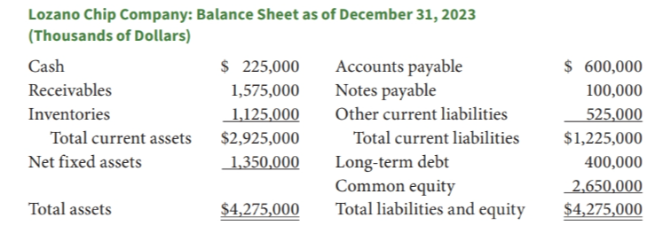
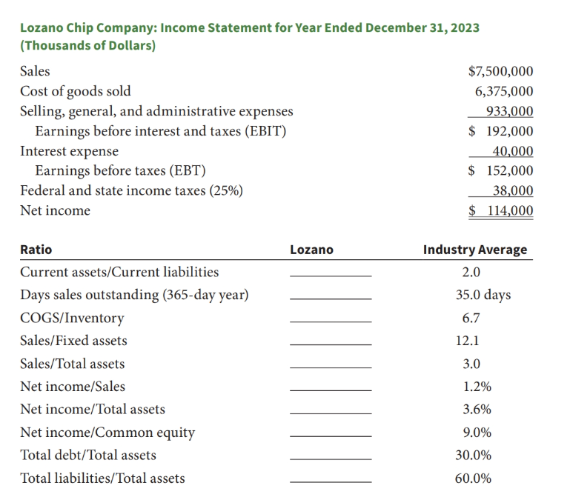

4）The Jimenez Corporation’s forecasted 2024 financial statements follow, along with some industry average ratios. Calculate Jimenez’s 2024 forecasted ratios, compare them with the industry average data, and comment briefly on Jimenez’s projected strengths and weaknesses. (Note: The statements and other data also are in the file Ch03 Tool Kit.xlsx. They are in the worksheet named Data for Problem 3-14.)

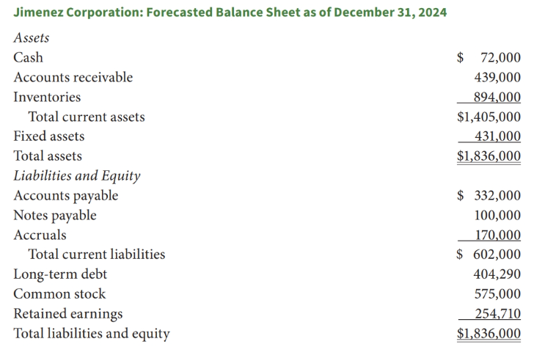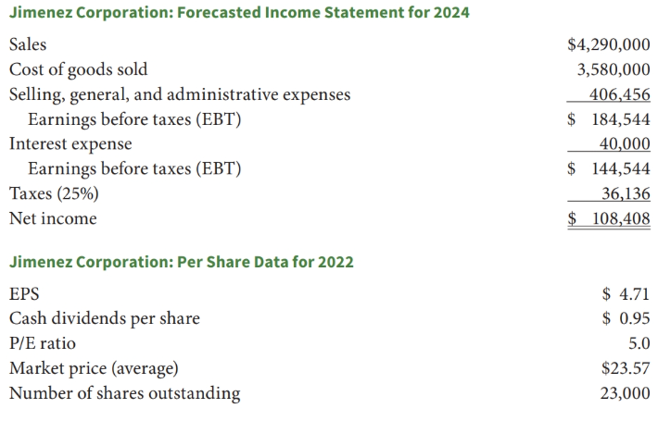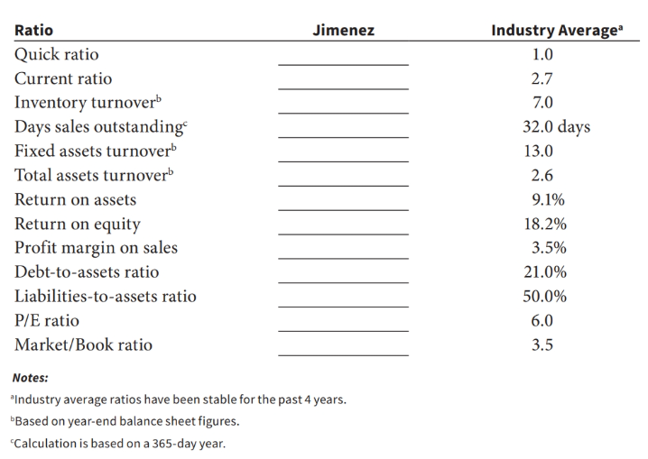
5）
6）

