Homework #1 - Real Estate Finance and Investment - BU 3530.01
Fall 2020
Please refer to Chapter 3 or Chapter 4 in the textbook, or Moodle for additional information. Please provide calculator inputs (N, I, PV, PMT, FV) for answers to questions 1, 2, and 3 (even if Excel is used for the calculator questions). You will need to make sure that these can be solved on the calculator. This is required for the class. You can answer questions on this sheet or if you use excel submit them on an excel page. I am happy to help anyway I can with this.

1. You buy a residential property and it has a rental unit that generates $1,100 per month. The property has been rented by a long-term tenant and they have no intention of leaving. Assume the rents remain flat and you plan to live in this property for eight years. If you have a goal of 10% on investments you would consider higher risk, how much is this income stream worth to you when you purchase this property?

How would you use this information? Be Brief

2. The residential property purchased in Question 1 required bank financing. The final cost of the house was $359,000. The bank will provide a traditional 30-year fixed rate loan with financing at 3.38%. In order to avoid having to pay private mortgage insurance (PMI) you will put 20% down on the property.
- How much will the spend each year on mortgage payments? (hint – do not forget how typical loan payments are calculated)

- What would be the loan balance if you decided to sell the house in eight years?

- Create an amortization chart showing principal payments, interest payments and ending balance. It should look something like below…. But please make sure it has a title and labels and is a little larger.
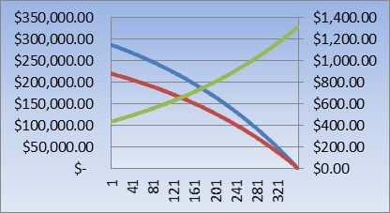
3. When you do the home inspection on the house it is discovered that the heating system and roof will require replacement in the five years. The cost to replace them today is $40,000, but the contractor tells you that in five years inflation will increase costs by approximately 15%. You believe that to not have a large cash hit in five years, that you want to fund the purchase ahead of time. Assuming that you can get 5.5% blended return on your investments, what payments will be required...
- If the payments are made annually?

- If the payments are made monthly?

- If a single payment is made today?

4. Using the information from the prior problems and below, what is the expected IRR and NPV of the cash flows?
Final assumptions: When you bought the property buying costs were 2% of the purchase price. When you sold the property selling costs were 7% of the selling price. Since purchasing the property housing market has been good and home prices increased 2.2% per year. To replace the roof, you chose to make a single payment annually.
Hint/BONUS – Hint – This problem is best solved using excel. Think of the different calculations that will need to be made and possibility of making an error. BONUS – Show the calculator inputs required to get the NPV and IRR. You do not need to show the intermediate steps. Just the final cash flow entries used to calculate the NPV and IRR on the calculator.

Do you think this was a smart investment? Be brief

