Name:________________________________________ Date:__________________ Sec:____________
Lab 2: Virtual Lab – Lactase Enzyme: Exploration of the Basis of Lactose Intolerance
*make sure that your Adobe Flash player is enabled on your computer
This Lab will be due Thursday, September 17th ,at 8am. Please begin working on this as soon as possible. Please contact me if you have any questions: cwilliford@ivytech.edu.
Lactose is milk sugar. It is composed of two molecules of "simple" sugars chemically bonded together - glucose and galactose. The enzyme lactase breaks down lactose into glucose and galactose which are easily digested by humans.

Fig.1 Maltose, lactose, and sucrose molecules (dimers); model of lactase enzyme.
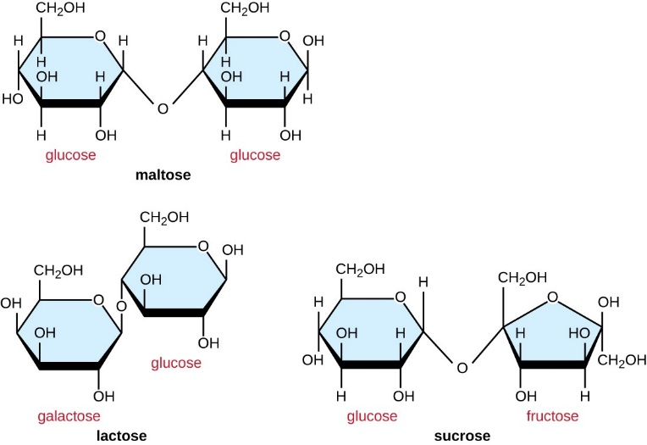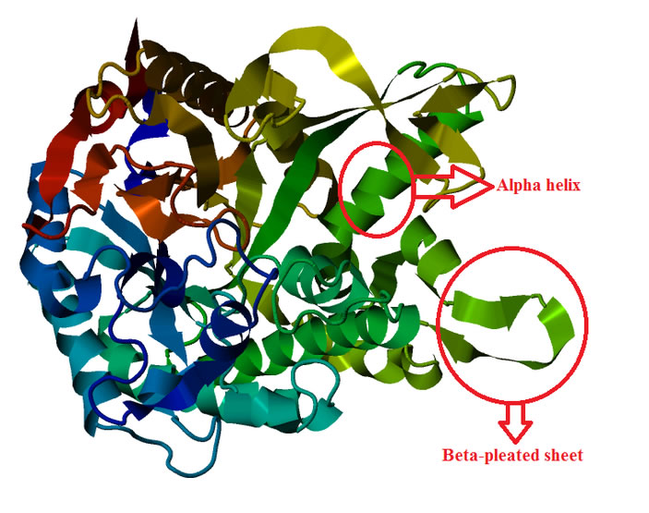

*Please review the following terms and watch the video links given and take notes.
Disaccharides – Sucrose, Maltose, Lactose – Carbohydrates: https://www.youtube.com/watch?v=eMD-gGsuGRc
Lactase & the Mechanism of Lactose Intolerance: https://www.youtube.com/watch?v=CXqXr6xK1xA

Most human infants produce ample quantities of lactase for milk digestion. However, in the vast majority of adult humans, the gene which specifies production of lactase is turned "off" and these individuals cannot digest lactose - they are lactose intolerant. Symptoms of lactose intolerance include cramps and diarrhea. The lactose molecule, which is large, accumulates in the large intestine and affects the osmotic balance there. Since water moves across semipermeable membranes, such as the intestine, from areas of high concentration to low concentration, the addition of large lactose molecules causes water to enter the intestine. This can result in the very unpleasant experience of watery stool or diarrhea. Since lactose is a sugar, it is an ideal food for the bacteria which normally inhabit our intestine (and are essential to digestion). However, the lactose will be fermented by these same friendly bacteria, and organic acids are gas are produced by them and we all know what discomfort intestinal gas can cause! So most folks who are lactose intolerant choose to avoid lactose-containing milk products, or modify the lactose, to avoid the cramps and diarrhea associated with the intolerance syndrome.

How do substrate concentration and pH affect the rate of an enzyme-controlled reaction?

To sustain the processes of life, a typical cell carries out thousands of biochemical reactions each second. Many of these reactions require the help of enzymes. Enzymes are proteins that speed up the rate of chemical reactions. Many important processes in the body involve the work of enzymes, including the digestion of nutrients such as carbohydrates, proteins and fats.

Enzymes are organic catalysts. A catalyst is a chemical that controls the rate of a reaction but is itself not used up in the process. Reactions that are accelerated due to the presence of enzymes are known as enzyme-catalyzed reactions.

Enzymes are proteins that accelerate chemical reactions but do not change themselves in the reaction. Enzymes enable molecules to undergo chemical changes, forming new substances called products. Substrates are molecules that are acted upon by enzymes. For instance, amylase, an enzyme found in saliva, helps break down complex starch molecules (substrates) into smaller sugar molecules (products). In other biochemical reactions, substrates require assistance of specific enzymes to form new products.

Each substrate fits into an area of the enzyme called the active site. This fitting together is often compared to a lock-and-key mechanism. However, researchers believe that the fit between enzyme and substrate need not be exact. Enzymes are viewed as flexible keys that can shape and conform to the shape of the substrate.

Purpose

In this investigation you will determine the effects of substrate concentration and pH on the initial rate of an enzyme-catalyzed reaction.

Objectives

- Determine the effect of substrate concentration on the initial rate of an enzyme-catalyzed reaction.
- Determine the effect of pH on the initial rate of an enzyme catalyzed reaction.

Procedure

Follow the instructions from the link below to complete the lab assignment:
🔷 http://glencoe.mheducation.com/sites/dl/free/0078802849/383930/BL_11.html
Include your plotted graph below the table in the journal section.

Before you begin conducting the lab, formulate your hypotheses (plural) (hypothesis = singular) as a group.

Remember, many good hypotheses do not just satisfy being testable, falsifiable, and repeatable; they also cleanly describe good “if this.. then that..” statements.

Your Hypothesis: ___________________________________________________________________ _____________________________________________________________________________________________________________________________________________________________________.

Journal

Title: Enzyme-controlled Reactions

Question: How do substrate concentration and pH affect enzyme-controlled reactions?

Amount of substrate | pH3 | pH5 | pH7 | pH9 | pH11
0.5 g
1.0 g
2.0 g
4.0 g
8.0 g

Journal Questions

- Describe the relationship between substrate concentration and the initial reaction rate of an enzyme-catalyzed reaction. Is this a linear relationship? What happens to the initial reaction rate as substrate concentration increases?

- What is the maximum initial reaction rate for this enzyme at pH 7?

- Explain why the maximum initial reaction rate cannot be reached at low substrate concentrations.

- What does your data indicate about the optimum pH level for this enzyme-catalyzed reaction?

- Enzymes function most efficiently at the temperature of a typical cell, which is 37 degrees Celsius. Increases or decreases in temperature can significantly lower the reaction rate. What does this suggest about the importance of temperature-regulating mechanisms in organisms? Explain.

- Using the information you’ve learned from conducting this lab assignment, how do you think substrate concentration and pH affect the enzyme lactase during milk digestion?

