Surface Water Hydrology Project Brief
(Session 2, 2020)

Project background
In this project, you are required to prepare hydrologic analysis of block of land planned for development (see attached map – based on your student number as explained above). The purpose is to satisfy regulatory requirements and get necessary approvals (from hydraulic and hydrologic perspectives) for development. You will need to collect necessary data (as formulated below) using ARR Vol 2 to construct rainfall patterns and the Bureau of Meteorology site (http://www.bom.gov.au/water/designRainfalls/ifd/index.shtml). Perform detailed hydrologic and hydraulic analyses of the basin before and after the proposed development. Discuss, in detail, the actions you propose so that the regulatory agencies’ requirements are met. You will need to perform analyses by using the basic principles you’ve learnt in Surface Water Hydrology (300983), Hydraulics (300765) and Fluid Mechanics (300762). You will also need to confirm reliability of your results by using the software packages HEC-HMS.
The submission must be in the form of a technical report following the formulated steps given below with a brief introduction to the problem, methodology used, your findings, recommendations, and references + all maps/drawings. It is to be typed using Times New Roman size 12 font and double spaced.
You will need to submit your report, all associated (Microsoft Excel) spreadsheets and all HECHMS files.
Please refer the learning guide for marking criteria.
Make justifiable and meaningful engineering assumptions, where necessary.
Please use the basins provided according to followings:
Basin 1 if 0 ≤ X ≤ 3; Use AEP 5% 3-hr storm duration
Basin 2 if 3 ˂ X ≤ 7; Use AEP 1% 3-hr storm duration
Basin 3 if X > 7; Use AEP 10% 3-hr storm duration
For example, use Basin 2, AEP 1% 3-hr storm duration for X = 7 if your student ID is 12345678.
Student ID: 19412317

Basin 1 (3 sub-basins)
Centroid of Basin 1 is as follows:
Lattitude = 31.073⁰ South
Longitude = 151.275⁰ East
Note: 1 and outlet are outlets of three Sub-basins
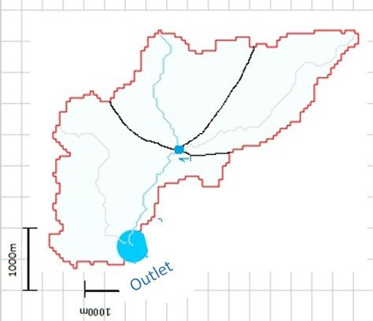

Use the scale shown in the figure to estimate the areas

Basin 2 (3 Sub-basins)
Centroid of Basin 1 is as follows:
Lattitude = 31.075⁰ South
Longitude = 150.810⁰ East
Note: 1 and outlet are outlets of three Sub-basins
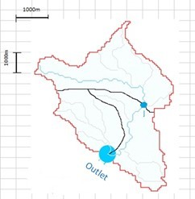

Use the scale shown in the figure to estimate the areas

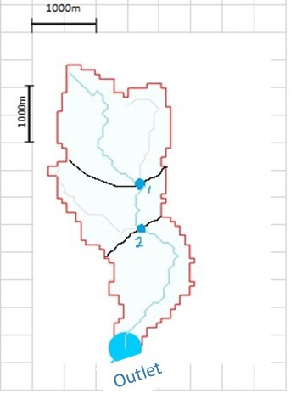
Basin

3

(3
Sub
-
basins)

Centroid of Basin 1 is as follows:

Lattitude = 33.063
⁰

South

Longitude = 150.606
⁰

East

Note: 1, 2 and outlet are outlets of three Sub
-
basins

Use the
scale shown in the figure to estimate the areas

Step 1: Physical parameters estimation
Using the scale provided in basin delineation, estimate (an approximate estimation will be enough) the area of each sub-basin, compute the total area of the basin and estimate the channel length.

Step 2: Rainfall hyetograph construction
Use the Bureau of Meteorology web site (http://www.bom.gov.au) to generate the IFD curves for your catchment. Use the 2016 IFD and the latitude and longitude stated in the figures (for your basin) to generate IFD information for your site. Use % AEP as allocated above and 3-hr storm for further analysis. Include both IFD table and IFD curves in your report.
Generate total rainfall hyetograph for the storm generated in above step (you need to use ARR Data Hub web site, https://data.arr-software.org/). Include total rainfall hyetograph, both table and histogram in your report.

Step 3: Rainfall Excess hyetograph construction
Now use initial and continuing loss model to construct rainfall excess hyetograph. You need to extract the initial and constant loss values from the ARR Data Hub web site. Make necessary adjustments, if required. You will need to explain how you achieved your result and include this in your report. Graphical representation suffices here.
For post-development condition, assume that both the initial loss and continuing loss will be reduced by 50% for the sub-basin you’re proposing to develop. Remember you’re developing only one of the three sub-basins; therefore, loss values and rainfall excess will change only for one subbasin.

Step 4: Desired duration unit hydrograph construction
You will be generating a desired unit hydrographs for your sub-catchments using the 5-minute unit hydrograph for a basin given in the table below and making reasonable assumptions as follows:
Use of spreadsheet is required to save time, as the process involves repetitive computations. You will need to include your spreadsheet.
A 5-minute unit hydrograph for a basin of 750 hectares is given in the table below.
Time (min) | 0 | 5 | 10 | 15 | 20 | 25
Discharge(m³/s) | 0 | 0.85 | 1.95 | 3.55 | 4.31 | 3.65
Time (min) | 30 | 35 | 40 | 45 | 50 | 55
Discharge(m³/s) | 2.95 | 2.15 | 1.59 | 1.15 | 0.85 | 0.65
Time (min) | 60 | 65 | 70 | 75 | 80 | 85
Discharge(m³/s) | 0.45 | 0.35 | 0.25 | 0.2 | 0.1 | 0

Compute ordinates of desired unit hydrographs for your sub-basins using above 5-minute unit hydrograph. Consider using the basin area as a scaling factor. For example, if your sub-basin area is 350 hectares then consider multiplying those ordinates from above table by 0.5.
Note: You will need to construct up to three unit hydrographs depending upon the size of subbasins.
You will need to explain the process you followed in your report. Make sure to verify your results by checking volumes after each computation.

Step 5: Storm hydrograph computation
Construct storm hydrograph for each sub-basin using rainfall excess (step 3) and respective Δt-hr unit hydrographs generated above in step 4. The constructed hydrographs are the responses at the outlet of each sub-basins under the existing conditions.
Step 6: Network diagram construction, routing through channel(s) and computation of hydrograph at the outlet of the whole basin.
Construct the hydrologic network to show connectivity of sub-basins, channels and reservoirs (if any).
You will require to extract channel properties for routing the hydrographs through channels using Muskingum routing method. For this, assume the following.
Use weighting factor, x = 0.3
Use average channel velocity 1.1 m/s to estimate average flow velocity in the channel. Use this average flow velocity to estimate travel time constant, K.
Use these values of x & K to route relevant hydrographs through respective channel(s) and compute the hydrograph at the outlet of the basin.
This completes generation of pre-development hydrograph at the basin outlet.

Step 7: Construction of Post-development hydrographs
Consider developing one of the sub-basins by proposing the following:
Both initial loss and continuing loss will be reduced by 50%. 5-minute unit-hydrograph will have the following characteristics.
- Peak discharge will increase by 30%
- Time to peak will decrease by 15%
- Time base will decrease by 25%
Use the above adjustments to scale and generate meaningful post-development 5-min unit hydrograph. You will have to ensure that the volume balance works out. This may require a few iterations.
You will then need to construct Δt -hr unit hydrograph (post-development) for the sub-basin being developed and use this to generate post-development response from the basin.

Step 8: Comparison of Pre- and Post-development hydrographs
Now compare the pre-development and post-development hydrographs. Present your results in graphical form and present salient values in a tabular form. Analyse and discuss your results.
Next, propose a solution that will ensure that the peak of the post-development hydrograph at the outlet does not exceed the peak of the pre-development hydrograph at the outlet. You may have to design a reservoir incorporating outlet structures to achieve this. If you’re to use this approach, you will need to route the post-development hydrograph through the reservoir.
You will need to discuss your strategy, provide the size of the reservoir and the details of outlet structures in your report.

Step 9: Use of HEC-HMS to verify your results
This is the last step. You will use HEC-HMS (ver. 4.3) to verify your results. You will need to include all HEC-HMS files in your submission.

Best Wishes!

