Physics 12B
Department of Physics and Astronomy
Hooke’s Law and Simple Harmonic Motion

Name _____________________________
Experimental Objectives

- Validate Hooke’s Law (Static Part)
- Analyze how different combinations of springs affect the stretching of a system.
- Compare the dynamical determination of k for a chosen spring to its static value.

Background:

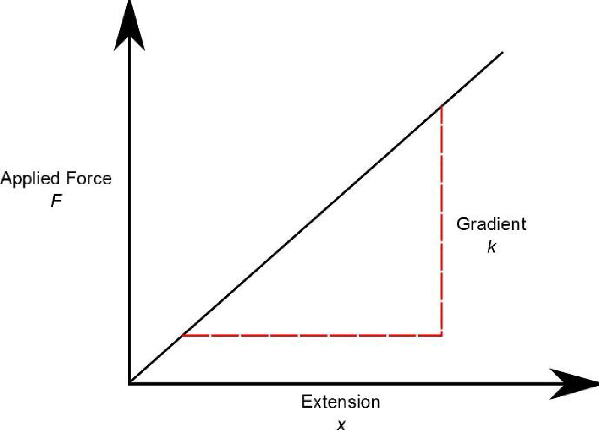
Hooke's law states that the extension of a spring is proportional to the applied force.

If a spring obeys Hooke's law, then a graph of applied force against extension will be a straight line, whose gradient (slope) is k:

The equation of the straight line is:
$$F = k x$$
where:
$F$= stretching force applied to the spring
$k$ = spring constant
$x$ = extension of the spring

Part 1: Validating Hooke’s Law

Open the following simulator and click the energy option:
https://phet.colorado.edu/sims/html/masses-and-springs-basics/latest/masses-and-springs-basics_en.html

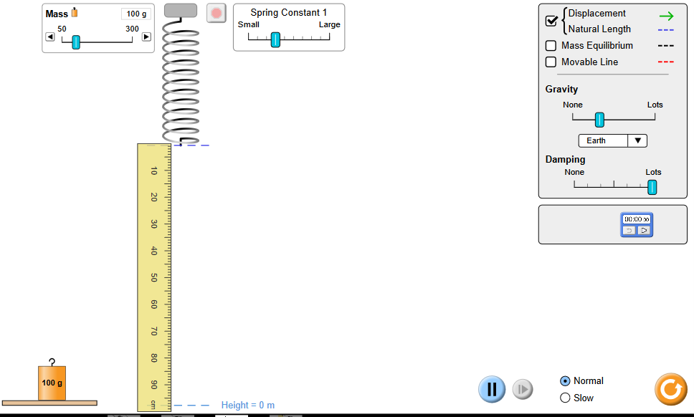

- Place the 100g mass onto the spring. The spring will begin to oscillate up and down. Stop this by clicking on the mass several times or increasing the ‘Damping’ value to ‘Lots’.
- Click the ‘Displacement’ and ‘Movable Line’ options on the right. Adjust the movable red line to the tip of the green arrow.

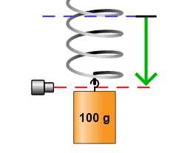

- Use the ruler tool (the units are in cm) on the bottom right to measure the extension of the spring with the 100g mass. Convert this mass to a weight (use $g=9.8 ms^{-2}$) and add this data to table 1. Remember to convert g to kg, and cm to m.

Mass added (g) | Weight (N) | Extension (m)
100g
Table 1

- Using the slider at the top, change the mass and record 5 more results of weight and extension. Add your results to table 1.

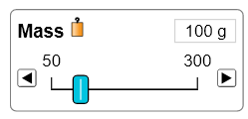

- Plot a graph for Force (y-axis) against extension (x-axis). Draw a line of best fit through your points.

- Using your graph, determine the spring constant of your spring (in $N/m$) by finding the slope of the line.

- What evidence from your graph shows that the spring obeys Hooke’s Law?

Part II: Analyzing Systems of Springs

Open the simulation below and press the systems open:

https://phet.colorado.edu/sims/html/hookes-law/latest/hookes-law_en.html

- Select the options ‘Displacement’, ‘Equilibrium Potion’ and ‘Values’. Make sure the option of two springs in parallel is selected so that the springs look like the setup in the image below.

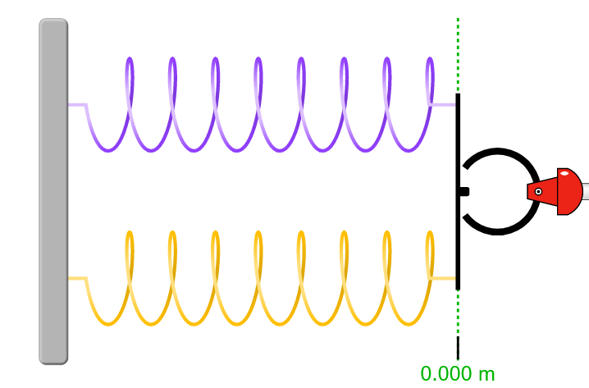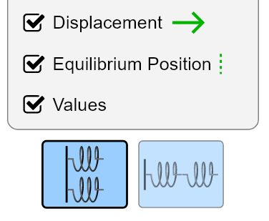

- Keep the top spring constant $k_{1}=200 N/m$ and the bottom spring constant $k_{2}=200 N/m$. Apply 100N of force to the right. Measure the extension and determine the total spring constant of the two springs in parallel ($\frac{Force}{Extension}$). Record your results in table 2.

Two Springs in Parallel

$k_{1}$ ($N/m)$ | $k_{2}$ ($N/m)$ | F (N) | Extension (m) | Total $k$ ($N/m)$
 |  | 100 N
 |  | 100 N
 |  | 100 N
 |  | 100 N
Table 2
- Repeat step b) three more times by changing the values of $k_{1}$ and $k_{2}$ (making sure the two values are identical in each case) and adding the results to table 2.

- Describe the relationship between the individual spring constants $k_{1}$ and $k_{2}$, and the total spring constant $k$for springs in parallel. Try and write this in the form of an equation.

- Press the series spring button so that the springs change their combination to look like the setup in the image below:

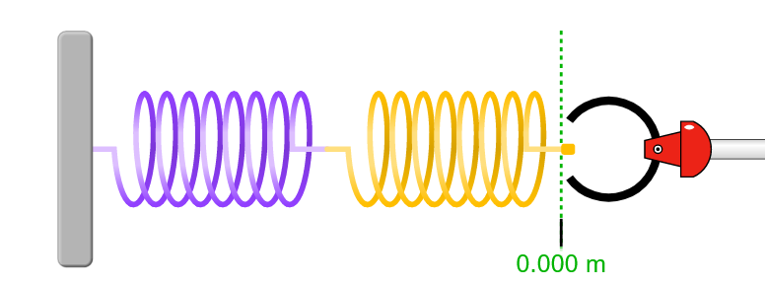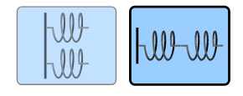

- Keep the left spring constant $k_{1}=400 N/m$ and the right spring constant $k_{2}=400 N/m$. Apply 100N of force to the right. Measure the extension and determine the total spring constant $k$ of the two springs in series ($\frac{Force}{Extension}$). Record your results in table 3.

Two Springs in Series

$k_{1}$ ($N/m)$ | $k_{2}$ ($N/m)$ | F (N) | Extension (m) | Total $k$ ($N/m)$
 |  | 100 N
 |  | 100 N
 |  | 100 N
 |  | 100 N
Table 3

- Repeat step f) three more times by changing the values of $k_{1}$ and $k_{2}$ (again making sure that the two values are identical in each case) and adding the results to table 3.

- Three students offer a model for finding the total spring constant $k$ for two springs in series:

- Student 1: $k=\frac{k_{1}+k_{2}}{k_{1}k_{2}}$
- Student 2: $k=\frac{{\left(k_{1}+k_{2}\right)}^{2}}{k_{1}+k_{2}}$
- Student 3: $\frac{1}{k}=\frac{1}{k_{1}}+\frac{1}{k_{2}}$

Explain which student’s model is correct based on your results.

Part III
Dynamic Behavior of the spring
Go back to the first simulation https://phet.colorado.edu/sims/html/masses-and-springs-basics/latest/masses-and-springs-basics_en.html

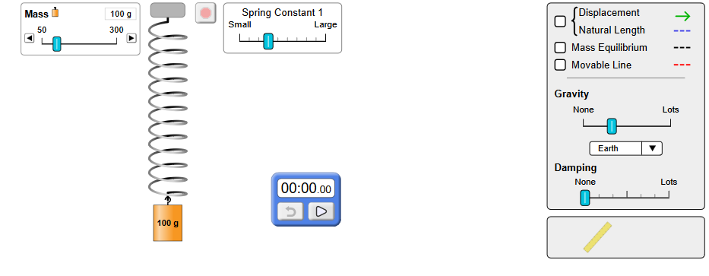
- Choose the timer and set the Damping to None; Now pull on the spring and set the timer when the spring is at the lowest point, count the time for the spring to repeat the motion up and down (one complete cycle) ten times. Then divide the timer reading by 10 to get the experimental period of the motion of the spring (T_{exp}) in seconds.
- Change the mass five times and for each value repeat the procedure in a) above.
- Fill in the table below and plot a graph of T_{exp}² as a function of the masses
Mass (Kg) | T_{exp} (sec) | T_{exp}²(sec²)

- Determine the slope of the graph
- Now the theoretical value of the period is given by the equation T_{th} = 2π$\sqrt{m/k}$
Hence T_{th}² = 4π² m/k
And a graph of T_{th}² as a function of m looks like
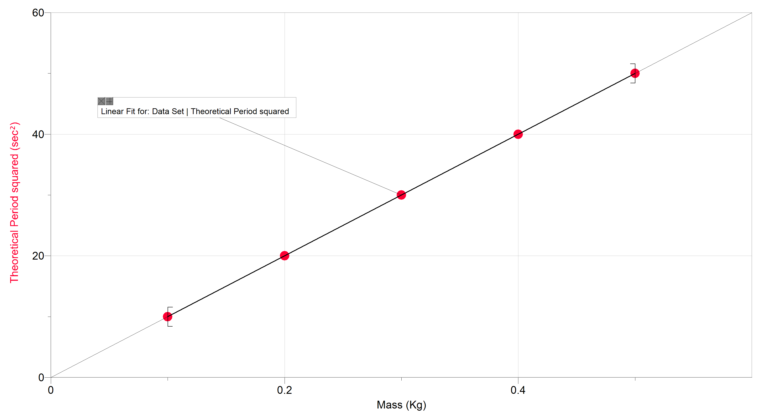
Since this is the graph of a linear equation y = mx, where T_{th}² corresponds to y, and m corresponds to x
Then 4π²/k = slope, and so k = 4 π²/ slope yields the experimental value of the spring constant
- Compare the value of k for the dynamic behavior of the spring with its static value from part I.
- Reflections: what are the main sources of error in this experiment?

