Question 1 (25 marks)
In 2011, HSBC Holdings plc (HSBC) cited unfavourable market conditions when shelving plans to list on a proposed Shanghai international board, a move which never came to fruition. However, under the recent Shanghai-London stock connect, firms listed in Shanghai will be able to sell Global Depositary Receipts (GDRs) to investors in London, and those listed in London will be able to issue CDRs to investors in Shanghai. HSBC is set to be the first company to issue CDRs.
Reference:
Reuters 2018, HSBC poised to be first firm to issue Chinese Depositary Receipts: Available from: https://www.reuters.com/article/us-hsbc-listing-shanghai/hsbc-poised-to-be-first-firm-to-issue-chinese-depositary-receipts-sources-idUSKCN1MS1KM. Accessed 2 July 2020
Required:
- Conduct an arbitrage between HSBC shares listed on the HKSE and those listed on the LSE. Assume the transaction was for 100,000 shares purchased at the closing price on the London Stock Exchange (LSE) on 31 March 2020 and all shares were sold at the opening price on the Hong Kong Stock Exchange (HKSE) on 1 April 2020. Assume brokerage fee at 0.4% per trade and that it was possible to conduct the arbitrage across the two markets.
You are provided with additional information:
31 March 2020 - HKD/GBP spot rate (mid) 0.10440
1 April 2020 - HKD/GBP spot rate Bid 0.10400 and offer 0.10450
GBP borrowing rate = GBP LIBOR (overnight) + 0.3 basis points

GBP LIBOR (Overnight)
June 01 2020 | 0.05363 %
May 01 2020 | 0.05175 %
April 01 2020 | 0.06338 %
March 02 2020 | 0.68413 %
February 03 2020 | 0.68263 %
January 02 2020 | 0.66613 %

Source: https://www.global-rates.com/interest-rates/libor/british-pound-sterling/gbp-libor-interest-rate-overnight.aspx

What is the arbitrage gain / loss and at what range of spot exchange rates would make the trade profitable / non-profitable?

Word count requirement: 250. Minimum number of references: 2.

- Comment on the profit or loss in part a above.(explain the sources of gain or loss, more than one sources, means what are the reasons be having gain or loss, more than one comment. Also include in the comment nature is arbitrage, does the to feel the requirement of arbitrage, comment it this to feel the requirement of arbitrage, it is pure arbitrage or not, why . )
Word count requirement: 150
Question 2
You deposited GBP 2,500 into your recently-opened futures trading account. At that time, the spot rate for British pound against the US dollar spot was USD1.2500. This rate locked the beginning account balance in US dollars. The account has a trading leverage of 100:1, which defines the initial margin requirement. The variation margin was set at 40% of the initial margin.
You conducted futures trades (in standard contract size **) on the British pound against the US dollar. The online broker takes a 5-pip spread on either side of the mid-rate. The table below lists your trades, all executed at settlement prices: You complied with margin calls, if any.
https://www.cmegroup.com/trading/fx/g10/british-pound_contract_specifications.html
Day | US dollars per GBP  (Settlement price – mid-rates) | Trades
1 | 1.2400 | Shorted 4 contracts
2 | 1.2480 | ---
3 | 1.2520 | ---
4 | 1.2460 | Squared all contracts

Required:
Calculate your daily trading profit / loss, margin call sums if any, the net profit / loss in monetary and in percentage terms at the end of Day 4.
Summarize your findings in a table, accompanied by working and explanation.( why do I loss or make money, when do you get artribute margin call why do you get margin call

Word count requirement: 200. 2 reference
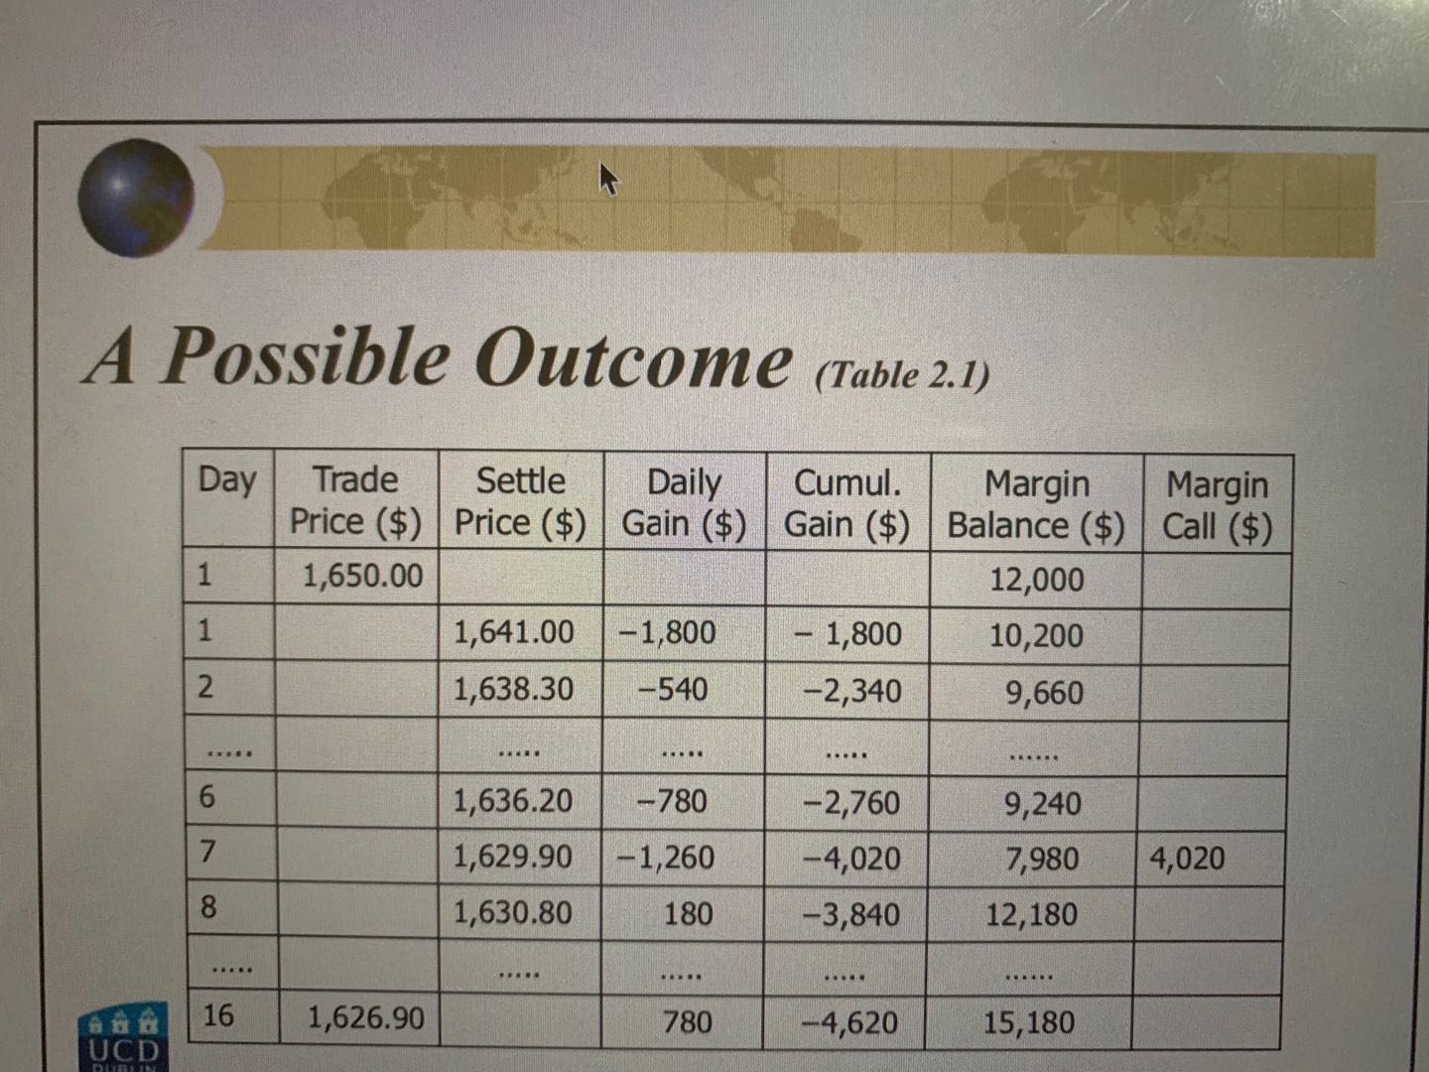
can use this table to do the summary but must have explain.

Requirement
Each question do the table more clear to see the stept.
Detail explanation why you take this number, how come the number. explain the step, how come the result, explain the result, and step by step more clear

