Assignment brief/Guidance notes. Use this information in conjunction with the tutorial sessions for the case study.

Important points
Answer only what is being asked.
Do not jump ahead and use information from the next question this is not the point of the case study.
Do not use the first person.
Use literature throughout.
Read your work through carefully for sense and spelling.
Do not include additional figures/tables.

Case study for 601114 Cellular Pathology 2020/21 – Maximum word count 3000 words

Introduction and presenting history

A 80 year old male patient presents at his GP surgery with haemoptysis and shortness of breath. Prior to his retirement the man worked in the building manufacturing industry using asbestos. The patient also has a 30 a day smoking habit for over the past 50 years.

Q1) Based on just the presenting history explain what the GPs most likely thoughts on the patients diagnosis and possible differential diagnosis (10 marks)

Look at the key symptoms and consider the details regarding the patients age/gender. Stick with the obvious, do not include diseases/conditions that are only remotely linked. Consider the risk factors that the patient has for specific diseases. You MUST use the literature. What are the symptoms immediately suggestive of? Consider the information given in the tutorial on the Case Study. There should be on differential diagnosis only.

Investigations
The GP refers the patient to the local hospital where a chest x ray is performed and reveals a medium sized mass on the upper aspect of the patients left lung some distance from the central bronchus. A lung biopsy is performed and tissue sections are stained using H&E.
The findings from H&E performed on the blocks from the biopsy are seen below (Figures 1 and 2).

Figure 1: H&E Low power
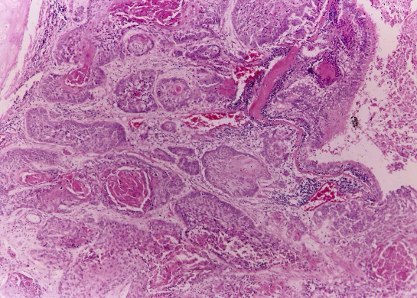
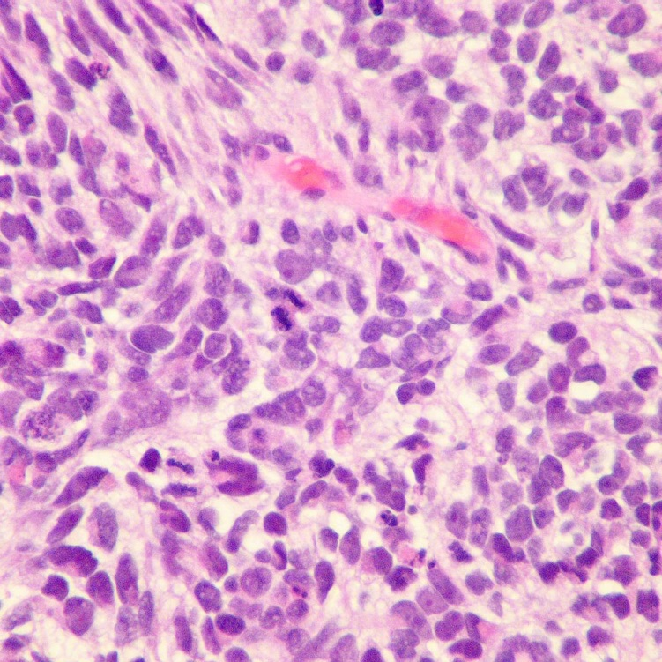

Figure 2: H&E high power

Q2a) Why is H&E the most useful stain for use in this scenario?
Think about what each element of H&E stains for and think about what information is needed from this tissue to make a diagnosis. How does H&E allow this information to be obtained. Think about the urgency of the results and other factors that determine the usefulness of using a particular technique in an NHS lab. Again your answer should be referenced.

Q2b ) Looking at Figure 1 is the lung tissue as you would expect it to appear and if not why not?
Compare the image with an image of normal lung tissue ( you will have to use a histology book for this). Compare the obvious structural features, how do the images differ, is anything missing? Remember tissue is designed for a specific function, can the tissue still meet this function, if not why not?

Q2c) Looking at Figure 2 what nuclear changes can you see and what are they suggestive of? How do the changes differ from what you would expect in normal lung tissue?

Look at colour intensity, size of the nucleaus, number of nuclei. How do they compare with what you would expect in cells that are mature and differentiated? What are the changes suggestive of in terms of activity?

All answers must be referenced.

(25 marks)

Following a confirmation of non-small cell lung carcinoma (NSCLC) a wedge dissection of the lung mass was requested. On review of this material an unexpected foreign body was identified (Figure 3).
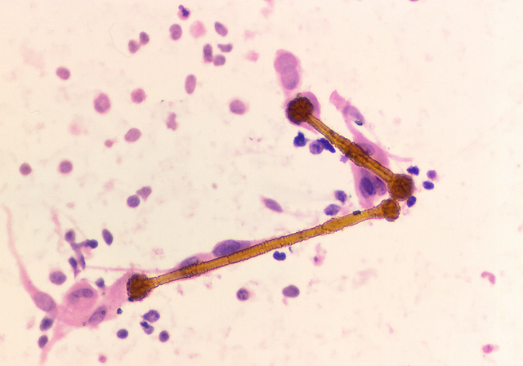

Figure 3: H&E foreign body

Q3

  - )Explain what this figure is and why it is present.

Consult the patient history , the text books and the literature. Remember to explain why this foreign body is present.

b) Critically evaluate what special stains can be used to highlight it.

This should be straight forward but remember the question asks for a ‘critical evaluation’ so do not just describe the stain.

c) Diagnostically, what other lung cancer may this finding support?
This should be obvious but you need to support your explanation using the literature. (25 marks)

Q4
In order to confirm the diagnosis of NSCLC immunohistochemistry was performed. Suggest and evaluate the antibodies that would be used in order to support the diagnosis of NSCLC.
(20 marks)

You must read around NSCLC to begin with. What is the cell type of origin? To identify a primary it is essential to search the tissue for a protein expressed by the primary cell type. Look at the lecture which covers IHC as a starting point. Also remember that you need to rule out other potential primaries, look at the literature to help you decide what to include. You should be creating a panel of antibodies and explaining what each one binds to and how this will aid in determining a diagnosis of NSCLC.

Q5
At a subsequent multi- disciplinary team meeting review of the case, discuss and evaluate what options could be considered for this patient’s management and treatment. (20 marks)

You need some understanding of NSCLC and how it can be treated. Factors to consider include the patients age, past history, tumour location, type of tumour. What is feasible for this particular patient what is the likely prognosis? What does the literature say in terms of treatment and survival.

You MUST now create a correctly presented reference list.

