Assignment: MKT 3301

Name: ____________________________________ Date: _____________________CRN: _____________

Mini Case: Quality Iron Casting (25 points)
Read the case and answer the questions provided on the following pages. Please type your answer below each question keeping the same sequence and format. Your explanation should be precise, within a short paragraph providing reference gleaned from the case provided below: (There is no need to do any research or refer to any external resource to complete this assignment.)
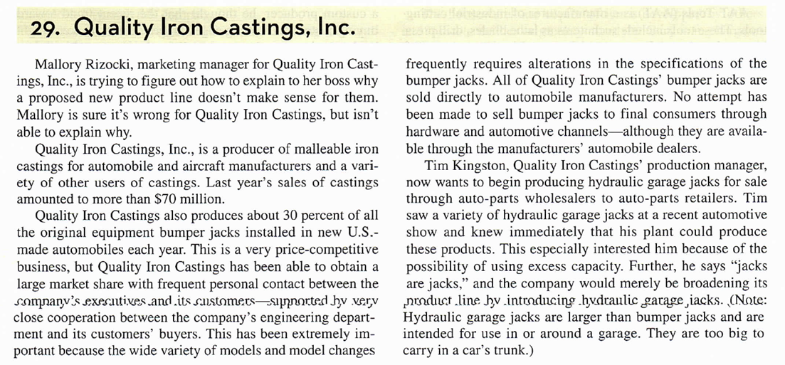
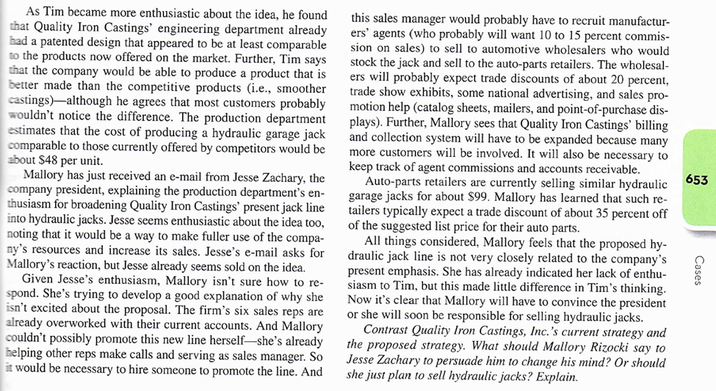

- Explain the current marketing strategy for the bumper jacks that Quality Iron Castings currently sell along the marketing strategy components, provide explanation to support your choice of answer. (10 pts)

- Target market: Select and provide details: Consumer/Business market (2)
- Marketing Mix: (6)
- Product: Product Name and type; Product Class: Select and provide details: Business/Consumer.
- Promotion: Select and provide details: Earned/Owned/Paid/Personal Selling
- Distribution: Select and provide details: Direct/Indirect
- Pricing: Do you have any information relevant to pricing given in this case?

- What are the components of a marketing strategy for the Proposed hydraulic garage jacks? (Proposed Marketing strategy) (10 pts). Provide explanation to support your choice of answer.

  - Target market: Select and provide details: Consumer/Business market (2)
  - Marketing mix: (6 pts)
- Product: Product Name and type; Product Class: Select and provide details: Business/Consumer.
- Promotion: Select and provide details: Earned/Owned/Paid/Personal Selling
- Distribution: Select and provide details: Direct/Indirect
- Pricing: Does the new product price appear to be competitive in the market given current competitor’s retail price? Explain.
(Bonus Points 5): Calculate new product retail price, finding the following facts from the case and use Mark Up Formula (Ch 18) to calculate Retail price for Hydraulic Jack.
Manufacturing cost: ?; Manufacturing Agents: 15%; mark up; Wholesaler Mark up: ?; Retailer Mark up: 35%

- What type of orientation does Mr. Kingston the Production Manager appears to have? Why do you think this? (2 pts.)
- Production Oriented
- Market Oriented

- Based on your understanding of current and proposed strategies and pricing, is it a good idea for Quality Iron to market and sell Hydraulic Jacks? Give at least 2 good reasons? (3 pts)

