LO 1-Record business transactions using double entry book-keeping, and be able to extract a trial balance
Business transactions-
A business transaction is a transaction conducted which begins the process of starting the accounting cycle.
In the accounting cycle there are four key transactions that occur within the double-entry book keeping system. The double-entry book keeping is a system of accounting in which each transaction has a corresponding positive and negative entry (debits and credits).
The four main transactions relate to sales, purchases, receipts and payments made by an individual or organisation.
Sales- Sales represent a transfer of property for money or credit. Sales can be generated through the ordinary activities of the business. Incomes generated through activities that are not part of the core business operations of the business are not classified as sale revenue but are classified instead as gains. For example generating sales revenue through the main day to day activities of say a greengrocers would be an example of sales income generated. If the business was to sell one of its vehicles then the income from this transaction would be classified as a gain rather than sale revenue. Sales revenue can be classified as sales or turnover in respect of sales of goods or provision of services. Normally for a sale to occur the seller must have suitably transferred the risk and reward of the asset by delivering this directly to the buyer.
In respect of a double entry system the transaction will involve two entries, one which was a debit entry and a corresponding credit entry.
A double-entry bookkeeping system is a set of rules for recording financial information in a financial accounting system in which every transaction or event changes at least two different nominal ledger accounts. This then means we would have to create two separate accounts. The debit entry will be recorded for receiving value whilst the credit entry for actually giving value.
Purchases-
Purchases can be seen as the costs incurred of buying an asset or inventory within the ordinary course of the business with the intention of selling this. Purchases can be for goods and services and therefore may be for raw materials for manufacture or the finished product perhaps for retailers or wholesalers etc. Purchases are considered to have been made when the risk and rewards are in the ultimate hands of the buyer and therefore would have physically received the asset.
As this is a type of expense it would need to be recorded in an income statement as representing the cost of goods sold.
Assets will of course not be generally for immediate resale and therefore will be classed as either a fixed or current asset entity and be shown in the balance sheet.
Fixed assets can include vehicles, plant and machinery, fixtures and fittings, equipment, land and buildings and would normally be expected to used within the business for at least 12 months to be classified as fixed and therefore of a long term nature.
Current assets usually would normally incur a period of no more than 12 months and include items such as stock, debtors ( customers owning money and offered credit terms), cash and other liquid funds, investments etc.

Cash Sales and Purchases – here the customer pays the supplier immediately for the goods or services bought and sold. Payment is usually made in the form of cash (notes and coins), or by debit card, credit card or cheque. Cash transactions should be supported by a receipt issued by the supplier to the customer.

Credit Sales and Purchases – a credit based transaction takes place when the seller gives the buyer a period of time in which to pay for the goods or services exchanged.

Most business-to-business transactions (where one business trades with another) are credit based, with a period of 30 days credit being quite common.

The document issued by the seller to the buyer to support a credit based sale is the sales invoice. Of course the buyer will use the invoice they receive from a supplier as a purchase invoice.
RECEIPTS AND PAYMENTS-
(Receipts- Income and Payments-Expenditure)

The books of account are the core of the financial information processes, being a record of financial transactions from which financial statements are prepared. It is essential therefore, that the bookkeeper is capable of identifying and categorising items of business income and expenditure.

The following definitions can be applied to the terms ‘income’ and ‘expenditure’. It should also be noted that the terms ‘receipts’ and ‘payments’ are also used to describe ‘income’ and ‘expenditure’.

Income – business receipts (income) are categorised as being either capital income or revenue income.

Capital Income – is defined as being income borrowed by the business. Such income will be used to finance the setting-up and expansion of the business. It includes capital invested by the owner(s) of a business and funds taken from other persons or organisations who provide finance to a business on a long term basis.

Revenue Income – this is income earned by the business from its trading or non-trading activities. Trading income will result from sales made to the customers of the business. Non-trading income results from the provision of business services, from interest earned on monies invested by a business, from rent received on property sub-let by a business etc.

Expenditure – business payments (expenditure) are also categorised as being capital or revenue by nature, i.e. Capital Expenditure or Revenue Expenditure.

Capital Expenditure – is defined as expenditure which has a long-term effect on the profit making capacity of a business. Capital expenditure includes payments made to buy fixed assets (items purchased for use in the business over several years), it also includes payments made to install, modify and improve fixed assets.

Revenue Expenditure – this expenditure has only a short-term effect on the profit making capacity of a business. The business benefits from such expenditure in one accounting period. Revenue expenditure includes payments made to purchase goods for resale, payments made in respect of business expenses such as rent, rates, insurances, heating and lighting, wages and salaries, telephone (line rental and call charges), vehicle running costs (road tax, insurance, fuel and repairs), repairs and maintenance of fixed assets etc.

The following is an example of several typical items of business income and expenditure. A table has been prepared indicating how each item has been categorised in accordance with the definitions given above:

TRIAL BALANCE
A Trial Balance acts as the first step in the preparation of financial statements. It is a working document that accountants/book-keepers use as a basis while preparing financial statements. Trial balance ensures that for every debit entry recorded, a corresponding credit entry has been recorded in the books in accordance with the double entry methods . If the totals of the trial balance do not agree, the differences may be investigated and resolved before financial statements are prepared. Rectifying basic accounting errors can be a much lengthy task after the financial statements have been prepared because of the changes that would be required to correct the financial statements. Trial balance ensures that the account balances are accurately extracted from accounting ledgers.
The main components of a trial balance quite simply represent every business transaction that flows in or out of the business and therefore every journal entry recorded into or out of the general ledgers.
Every occasion whereby a transaction is made via a journal entry due to sales, liabilities, cost of sales (purchases), asset changes, expenses etc. this would in turn be included within the trial balance calculations.
Errors can remain within the trial balance even if this balances and this can include an incorrect debit amount posted with a corresponding credit entry entered to balance figures. Occasionally, entries could be omitted altogether and still achieve equal balances.
EXAMPLE OF A TRIAL BALANCE
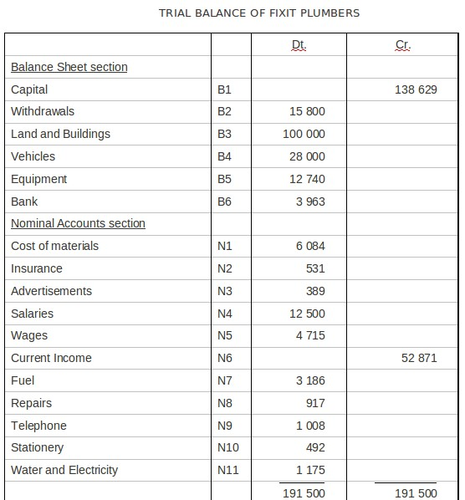

Accounting system is based on the principal that for every Debit entry, there will always be an equal Credit entry. This is known as the Duality Principal.
Debit entries are ones that account for the following effects:
Increase in assets
Increase in expense
Decrease in liability
Decrease in equity
Decrease in income
Credit entries are ones that account for the following effects:
Decrease in assets
Decrease in expense
Increase in liability Increase in equity
Increase in income
Double Entry is recorded in a manner that the Accounting Equation is always in balance.
Assets - Liabilities = Capital Any increase in expense (Dr) will be offset by a decrease in assets (Cr) or increase in liability or equity (Cr) and vice-versa.
Debits and credits are the respective sides of each account. Debits appear on the left side of the account whilst credits appear on the right side.
SUMMARY OF THE ACCOUNTING CYCLE
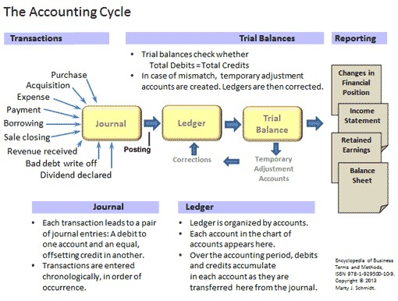

Accounting Ethics

In 2005 the International Federation of Accountants (IFAC) issued a ‘Code of Ethics for Professional Accountants’. The code was based on recognition of the fact that it was in the public interest that those within the accountancy profession provide services of a consistently high quality, and that accountants, as well as having a responsibility to individual clients or employers, also have a responsibility to act in the public interest.

The code of practice is used by accountants throughout the world, its purpose being to assist accountants in applying ethics in meeting the interests of their clients, employers and the public. Most professional accountancy bodies, whether they are affiliated to the IFAC or not, tend to base their codes of ethics on the fundamental principles established by the IFAC.
The ‘Code of Ethics for Professional Accountants’ establishes five fundamental principles of professional ethics and provides a conceptual framework for applying those principles.

The IFAC recognises that compliance with the code of ethics based upon a set of rules requiring accountants to define every situation that is likely to create a threat to their ability to comply with the fundamental principles would be impossible to implement. The nature of an accountant’s engagements and work assignments is likely to vary considerably from client to client and from assignment to assignment. As a result different threats may arise requiring the application of different safeguards. The conceptual framework, therefore, requires the professional accountant to identify any threats to compliance with the fundamental principles, and to take appropriate steps to eliminate or reduce such threats to an acceptable level, so that they are able to comply with the code.

The five fundamental principles established by the IFAC’s code of ethics are as follows:
Fundamental Principles The IESBA Code requires accountants to adhere to five fundamental principles:
- Integrity—A professional accountant should be straightforward and honest in performing professional services.
- Objectivity—A professional accountant should not allow bias, conflict of interest or undue influence of others to override professional or business judgments.
- Professional Competence and Due Care—A professional accountant has a continuing duty to maintain professional knowledge and skill at the level required to ensure that a client or employer receives competent professional service based on current developments. A professional accountant should act diligently and in accordance with applicable technical and professional standards when providing professional services.
- Confidentiality—A professional accountant should respect the confidentiality of information acquired as a result of professional and business relationships and should not disclose any such information to third parties without proper and specific authority unless there is a legal or professional right or duty to disclose. Confidential information acquired as a result of professional and business relationships should not be used for the personal advantage of the professional accountant or third parties.
- Professional Behaviour—A professional accountant should comply with relevant laws and regulations and should avoid any action that discredits the profession.

References
The International Ethics Standards Board for Accountants

