LO 2-Prepare accounts for sole-traders, partnerships, and limited companies in accordance with appropriate principles, conventions and standards
Financial reports and financial statements
Financial reports are about the transactions that have financial effects. There are often specific to management and unlike financial statements and accounting principles required to produce at set times, reports can be less formal and are often set by the user for a specific purpose ad hoc or on a regular basis.
Financial reports can be helpful to inform decision making and may assist users both inside and outside of the organisation e.g. bank statements, debtors and creditors analysis reports.
The main financial statements are subject to much more stringent principles and standards e.g. IFRS (International Financial Reporting Standards) and IAS (International Accounting Standards) and include the income statement (Profit & Loss Account), Balance Sheet and Statement for Cash Flow.
The Companies Act 1986 requires organisations to prepare a Balance Sheet and Profit and Loss Account and to submit to Companies House if the organisation is incorporated.
As discussed above, management also use these statements to manage the organisation, to consider future strategy, to take day to day and longer term decisions. External stakeholders also use the information to make decisions regarding their involvement / possible involvement with the organisation too.
The purpose of the balance sheet, also known as “Statement of Financial Position”, is to present the organisation’s assets, liabilities and capital at a specific date. It’s a sort of “snapshot” which includes details of what the organisation owns and owes at a given moment in time. The Balance Sheet always balances assets and liabilities hence its name.;
A balance sheet consists of two parts. The top part details the assets of the organisation which includes current assets, fixed assets, cash, payments due from sales and stock. It also details current liabilities including short term debt, expenses to be paid and long term debts. The bottom part of the Balance Sheet shows how the assets have been obtained and therefore shows the stakeholders equity, share capital and any retained earnings (profit).
The balance sheet provides information on the organisation’s solvency and is mainly used by investors as it provides basic understanding of the organisation’s operations, including what it owes. It does not provide the actual value of the organisation as it does not include intangible assets such as brand, market leadership, etc. and that it only provides historical costs of assets and liablities.
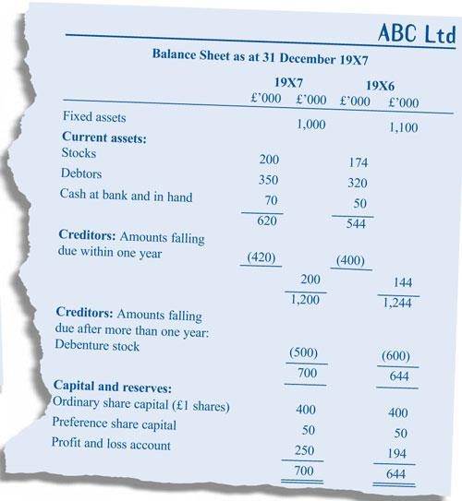

The profit and loss account (P&L), also known as the “Statement of Financial Performance” or “Income Statement”, includes all the income and expenses recorded over a certain period of time, which is usually a year but this can vary. The purpose of the P&L is to show whether the company has made a profit or a loss and how this has happened.
The P&L should only include the costs of those products sold during the period otherwise the profit will show incorrect information. It can be prepared for the annual published accounts, which are available to the general public; or for the management, who will then use it to monitor the company closely, and they can request monthly, weekly or quarterly P&L statements.
The P&L accounts consist of two parts. The top part considers all income whilst the bottom part considers all costs that have been incurred during the same period to generate that income.
Income could include interest, sales revenue or royalties for example. Costs could be production costs including materials, overheads, salaries and wages. They are usually detailed in terms of direct costs which are deducted to give the gross operating margin and then operating expenses – non direct costs which could include other salaries, insurance etc. A provision is often made for bad debt and depreciation is also shown along with any loan interest. This then gives the amount of net profit made before tax or pre-tax income.

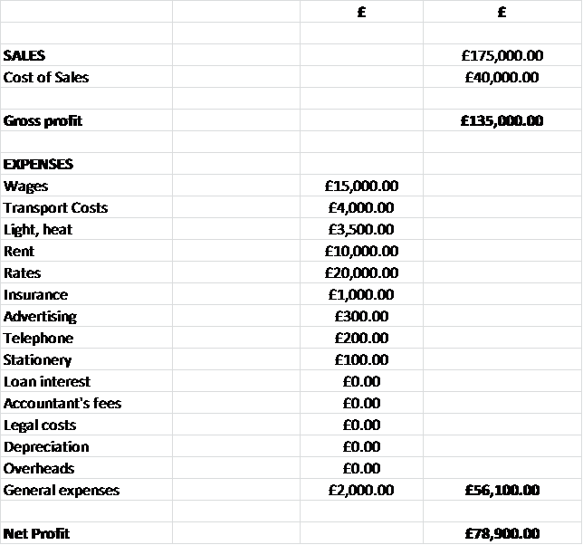

The purpose of the cash flow is to list the company’s profits and cash; it also gives information on where the money comes from and where the money is put to. The period cover by the cash flow statement should be determined by the organisation but is frequently prepared monthly. Remember, the cash flow statement is often considered in advance so that the organisation can ensure that funding is available for monies owed and is sometimes combined with the budget to produce a budget cash flow forecast.
Cash Flow statements include certain information that the P&L accounts do not include. For instance, the revenues listed on the P&L accounts might not have been received and some expenses on the P&L might not have been paid; however, all of these information is contained in the cash flow statement, which is why investors sometimes prefer to use it. The cash flow statement is not a document which is required to be sent to Companies House however and so investors would need to request it.
Shareholders will also be interested in reviewing the cash flow statement as a company that consistently has a good level of cash, generating more profits than expenses or costs, demonstrates that will be able to afford its liabilities, pay dividends and invest in future projects.
The top part of the cash flow forecast shows the revenue / income and where that money is coming from such as starting cash, sales of goods / services, sale of assets, loan income etc. The bottom part shows how the money is being used – salaries, operating expenses, loan repayments, capital expenditure, tax payments. The very bottom shows the net cash flow and the cash balance which is then the starting balance for the next period (usually the next month) .

- 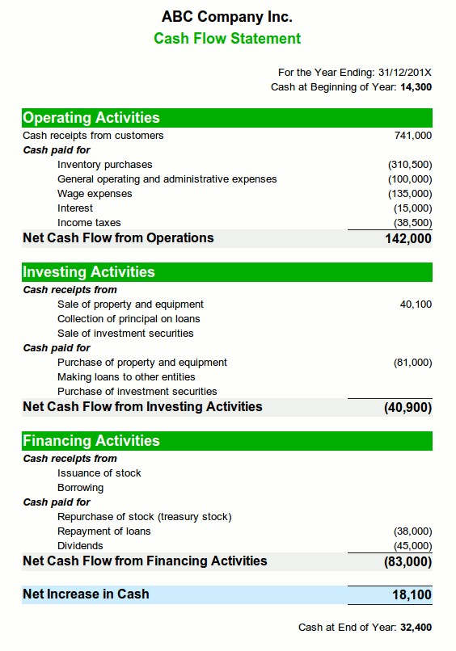

TYPES OF ACCOUNTS
Prepare financial statements in a form suitable for publication by a sole trader, partnership and limited company
As highlighted, many smaller organisations tend to keep lists of transactions rather than doubleentry journals to record their transactions. Organisations which are not incorporated do not have
a legal obligation to submit their accounts to Companies House, frequently financial statements are produced since they are useful for management purposes. For Partnerships, financial
statements enable all partners to see how well (or otherwise) the undertaking is performing also
and a partner is usually designated to record and report on the organisation’s financial status (i.e. prepare financial statements) for the partners to be able to take decisions regarding drawings,
growth trends, whether further resources are needed to maintain efficiency and effectiveness, evaluate organisational performance and whether any action needs to be taken to improve the performance of the organisation for example.
We have also identified that these financial statements need to comply with legislative and regulatory requirements depending on whether the organisation is incorporated and the size of the organisation too.
However, the profit and loss account / income statement and balance sheet still tend to look very similar regardless of the size of the organisation. From these statements, the organisation’s performance can be analysed.
Remember, the International Accounting Standards (IAS) and the Companies Act 2006 requires that a similar format is to be used by organisations when preparing the key financial statements although there can be a little difference between the two for different types of organisations.
For example, non-incorporated companies are not going to show share capital and not for profit organisations tend to consider their P&L as an income or revenue statement rather than a profit and loss account.
These distinctions are considered more closely for each of the financial statements below:
The Balance Sheet
The top part of a balance sheet, which is net assets, will mostly remain the same for all companies; however, the bottom part will vary, depending on the type of company:

A company will include relevant information to its shareholders, as they are the owners of the organisation. For instance, a limited company will include the initial capital invested and any profits generated.

Given that partners are personally responsible for the partnership’s liabilities, the information to be included will be capital accounts and current accounts. Capital accounts represent their investment, and current accounts represent shares, interest, salaries, etc.

The bottom part of the balance sheet is much simpler. Profits or losses are directly passed on to capital accounts; therefore, there will only be one line at the end called Capital.
HND Business and Accountancy – Financial Accounting and Reporting Learning Outcome 3

Be Able to Present Financial Information in Accepted Formats of Publication

Brighton School of Business and Management Limited

From a charity’s point of view, it is important to understand the origin of the funds and how they can be spent. For this purpose Funds are divided in “Unrestricted”, “Restricted”, or “Endowment”

Based on the example below, which is a balance sheet of the whole UK government’s accounts, the government’s balance sheet has a few differences, as its main focus is to distinguish their
funds as their revenue comes from different sources, and to ensure the country is not on deficit. The main difference is the bottom part, which focuses on its “Reserves”.
The Profit and Loss Account

Public limited companies and private limited companies must provide the standard information on the P&L accounts. It should also include corporation tax and dividends.

They are given more freedom on how to present the P&L statements and usually they provide more detailed information about expenses.
- Partnerships:
Their P&L will neither include corporation tax, as they pay personal income tax; nor dividends, as profits will be divided between partners and will be detailed in the bottom part of the P&L.
- A sole trader:
Their P&L will neither include corporation tax, as they pay personal income tax; nor dividends, as profits will just be paid directly to their accounts.

A charity must categorise its funds in “Unrestricted”, “Restricted”, and “Endowment” to be able to know how quickly these funds can be available to spend. The first part of the P&L statement will refer to how the funds have been obtained. The second part will refer to how these resources have been spent. Note the bottom part is exempt from taxes.

As local authorities are mostly funded by the government, they do not pay tax. In fact, they receive funds from collection of local taxes.

