Narrative assignment/Infographic
- For the narrative assessment you are required to discuss the relevant health related issue that the individual is experiencing considering a holistic view of the individual
- Below is a household for each field of nursing, Mental health, Adult & Child. Please only select the one for your specific discipline.

Mental health- Option- Occupant 1 Fred- Depression
House 4
House 4 is a multi-occupancy (student) house in Medication Row. It has 5 occupants all of which are students

Occupant 1: Fred. He is 19 years old and he is in his second year of studying for a BSc in Geography at Swansea University.

Occupant 2: Ndabaningi. He is 22 years old. He is an international student studying an MSc in Law full time at Swansea University.

Occupant 3: Louise. She is 19 and a second-year nursing student

Occupant 4: Rabia. She is 21 years old and is in her third year studying Engineering. She is first generation British. She has a strong Muslim faith.

Occupant 5: Alexandra. She is 20 years old and is in her second year of her nursing degree. She is a member of‘The Church of Jesus Christ of Latter-day Saints’ (Mormonism religion)

Fred’s Biography
Fred was born in Glasgow and his family of 5 still live there. He moved to Swansea to study last year when he lived in halls. He has never lived with his house mates before as his flat mates from halls have either dropped out or moved back to their home place to continue their studies. He was the only one who is continuing to study at Swansea from his flat. He is on a student grant and works in the campus shop in the evening and weekends to supplement his income whilst in university. He has always loved geography and is very active campaigning against climate change.
He has no physical health issues, had normal childhood illnesses, but he does partake in recreational illicit drugs when he is not studying or working. His mum and dad are both healthy, he has two younger sisters and one older brother. His youngest sister has type 1 diabetes but is well. They all partake in illicit drug use recreationally; it is well accepted although illegal in his hometown.
He usually gets on very well with his household however Alexandra and Rabia are frequently complaining about the mess that Fred leaves around the house calling him lazy. He has a good relationship with Ndabaningi where they frequently play the PlayStation together typically until the early hours of the morning. Lately Fred has had trouble sleeping, seems more reclusive to his flatmates and appears more irritable and un-motivated to do day to day tasks.
Adult- Option Occupant 2 Joan Jackson 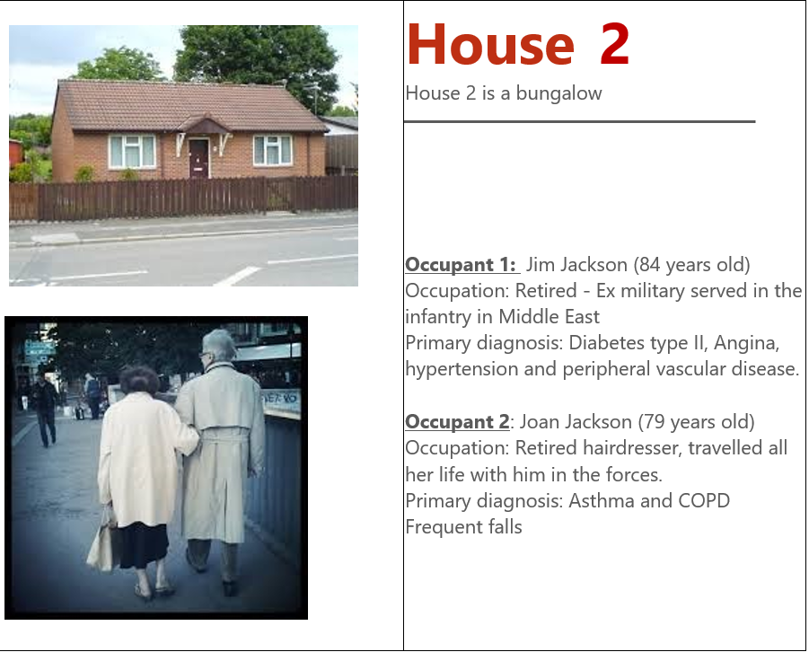
Joan’s Biography
Joan was born in Sheffield but her family moved to Wales as her father got a job in the steelworks in Port Talbot. She was training as a hairdresser when she met Jim. They married when she 17 and went away with him on almost all of his postings. She worked as a hairdresser in the camps and they enjoyed seeing the world via his army life. They were unable to have children and this was a disappointment to them both, but they have nieces and nephews locally who keep in touch as both of their siblings have now passed.
Joan has smoked all her life and continues to smoke although she has cut down. It was very fashionable to smoke in her younger days and she has no wish to ever give up; ‘too late now’. She always likes to look smart, which is very important to her.
She has some problems with falls and gets around the house using the furniture and when they go out she always holds on tight to Jim. She gets problems with her chest, secondary from her years of smoking. She takes her pumps and attends the surgery for check-ups.
They enjoy their life and they like to go dancing every week, this is getting harder for Joan, but she perseveres.

CHILD- Option- Jamie-Jay/ Jordan Jay
Caravan
Small caravan at the edge of the site which is just off entrance to the street

Occupant 1: Jamie Jay (senior) 27 years old
Works as a self-employed laborer

Occupant 2: Sally-Anne 26 years old
Housewife

Occupant 3: Chelsea-May 11 years old

Occupant 4: Jamie Jay Junior, 10 years old

Occupant 5: Jordan-Jay 4 years old

Occupant 6: Babie-Gal, 3 weeks old

Jamie-Jay biography
Jamie-Jay cannot read or write, attended school up to 10 years old (junior school only). He is a self-employed labourer, works hard and earns a good wage. He controls the money. He has Phenylketonuria, but does not adhere to the diet. He is strong physically. He also claims significant benefits but it always goes into his bank account. He is a smoker and drinks alcohol in excess on a few occasions per week.
Sally-Anne
Cannot read or write, attended school until 11 years old. Devoted to her children, very good housekeeper but access to money (apart from Child Benefit) is only via husband. She has had numerous miscarriages. She reluctantly attends for health appointments herself, but confides in the health visitor. She is a smoker, drinks alcohol to excess when she meets up with friends for birthdays and social gatherings. She is grossly obese and comfort eats.
First baby was a traumatic vaginal delivery and the others have been elective LSCS.
Chelsea-May
She skips school a lot, mum tries to make her go but as she helps mum with the children she does not push her too hard. She can read and write and helps mum with reading letters from school and the GP surgery. She has a quiet kindly disposition. She does not smoke, she is slim and very body conscious.
Jamie-Jay Junior
Reluctantly goes to school but prefers to go to work with his dad. He can read and write at a very basic level. He has PKU and his behaviour is very challenging. This has affected his school experience. He is grossly overweight and does not adhere to his diet despite his mum trying hard to encourage him. He smokes cigarettes secretly (steals them from wherever the opportunity arrises)
Jordan-Jay
Attends school and has been enjoying it until recently. He is starting to display challenging behaviour like his brother. He is grossly overweight, has asthma and gets recurrent ear infections.
Babie-Gal
Caesarean Section delivery, 2.6Kg born, good Apgar score. Bottle fed. Recent admission to hospital with chest infection. Developing normally so far.
New-born screen results are negative.
All children are fully immunised after much encouragement from the health visitor. Although Sally-Anne is reluctant to attend healthcare for herself she will very regularly access the GP for minor childhood ailments.

This residence has the potential for discussion around domestic violence, social isolation, mental health, chronic conditions, minor childhood ailments, genetically inherited conditions, childhood development, safeguarding, and accident prevention.
Smoking cessation, alcohol also need to be considered

