How can we determine the order of events in geologic history?

The learning objectives for today are: Students will be able to….
- Apply geologic principles to determine the relative ages of rock sequences and recreate the geologic history of an area.
- Explain unconformities, and recognize unconformities in cross sections of rock layers
- Explain how fossils with known age ranges can be used to constrain the ages of rock layers
- Correlate geologic maps (surface views of geologic units) with cross sections (side views).

Materials: Please have your notes from the pre-lab activities available.
- https://www.nature.com/scitable/knowledge/library/dating-rocks-and-fossils-using-geologic-methods-107924044/
- https://www.youtube.com/watch?v=DNcYBLG3TBo&t=3s

Background: Deposition and erosion of sedimentary rocks

Before you Begin: Define the Principle of Stratigraphy/Relative Dating from the pre-lab activity.
- Principle of Original Horizontality –

- Principle of Superposition –

- Principle of cross-cutting relationships –

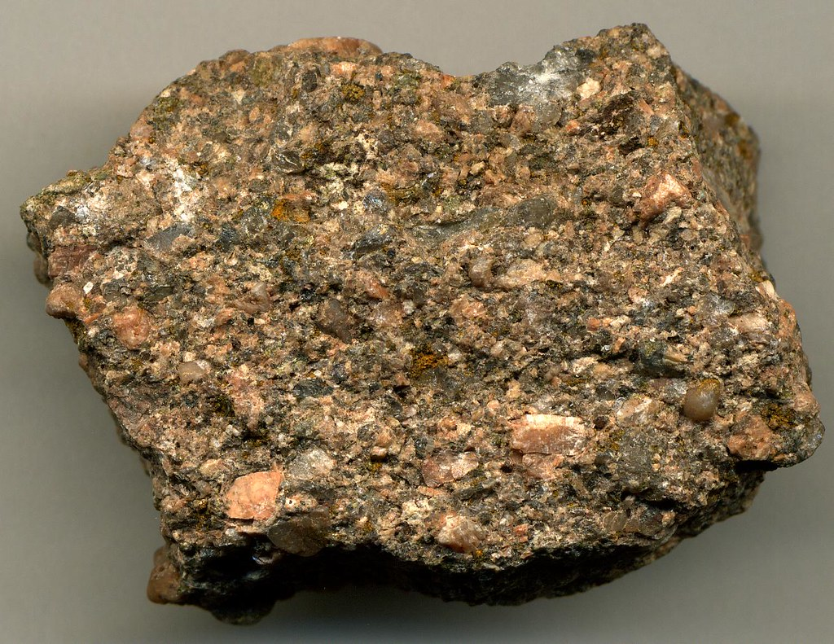
- Principle of Faunal Succession –
Image: James St. John

- Other relative dating principles exist. Another principle is based on the answer to this question: Which is older: the sediments in the rock shown, or the rock itself? Explain your line of reasoning.

- Unconformities reveal missing information: If rocks have been broken down and moved away over time, they will no longer be part of the stratigraphic record. Describe at least 2 ways to recognize unconformities. How can you tell rocks are missing?

Part 1. Applying the Principles of Relative Dating
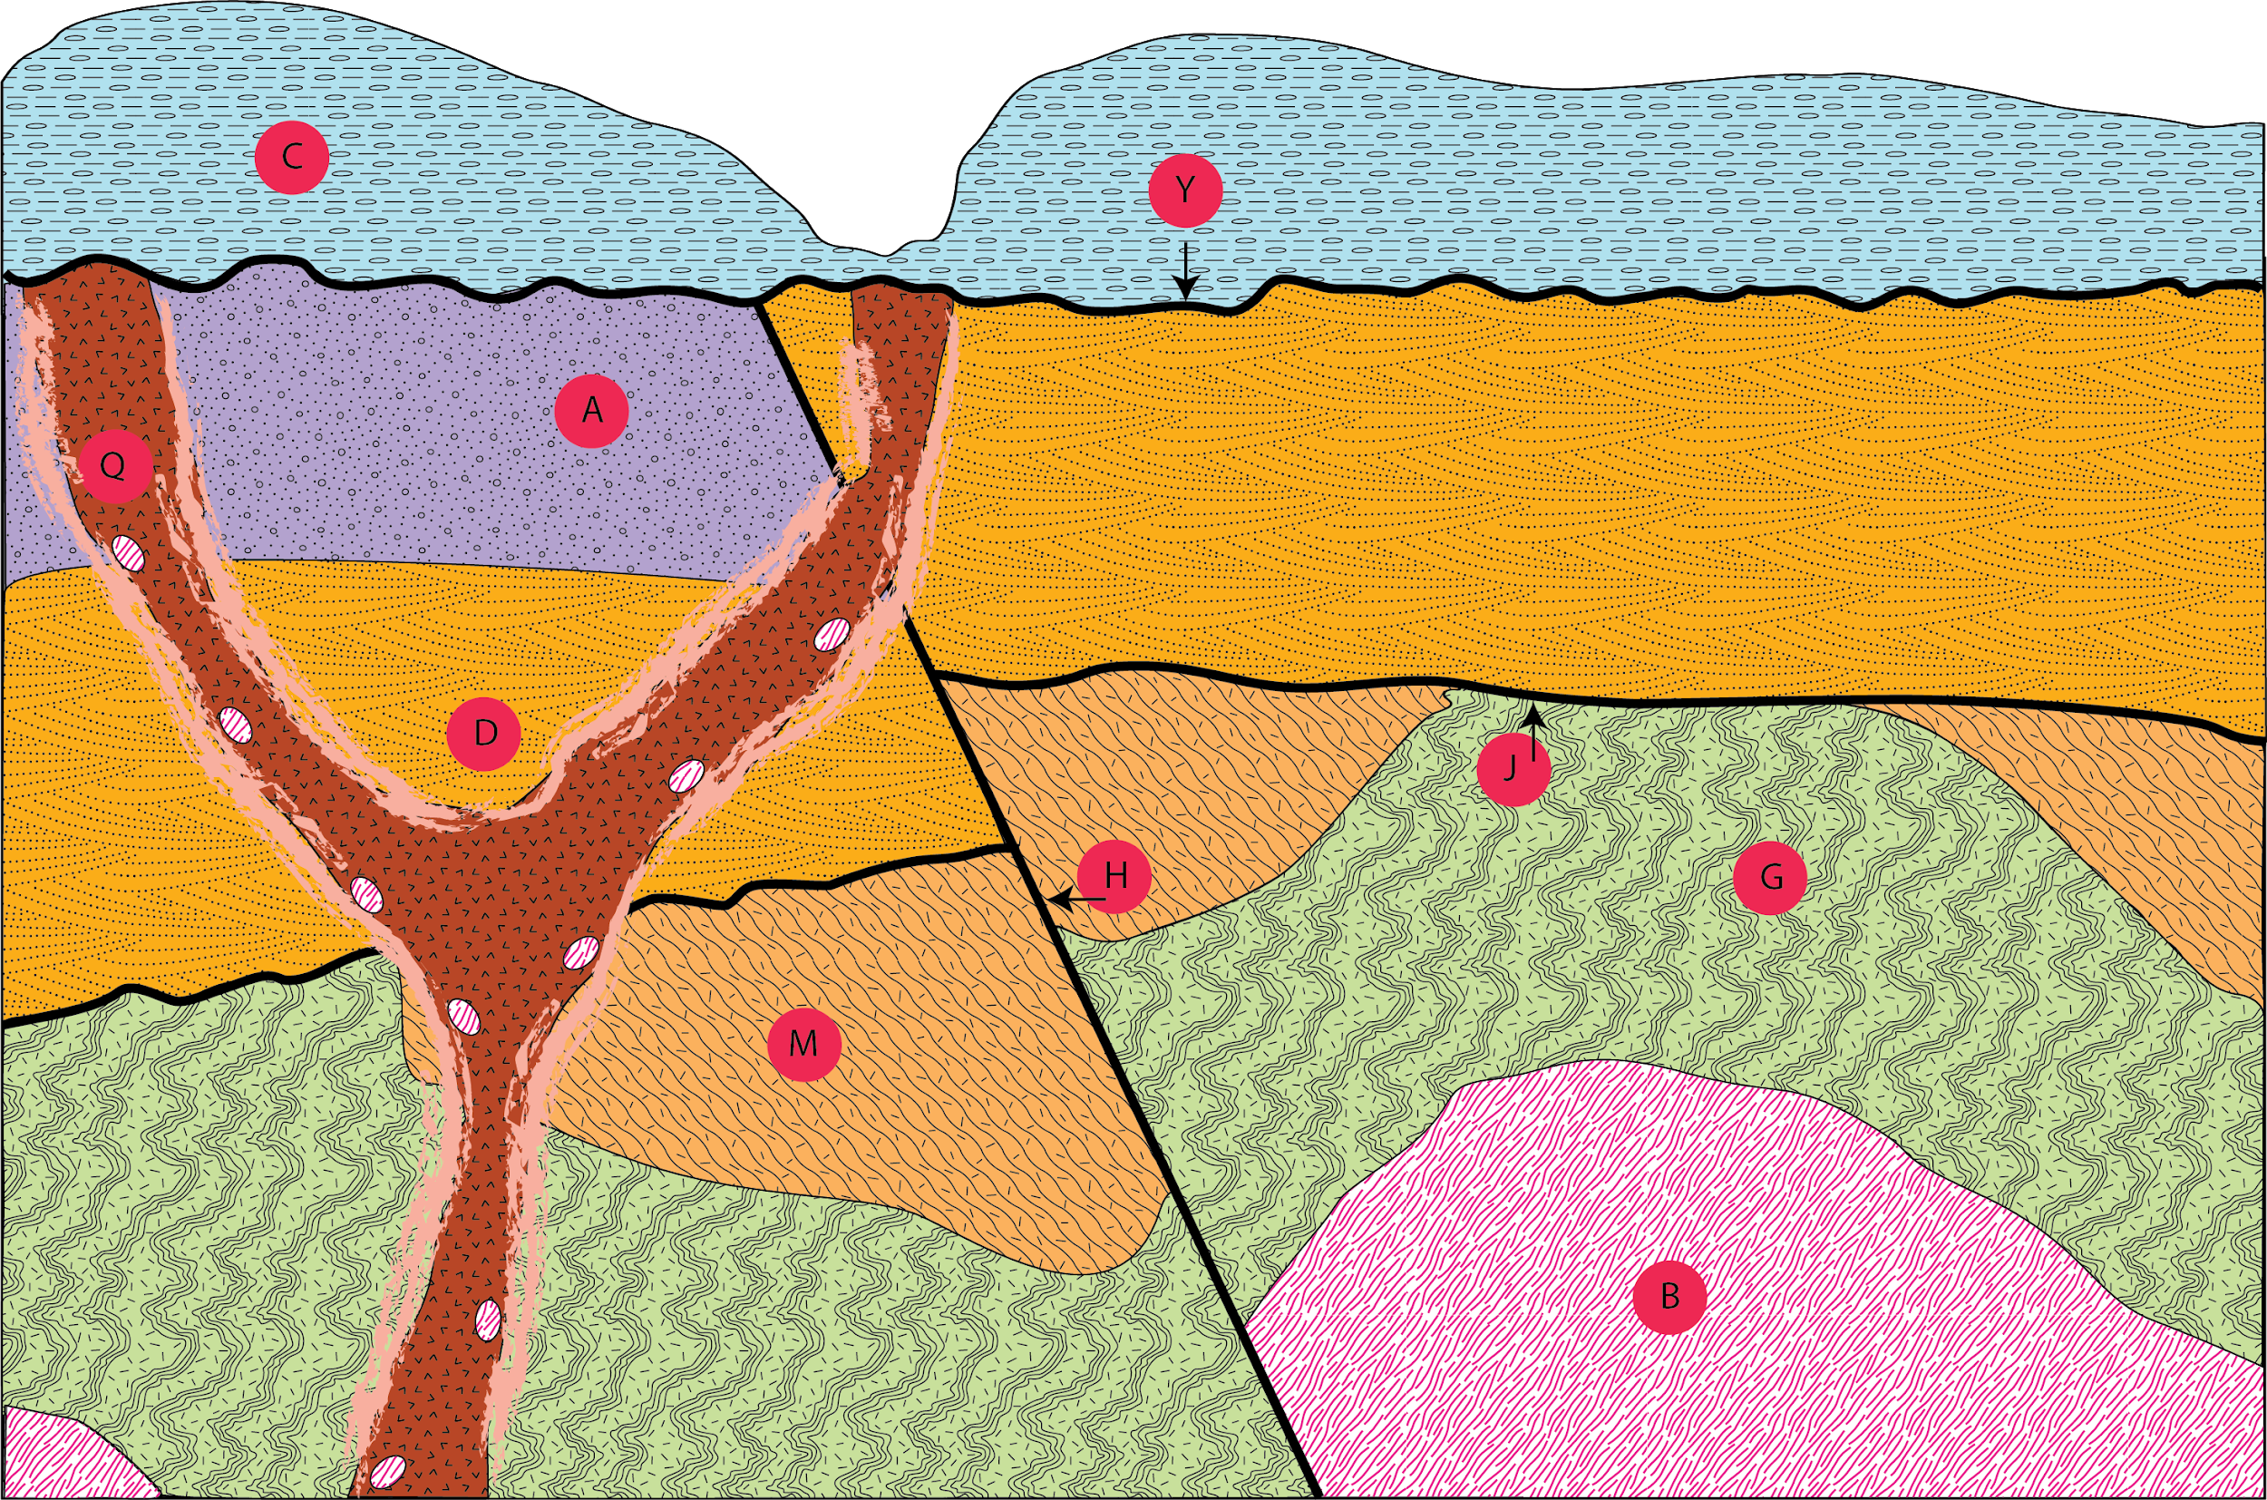
Using the Principles of Relative Dating we can establish a sequence of events for a given geologic cross section. The key for rock type symbols is provided so that you can determine what processes acted to generate different parts of the cross section.
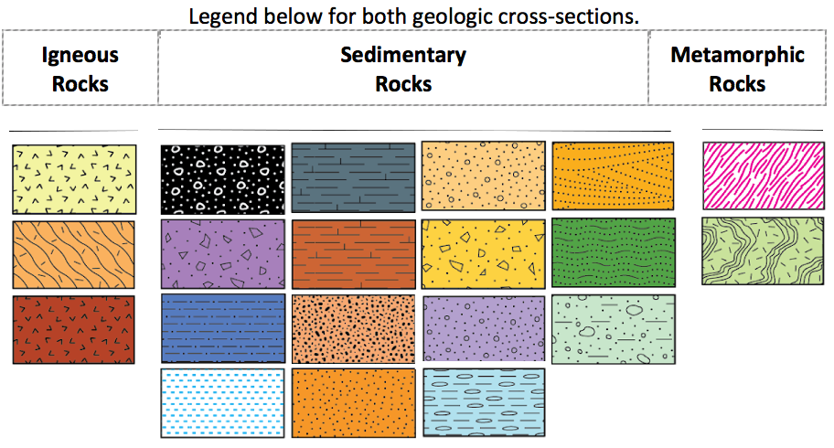

- In the diagram above, which were the first three units to form? _______, _______, _______

- These rocks were originally deposited as flat lying. What has happened to them?

- What event is represented by the feature labeled J? ________________________________

--------------------------------------------------------------------------------------------------------------------------------------------------
- Now put the layers from the diagram below in order. It uses the same set of symbols to represent rock types. Remember that this is easier if you work from oldest to youngest.
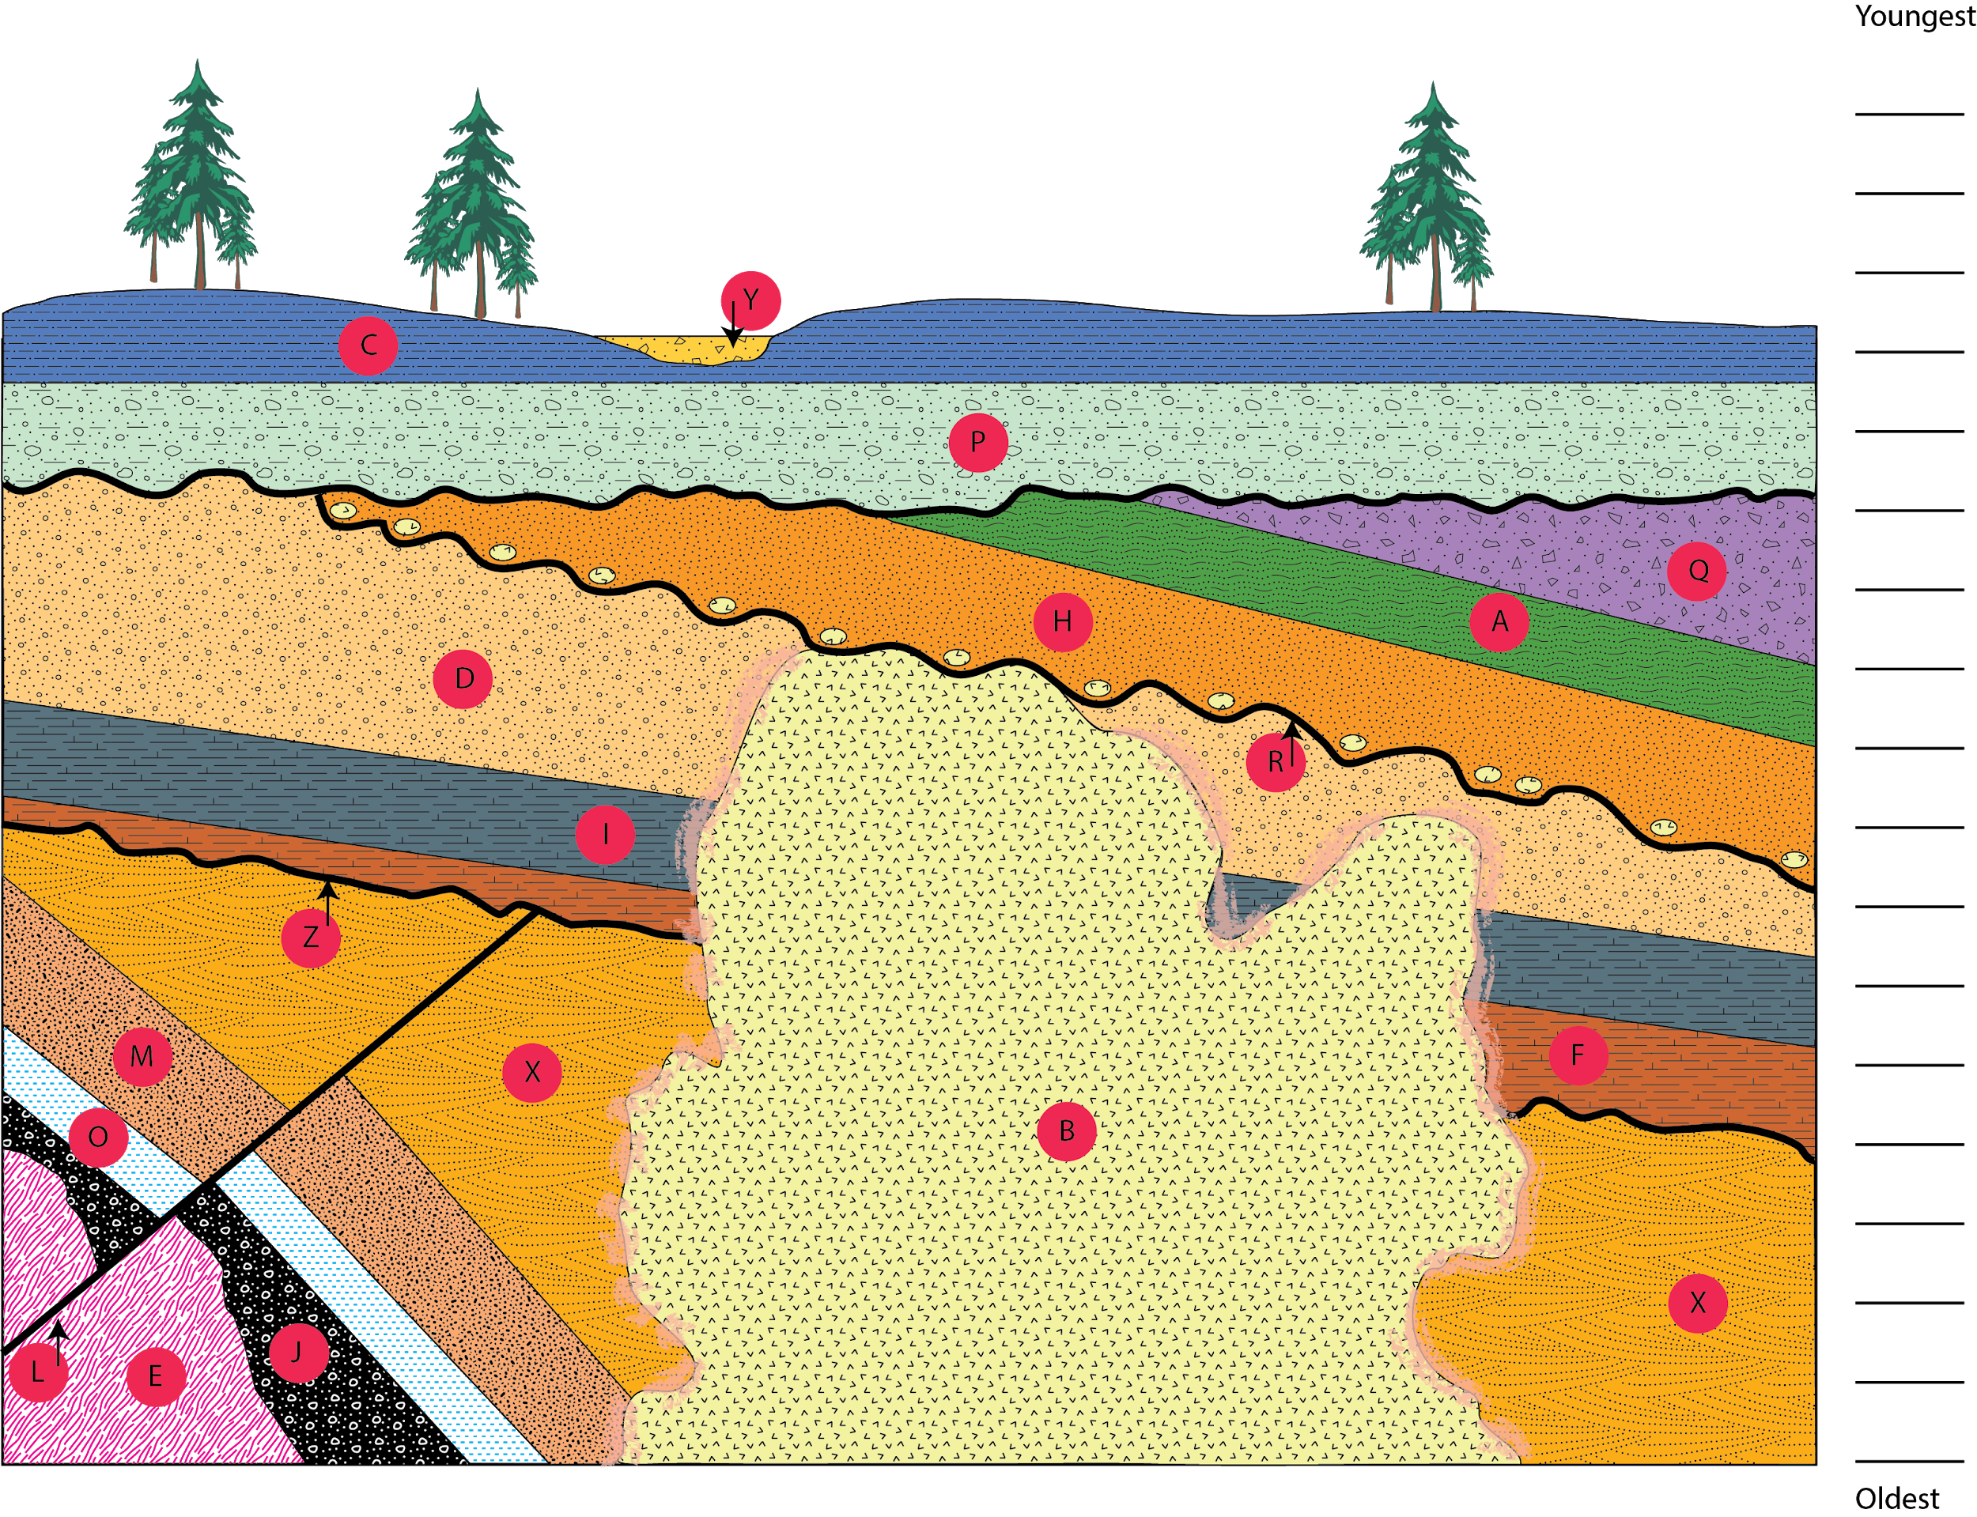

- If present, how many unconformities are illustrated in this diagram? ______________________

- Find and label one igneous (I), one sedimentary (S), and one metamorphic (M) rock layer using the legend provided.
- Consider the principles you used to sequence each unit. Identify the principles used for each rock type and answer the following: Were certain relative dating principles used more often for a particular rock type? Were there principles used exclusively for one rock type and not others?

Part 2. Biostratigraphy
Figure 1: Stratigraphic section containing 3 strata (rock layers) and 5 fossils, labeled as A, B, C, D, and E. Some fossils appear in more than one layer.

Biostratigraphy is the correlation of rock units based on fossil content. Each strata (layer) contains a certain fossil assemblage of coexisting species. Because the assemblage was deposited together, the fossils must have all existed at the same time. By determining the time when the age ranges of each particular fossils overlap, the absolute age of the beds can be determined.

Index fossils can be used to determine the ages of rock beds and the history of an area.

- From the pre-lab reading, define index fossil:

Figure 1 shows a cross-section (side view) of three rock layers and the fossils associated with each layer.

- According to the principle of superposition, which layer is the oldest? __________________________

- Fossil “A” is found in layers 1 and 3. Make a hypothesis about that fossil and/or the rock layers based on that observation.

To test your hypothesis and determine the absolute age of the layers, you can:
  - Identify each of fossil. These fossils are associated with specific periods of geologic time. This has been done for you, and the period of time associated with each fossil is shown in Table 1.
  - Analyze the fossil assemblages for each layer to see if we narrow time of formation based on the overlap of associated fossil time periods. See Table 1.
  - Determine the time period of formation for each layer, and look for unconformities.

- In what time period did layer 1 form? (see Table 1) __________________

- In what time period did layer 2 form? __________________

- In what time period did layer 3 form? _________________

- An unconformity exists between layers 2 and 3. What period of time is missing? _____________
 |  | Layer 1 |  | Layer 2 |  | Layer 3
Geologic Age | Code | Fossil A | Fossil E | Fossil C | Fossil D | Fossil A | Fossil B | Fossil C
Quaternary | Q
Tertiary | T
Cretaceous | K
Jurassic | J
Triassic | Tr
Permian | P
Pennsylvanian | IP
Mississippian | M
Devonian | D | x | x
Silurian | S
Ordovician | O
Cambrian | Ꞓ
Precambrian | pC
Table 1: Shaded areas represent time periods in which each fossil is found. Data is organized based on the stratigraphic section (rock layers) from Figure 1. Fossils are labeled in Figure 1.

Part 3. Geologic maps + cross-sections.

Often geologists do not get to see cross-sections of the inside of the Earth (though we do love road cuts for this reason!) Instead, geologists look at the rocks exposed at the Earth’s surface to determine the geologic history of an area. Often, geologists take cores to get a look inside the Earth to test their hypotheses.

In this section, you will see cross-sections such as the ones you saw in Parts 1&2 of the lab, and corresponding surface features. Next week’s lab will focus on what we see from the surface view only.
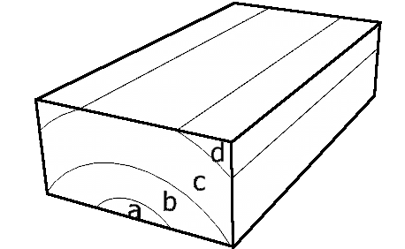
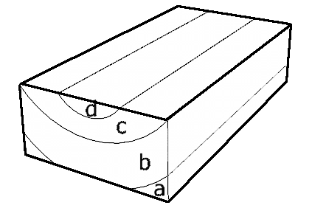
- b.

- Put the layers shown in figures a. and b. above in order from oldest to youngest:

  - Figure a: __________________________

  - Figure b:__________________________

- Compare and contrast what is seen on the map view for each. How are they the same? How are they different?

-------------------------------------------------------------------------------------------------------------------------------------------------

- Assume that in the image to the left, “1” represents the oldest layer and “3” represents the youngest/most recent layer. Would the “cross section view” of this diagram look more like figure a. or figure b. above?

-------------------------------------------------------------------------------------------------------------------------------------------------
- What would be visible from the surface in an area with flat-lying layers, such as the ones shown in the figure to the right?
a
b
c
d

Given your understanding of superposition, do you think all of geologic time is preserved in the rock record? If it were, rocks produced recently would be nearest the surface of Earth (where we walk), with older rocks buried deeply below those, everywhere. Is that how rocks are really arranged on Earth?

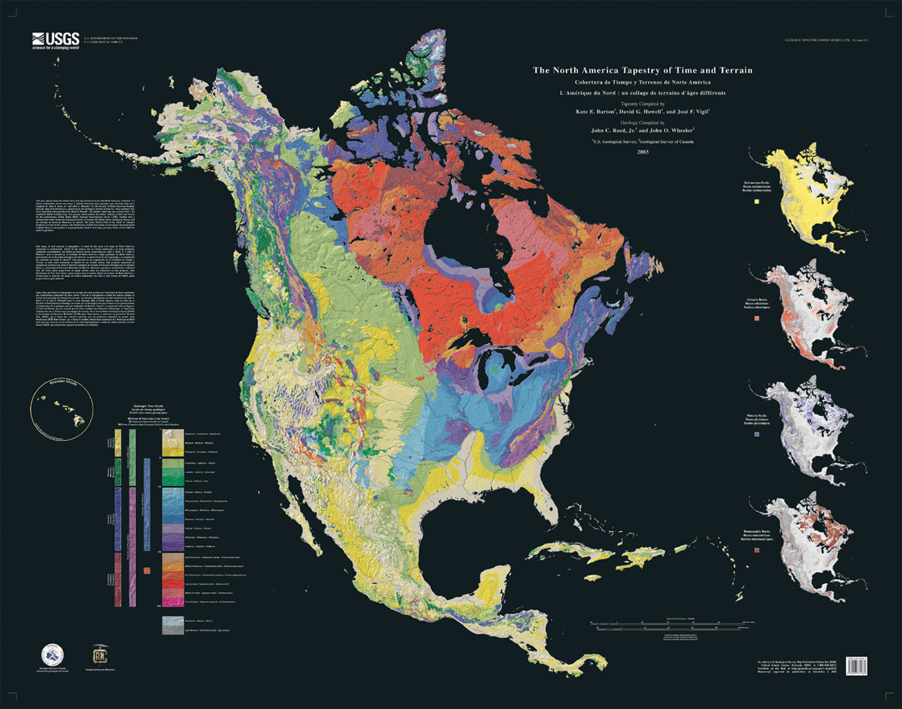
Let’s look at a real-world example: the “Canadian Shield”.

This is a geologic map of North America. There is a high-resolution version of this map on Sakai.

It shows the rocks immediately under our feet (and under any soil) in different colors that represent their age. The oldest rocks are in pink/red/orange, the youngest in tan/yellow. The “Canadian Shield” is that large patch of red and orange in the northern portion of the continent. Most rocks of the Canadian shield are between 1 and 3 billion years old!

- Why do you think the oldest rocks in North America are just beneath the surface in the Canadian Shield? What happened to the younger rocks that should be on top of them?

