University of Dayton
Electrical and Computer Engineering Department
Electronic System ECE304
Analog to digital Converter Project
Fall 2021

In this project you’ll design a 4 bits Analog to Digital Converter (ADC) to convert analog input from 0 to 9 V and use it in a fire alarm detection system
The digital part for this circuit is already provided and you’ll need to work only with analog feedback. We’ll use Multisim for simulation, the digital portion will be provided for you to add the analog one.
The digital part of ADC is shown in Fig. 1. You need to add the feed back to compare the digitals output with the analog input using the comparator. The feedback is a digital to analog converter (DAC). It is used to stop the counter when it reaches the same analog input value.

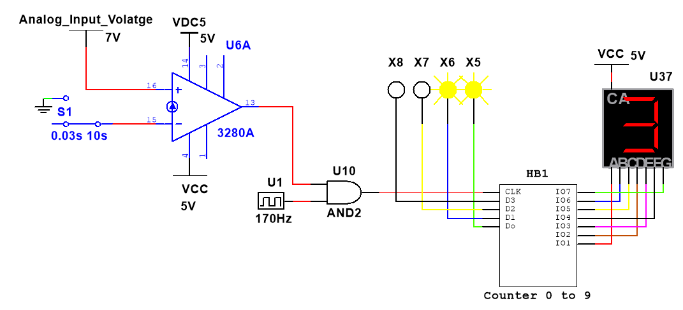
Figure 1 ADC Circuit
The second Part is to use the ADC in fire alarm detection system (FADS). The FADS use 4 fire detectors in 3 four different locations. Area 1 to 3. You design a circuit to detect and specify the detection’s locations based on the analog input value as shown in Fig. 2
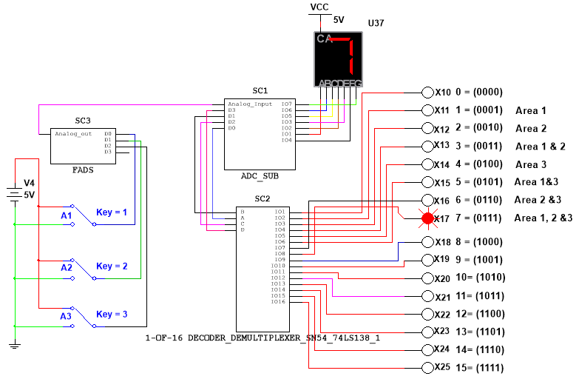
Figure 2 Fire Alarm Detection System (FADS)
Note: You need to use three bits for FADS and the real circuit runs much faster than the simulation. we slow it down so you can understand how it works. For the real one, the frequency is much higher to get a faster response and to be able to see only the final value and light indicator (LED). And you need to reset to go to a lower value, but here in the simulation you just need to rerun it again.

Analog Input | Digital Output
0 | 0000
1 | 0001
2 | 0010
3 | 0011
4 | 0100
5 | 0101
6 | 0110
7 | 0111
8 | 1000
9 | 1001

