Biology of Disease
Practical Case Study Workbook

Instructions
The questions in this workbook are designed to examine your understanding of integrated nature of laboratory diagnostics and aspects of the human adenocarcinoma.
You will need the case study brief (for all three practicals) to answer the following questions. These are available in the Practicals/Workshop folder on Moodle.
Please make sure that you answer your questions in the space provided. Please do not enlarge the boxes or change any formatting. This is to ensure that those using the PDF have same space as the ones using the word document. To avoid changes in formatting, change the size of the image before copy pasting.
Referencing/citing your sources is not required in this workbook. Please read the module and assessment handbook.

Practical One –Clinical Chemistry

Clinical chemistry

Section A: Urine testing

Analysis of CA's urine sample using 'Labstix'

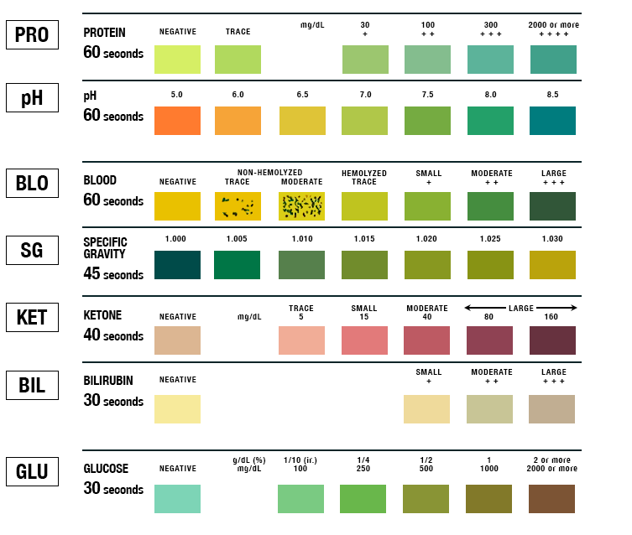

Now answer the following questions, being careful to think about what each test is designed to demonstrate and justifying the answer.

- Comment on each parameter from the ‘Labstix’ data above. Are there any abnormalities? (0.5 marks for each, 6 total)

Parameter | Value (give units where appropriate) | High level in urine known as: | Abnormality
Ketone
Protein
Glucose
Blood

Section B: Serum testing
b. Which enzyme are you measuring in your serum sample? Explain the relationship with the red colour observed in some samples. (3 marks)

c. Why do we include a STOP reaction in the experiment? (2 marks)

d. How can we ensure standardisation of results between different clinical laboratories? (1 mark)

e. Briefly describe the overall structure of Alkaline Phosphatases. (1 mark)

f. What are necessary at each catalytic site for alkaline phosphatase enzymatic activity? (2 marks)

Alkaline phosphatase measurement
According to the method sheet, carry out the experiment on the serum sample from CA provided and use the readings provided in table below.

Reading
Distilled water/zero | 0.000
Control sample | 0.108
Test Sample | 1.034
Standard | 0.246
g. Using the worked example as a guide (see the practical protocol), calculate the activity of alkaline phosphatase in CA’s serum sample from the readings provided in the table above. Show your working below. (5 marks)
Remember to subtract the control value from the test.

h. Input your IU/L value below. How does your value compare with the reference range provided in the practical session (also on the DLE)? (1 mark)

Mark: _______/21 ________%

Practical Two: Cellular Pathology

Analysis of CA’s biopsy slides. Examine the image in figure 1 and answer the following questions:

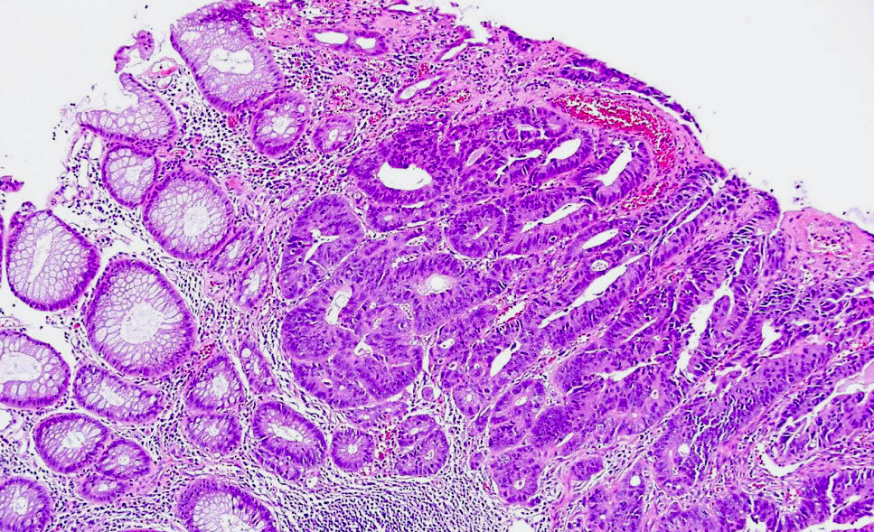

Figure 1. Haematoxylin and eosin stained image of CA’s biopsy x10 magnification

- Is CA’s biopsy displaying a normal tissue morphology throughout the section? Circle areas on figure 1 displaying normal morphology (3 marks)

2. List the four main layers of the large intestine (1 mark)

3. Has the gut sample in figure 2 been cut in cross or longitudinal section? (1 mark)
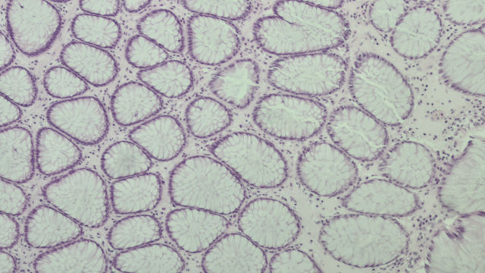

Figure 2. H&E-stained image of human gut

4. In a H&E stain of the large intestine which of the following cells nuclei should appear darker, goblet or absorptive cells? (1 mark)

5. What histological/cellular features/processes can be seen in A and B, which are also often features seen in other pathologies? (2 marks)

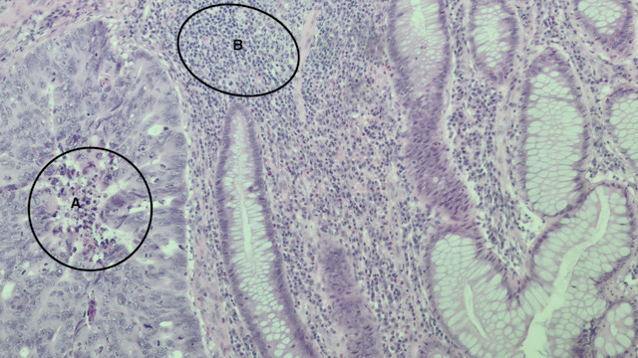
Figure 3 H&E stain of human adenocarcinoma

A is showing=

B is showing=

6. What are for the following definitions describing?

“Abnormal cytologic changes in epithelial cells associated with intensely stained nuclei or irregular nuclear chromatin often associated with neoplasia.” (1 mark)

“Rehydrate a section through graded alcohols to 100% H₂O” (1 mark)

7. The accumulation and nuclear translocation of ß-catenin often occurs in adenocarcinomas. Other than ß -catenin itself, which gene is most often mutated in colonic adenocarcinomas leading to this increase? (1 mark)

Further tests are performed on CA’s biopsy and an immunhistochemical stain for p53 is performed using horseradish peroxidase as a visualising enzyme and the results from this are shown in figure 4.
Figure 4. High power image of CA’s biopsy immunostained for p53 and counterstained with haematoxylin

8. Using a figure (i.e. a diagram with annotated labels) outline the intracellular mechanism regulating p53 levels in cells. Your answer as a minimum should make reference to the following mdm2, PUMA, CHK1/2, proteasome (4 marks).

9. Why would an increase in p53 protein level contribute to CA’s disease if p53 is a tumour suppressor? Suggest a reason for this paradox? What may have happened? (3 marks)

10. Detail why molecular analysis of colonic adenocarcinomas may look at BRAF mutations? What other mutations in intracellular signalling components linked to BRAF may be tested for? (2 marks)

11. Using a figure (i.e. a diagram with annotations) describe the signalling cascade that BRAF forms part of (this should include all elements from receptors on the cell membrane, and the intracellular signalling that transmit the signal to the nucleus) (4 marks)

12. Targeted therapies, such as panitumimab are used in some cases of adenocarcinoma of the colon. What DNA based laboratory technique could you use to determine if DS would respond to panitumumab? (1 mark)

Total Mark= /25 = %

Supporting resources: you may find the following useful as a starting point for further reading (copies of the texts are in the library.)

The open science lab on-line virtual microscope gut slides 21-25- choose gut from drop down menu https://learn5.open.ac.uk/mod/htmlactivity/view.php?id=19

Lodish, Berk, Kaiser, Bretscher, Ploegh, Amon, Scott (2013) Molecular cell biology, 7th edition, Lodish, Macmillan Higher Education (any other molecular cell biology text in the library would also be of similar use e.g. Alberts, Karp etc.)

Weinberg R (2013) The Biology of Cancer. Garland Science Press

Henwood A (2010) Microscopic Quality Control of Haematoxylin
and Eosin – Know your Histology. Connection 10: 115-120 available from https://www.researchgate.net/publication/316510040_Connection_2010_115_Microscopic_Quality_Control_of_Haematoxylin_and_Eosin_-_Know_your_Histology

Orchard G and Nation B (2012) Histopathology. Oxford University Press

Further specific searches for reviews and papers on Pubmed would also help and aid your understanding.

Practical Three: Immunology

Layout of samples and controls on ELISA plate
 | 1 | 2 | 3 | 4 | 5 | 6 | 7 | 8 | 9 | 10 | 11 | 12
A | Tube1 | Tube2 | Tube3 | Tube4 | Tube5 | Tube6 | Tube7 | Tube8 | Tube9 | Ser1 | Ser2 | Ser3
B | Tube1 | Tube2 | Tube3 | Tube4 | Tube5 | Tube6 | Tube7 | Tube8 | Tube9 | Ser1 | Ser2 | Ser3
C | Neg | Pos
D | Neg | Pos
E
F
G
H
Key: Ser= Serum sample, Neg= negative sample and Pos= Positive sample

Assuming the readings obtained at 405 nm in the plate reader as below:

 | 1 | 2 | 3 | 4 | 5 | 6 | 7 | 8 | 9 | 10 | 11 | 12
A | 2.804 | 2.07 | 1.405 | 0.835 | 0.583 | 0.329 | 0.222 | 0.205 | 0.19 | 1.751 | 0.540 | 0.914
B | 2.737 | 2.111 | 1.509 | 0.904 | 0.555 | 0.33 | 0.233 | 0.194 | 0.171 | 1.809 | 0.524 | 0.866
C | 0.140 | 1.090
D | 0.141 | 1.029

Answer the following questions

- Use the results to plot a graph of absorbance against positive control (standard) concentration on the next page (or on other graph paper if you wish). The top concentration in the positive control A1 is 50 ng/L CEA (remember you added 250 μl of 100 ng/L standard to 250 μl PBS). Make sure you label your axis appropriately, use correct units where applicable and have an appropriate descriptive legend beneath the graph. (6 marks)
Use this space for workings

Paste your graph here-

2. What is the antigen in this experiment? (1 mark)

3. What did the results from the controls show? (2 marks)

Positive-

Negative-

4. Assuming the top standard contains a final concentration of 50 ng/L CEA calculate the concentration of antigen in the serum samples. (3 marks)
SAMPLE 1: ___________________

SAMPLE 2: ___________________

SAMPLE 3: ___________________

Comments: The normal reference range for CEA is 2.5 ng/L to 5 ng/L

5. State whether serum samples 1-3 were normal or abnormal (1.5 marks)

1.

2.

3.

6. What is the biological function of CEA? (1 mark)

7. Why measure CEA levels prior to and after surgery? (2 marks)

8. Cancer biomarkers can sometimes produce false positives. Other than human error what could cause a false positive to occur in a CEA test? (2 marks)

9. Does high CEA level always indicate cancer? Justify your answer. (1.5 marks)

10. Based on the reports from the three practicals and haematology results (see Practical one- case study brief) what would be your diagnosis for the patient? Justify your answer. (4 marks)

Total Mark: / 24 %

Overall: / 70

Overall: %

General Feedback

