#37238: Research Report on Market Audit of Samsung Brand

Author
Institutional Affiliation
Course Code: Course Title
Instructor’s Name
Date

Research Report on Market Audit of Samsung Brand
Introduction
Samsung’s Galaxy S smartphone lineup represents the company’s flagship series alongside the higher priced Samsung Galaxy Note line. The latest in the product line, the Samsung Galaxy S22 and S22 Ultra, are among the best premium smartphones that money can buy as of 2022. Samsung has scaled the heights of smartphone sales in the U.S. especially following the aptly called “Huawei ban” of 2019 which saw former U.S. president, Donald Trump, add Huawei to a list of companies banned from doing business in the U.S. (Brown, 2022). Despite regaining its crown of top foreign consumer electronics manufacture in the U.S., Samsung’s premium Galaxy S series lineup has been unable to surpass the current king of smartphone sales in the U.S. and world over—Apple. The iPhone 13 and its variants currently hold top spot for most popular handset in the U.S. and other major markets in Europe and the Fat East. The three variants-- iPhone 13, iPhone 13 Pro, and iPhone 13 Pro Max—account for a whopping 48% market share (29% for the iPhone 13, 10% for the iPhone 13 Pro, and 9% for the iPhone 13 Pro Max) (Diaconescu, 2022).
External Forces Analysis
The external force analysis, also called, PESTEL analysis, assesses the political, economic, sociocultural, technological, legal, and environmental factors affecting the success of a company in certain jurisdictions.
Political
Samsung’s operations in the U.S. are restricted by jurisdictional regulations enforced by the federal government. Further, the company is also largely dependent on the country’s political stability without which profits would plummet and a dramatic surge in expenses. Political risk has various definitions, including (1) government interference with the operations of a company, (2) a reflection of government activities that culminate in changed circumstances in a manner that triggers enterprise consequences, (3) government policy governing foreign investment internally, and (4) expropriation in disfavor of less-developed or unstable countries (Costa & Figueira, 2017). President Trump’s disdain towards South Korea despite the two countries’ eight-decade long relationship has tarnished relations between them and has posed potential risk of intensified government regulation on the operations of Samsung.
Economic
The economic dimension is especially important for Samsung’s operations as it allows for increased product sales and a chance for product diversification. The global economic dysregulation caused by the emergence of the COVID-19 pandemic caused Samsung sales to drop considerably over the past two-year period. This was following strict stay-at-home measures imposed in the U.S. leading to significant reduction in smartphone sales owing to reduced movement of people (Adnan, 2022).
Sociocultural
Samsung runs as a family-owned conglomerate which manufactures products and distributes them all over the world, including the U.S. (Frue, 2019). To this end, the company must adapt its products to suit the needs of the audience in local markets by fully understanding the social dynamic governing these target markets (Ying, 2016). Despite this understanding, Samsung has regularly been falling behind in some of the enticing product offers that its competitors have been able to generously offer. For instance, the Galaxy S flagship lineup has always lagged behind in updating user devices to the latest Google Android version—devices such as the Google Pixel receive these updates almost instantaneously compared to months of waiting for Galaxy users. Further, most users are not fans of some of the preinstalled features, such as Samsung’s Bixby which, compared to rival voice assistants such as Apple’s Siri, suffer from much reduced functionality.
Technological
The company has been at the forefront of technological innovation. Boasting a richly diverse product range, Samsung has been able to remain at the top of the consumer electronics manufacturer list. In addition to being able to remain relevant in a world of rapidly evolving technology, Samsung must also remain committed to its pledge of providing safe sustainable products to its customers. A most infamous blunder in the technology world occurred in 2016 following Samsung’s release of the Galaxy Note 7. This line of Galaxy phones warranted a recall when numerous cases of exploding devices, caused by an internal battery defect, hit the headlines. Due to this unfortunate event, about 95% of all Note 7 gadgets purchased in the U.S. were recalled leading to massive financial loss to the company. Even today, Samsung still struggles with getting all its product features to align with current tech standards—for instance, the Galaxy S22 has received backlash for packing a 3500-mAh battery at a time when the current flagship standard for smartphone batteries is in the 5000-mAh region.
Legal
Samsung has not been stranger to litigation especially in the U.S. territory—the company has once had to face heavy penalties for allegedly imitating its rival company’s gadgets, the Apple iPad and iPhone (Management Study Guide, 2022). Samsung had also, at one point, been accused of illegally copying the Apple Store logo which led to an ensuing lawsuit from rival company Apple.
Environmental
There has been sharp pressure aimed at manufacturers for the production of environmentally friendly products and packaging. Samsung has led the way in actualizing this vision, with the newer range of its Galaxy S lineup boasting considerably smaller fully-recyclable packaging which aligns with the need to increase material recycling and avoid increasing soil and air pollution associated with the disposal of these materials
Internal Analysis
The analysis of Samsung’s strengths, weaknesses, potential opportunities, and imminent threats (also called SWOT analysis) helps benchmark the company’s internal environment to calibrate a functional blueprint or improvement map for its business operations.
Strengths
Samsung boasts a large market share—compared to Apple, Samsung comes in at a strong second place which has allowed the company to generate massive annual revenues from its product sales. Samsung also has a strong preference for product differentiation—the company has six different product lines under its Galaxy lineup (Note, S, J, A, M, and Fold series) which appeal to audiences with different financial capability. Additionally, the company has a diversified range of products such as televisions, kitchen appliances, sound systems, and computers.
Weaknesses
Samsung has noticeably been lagging behind in being able to capture an audience that stays loyal to its brand. Apple has had immense success with brand loyalty and this will only grow more in the future as the company continues to sell iPhones that articulate the company’s vision rather than Samsung’s approach of selling products with features that appeal to its audiences. Further, product diversification may also take away from the company’s ability to focus on perfecting their flagship line—appendix 1 illustrates investment decisions between Samsung and Apple proving that the latter invests more than double of what Samsung injects into the mobile business.
Opportunities
Samsung’s business model involves diversifying its product range to appeal to as many people as possible. The road towards putting a Samsung product in every home all over the world is rife with opportunity for the company to shift its focus from building brand loyalty and towards becoming a brand that is easy to go to.
Threats
The recent decline in revenues owing to the COVID-19 pandemic might eat into the company’s ability to continue innovating in the direction of creating mass-appealing products.
Recommendations
- Samsung should re-envision its core objectives to offset its overemphasis on product innovation with a shift in focus in the direction of tying its product innovation to a more pathos-driven vision
- The company should consider redesigning its camera technology to elevate its flagship line to a point of strong competition with its rival Apple. The latter’s main selling has, and continues to be, the high-end camera capabilities packed in its iPhone lineup.
- Samsung can consider mergers, acquisitions, or partnerships with companies like Blackberry or Sony’s smartphone division to expand its product innovation and create products that compete strongly at the flagship level
Conclusion
Samsung has been a strong competitor in the consumer electronics industry—it has the potential to become more and do more in a manner that rivals the current king of smartphones, Apple. Through a combination of technical and sociocultural factors, the company can scale the heights of competitive success and gain more market share in the U.S.

References
Adnan, F. 2022. Samsung’s best-selling phone in the US last quarter isn’t one you’d expect. https://www.sammobile.com/news/samsungs-best-selling-phone-in-us-last-quarter/
Brown, C. S. 2022. The Huawei ban explained: A complete timeline and everything you need to know. https://www.androidauthority.com/huawei-google-android-ban-988382/
Costa, L. P. D. S., & Figueira, A. C. R. 2017. Political risk and internationalization of enterprises: A literature review. Cadernos EBAPE. BR, 15, 63-87.
Diaconescu, A. 2022. These are the five best-selling smartphones in the US, UK, China, and more. https://www.phonearena.com/news/top-five-best-selling-smartphones-us-uk-china-more-countries-january-2022_id139384
Frue, K. 2019. PEST analysis of Samsung. https://pestleanalysis.com/pest-analysis-of-samsung/
Management Study Guide 2022. PESTLE analysis of Samsung. https://www.managementstudyguide.com/pestle-analysis-of-samsung.htm
Ritcher, F. 2019. Samsung's mobile business is half the size of Apple’s. https://www.statista.com/chart/8319/samsung-vs-apple/
Ying, F. 2016. Samsung's international strategy. An Analysis. https://www.grin.com/document/338598

Appendix 1
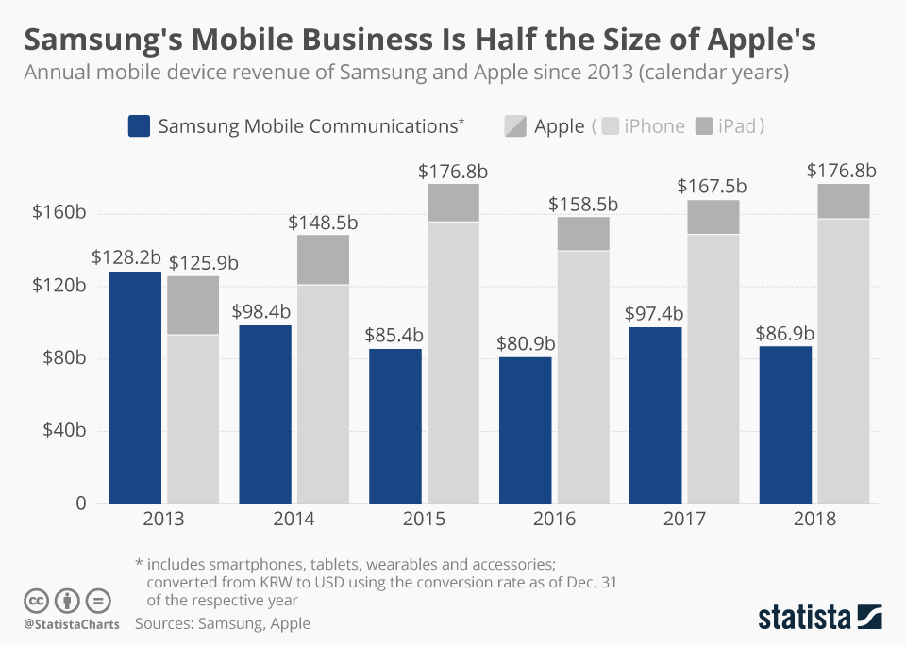
Ritcher, F. (2019). Samsung's mobile business is half the size of Apple’s. https://www.statista.com/chart/8319/samsung-vs-apple/

Appendix 2
This report assimilated findings from a questionnaire survey administered to 116 respondents through random sampling. The survey sought to conduct a market audit to establish the nature and function of Samsung’s business model in line with smartphone sales in the U.S.

Appendix 3 – Template
