Case Analysis- Case Study of an Acute Life-Threatening Condition

Short Answer Length: 1,000 words.

Aim of paper:
1. Demonstrate knowledge by analysing the information provided in the case study.
2. Apply the clinical information provided in the case study and describe this clinical information within a pathophysiological and patient focused framework.
3. Discuss nursing strategies and evidence-based rationales to manage a patient with acute heart failure
4. Discuss the pharmacological interventions related to the management of a patient with acute heart failure
Details:
You are to answer all questions related to the case study provided.
Your answers must be directly related to the clinical manifestations that your patient presents with.
You must submit your work with a minimum of six references from the past 5 years including peer-reviewed journal articles, textbook material or other appropriate evidence-based resources. Per the instructions, there needs to be a MINIMUM of six references that are no more than 5 years old. Every single new thought that is not my own words/personal opinion needs to be cited and referenced.

Case study
Mr. Aloha Das is a 68-year-old gentleman presenting to the emergency department at 0400hrs with worsening shortness of breath. Onset 2 days ago and progressively worsening. He also developed wheeze and right sided pleuritic chest pain this morning. Vomited x1, ongoing nausea. Has history of non-compliance with medication and adherence to fluid restriction.
Past History
Hypertension, Inferior Myocardial Infarction in 2020, Heart Failure, non-ischemic Cardiomyopathy, Permanent Pacemaker inserted 2021, DM Type II, GORD, Osteoarthritis.
Current medications:
Furosemide 40mg OD, Captopril 6.25 mg TiD, Digoxin 0.125 mg BD, Metformin 500mg TiD, Nexium 40 mg BD.
On 1.2 L fluid restriction; Echocardiogram results in 2021- systolic dysfunction, mild mitral valve regurgitation, dilated left atrium and ejection fraction (EF) 33%.

Nursing Assessment
A. Clear, speaking in short sentences
B. RR 28 bpm, SpO2 90% RA, bilateral crackles, diffuse wheeze anteriorly and posteriorly
C. HR 120 bpm, peripherally cold, centrally warm, BP 186/108 mmHg, capillary refill <3 sec
D. GCS 15 (E4V5M6) PEARL
E. Patient looks distressed, diaphoretic, right JVP distension++, bilateral pedal pitting edema 2+
F. No IV fluids in progress
G. BGL 14.0mmol/L

Plan
• Continuous cardiac monitoring
• 12 lead ECG
• Blood pathology order
• Troponin I High Sensitivity
• Chest X-Ray
• Insert IVC right hand
• Furosemide 40mg IV Stat
• Echocardiogram

Results of Investigations:
Chest x- ray: Left ventricular hypertrophy, interstitial edema noted by Kerley B lines in the costophrenic angle.

ECG:
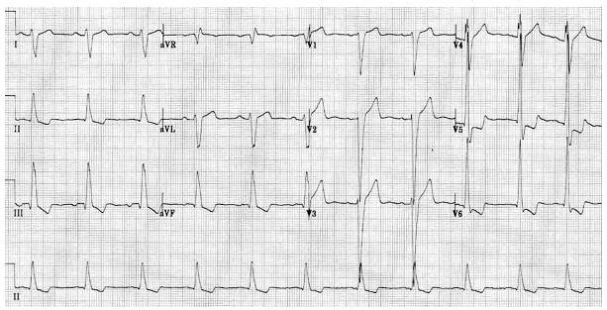

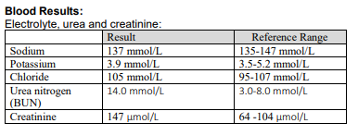
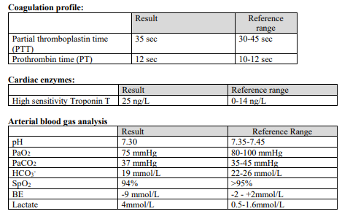
Impression: Exacerbation of Congestive Cardiac Failure and fluid volume overload

No introduction or definition of pathophysiology or pathogenesis is needed.
Question 1
In order to prioritise your nursing actions, you are expected to have a sound understanding of the pathogenesis and pathophysiology.
Explain the pathogenesis and pathophysiology causing the clinical manifestations with which Mr Das presents. Address every clinical manifestation.
Explain the pathogenesis and pathophysiology causing the clinical manifestations with which Mr Das presents. Address every clinical manifestation. So this includes how he presents and those mentioned in the A-G nursing assessment. One concept of pathophysiology can be associated with more than once clinical manifestation eg: breathing difficulty and low SPO2. Obviously, the answer will have to be concise to stay within the work limit. You can use the investigative findings to link to the patho if you like.
Question 2
Choose One high priority nursing intervention that you will perform for Mr Das
- Briefly explain why you chose this nursing intervention
- Explain how the nursing intervention will alleviate the clinical features of Mr Das using physiological linking
- Briefly describe the impact of not performing the intervention
Question 3
Mr Das has been prescribed Furosemide 40mg IV Stat and Glyceryl Trinitrate IV Infusion 10 mcg/min starting rate.
For both medications explain
- The mechanism of action
- Why your patient is receiving this medication in relation to his symptoms and diagnosis?
- What are the nursing considerations for this medication?
- What clinical response you expect?
- What continuing clinical observations will you need to undertake?
Note: What should you expect once Das receives the drugs? Link back to the case study and pathophysiology.

