PMY8111 Section A Question 3
PLEASE STATE YOUR FIVE DIGIT ANONYMOUS CODE:

- In 1975, Chien et al. published a research article entitled 'Controlled Drug Release from Polymeric Delivery Devices III: In Vitro-In Vivo Correlation for Intravaginal Release of Ethynodiol Diacetate from Silicone Devices in Rabbits'. In that study, female rabbits (n=40) were implanted with silicone vaginal rings containing ethynodiol diacetate for up to 8 weeks. In an effort to establish an in vitro-in vivo correlation, Chien and his co-authors produced the following graph, showing the correlation between the plasma concentration (C_{B}) of norethindrone (the major metabolite of ethynodiol diacetate) and the in vitro release rate (Q/t; referred to as 'flux' in the figure caption) at various time points.

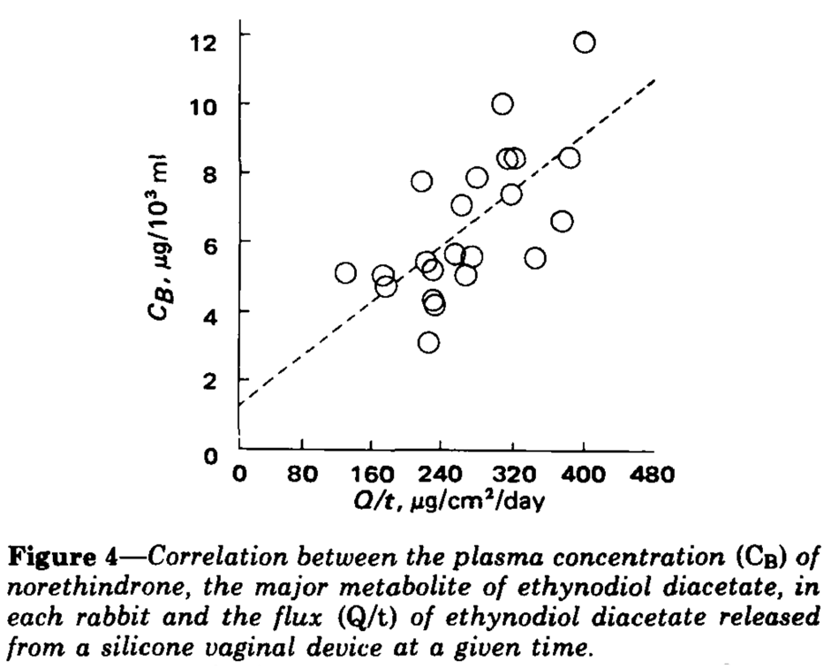
Figure 1.

- What level of in vitro-in vivo correlation (IVIVC) do the data in the figure represent? Give a reason for your answer.
[10%]

- Across how many time points were the in vivo and in vitro data collected?
[10%]

The article also includes the following graph, showing in vitro cumulative drug release (Q) versus the square root of time for a silicone elastomer ring device initially containing 30 mg ethynodiol diacetate.

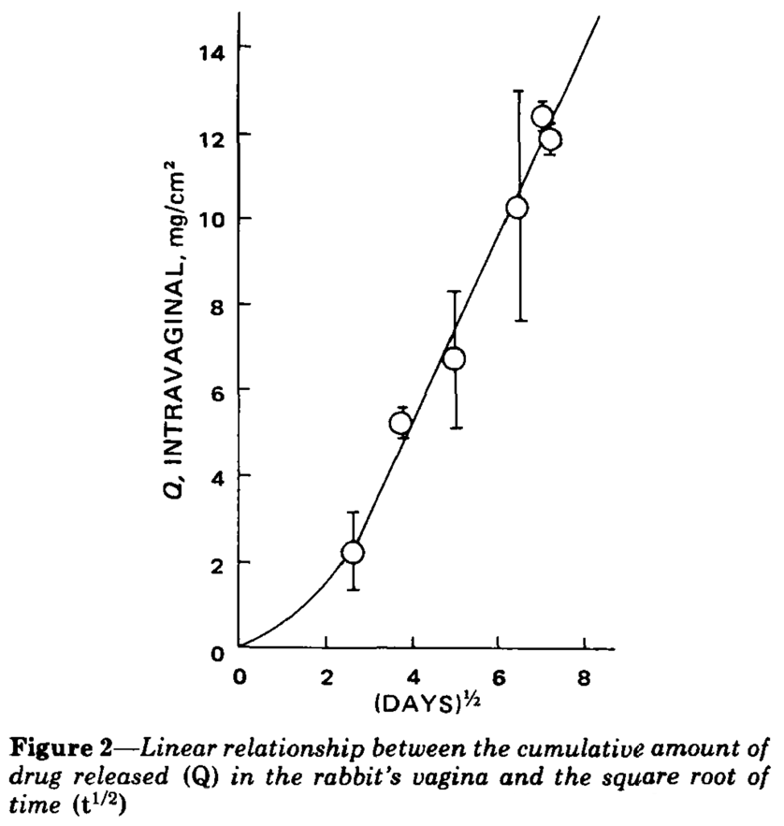

- Based on the data presented in this in vitro release graph, comment on the type (i.e., the design) of the vaginal ring that was tested.
[20%]

- How might you change the formulation to increase the rate of release of ethynodiol diacetate?
[10%]

- With reference to a specific example you have studied, outline the experimental techniques that can be used to investigate microbial penetration across microneedle-punctured skin.
[50%]

Please write your answer between the lines above and below this sentence (you may delete this text)

Please check you have entered your anonymous code at the top of the first page

For staff use only. Do not delete or alter this section in any way
Marks awarded for this question:

