PMY8111 Section A Question 3
PLEASE STATE YOUR FIVE DIGIT ANONYMOUS CODE:

- The figure below is taken from a research article entitled 'Development of level A, B and C in vitro–in vivo correlations for modified-release levosimendan capsules'. Levosimendan is used for the treatment of congestive heart failure. The figure shows a plot of in vitro dissolution data versus in vivo absorption data for a lead candidate modified-release levosimendan oral capsule formulation.

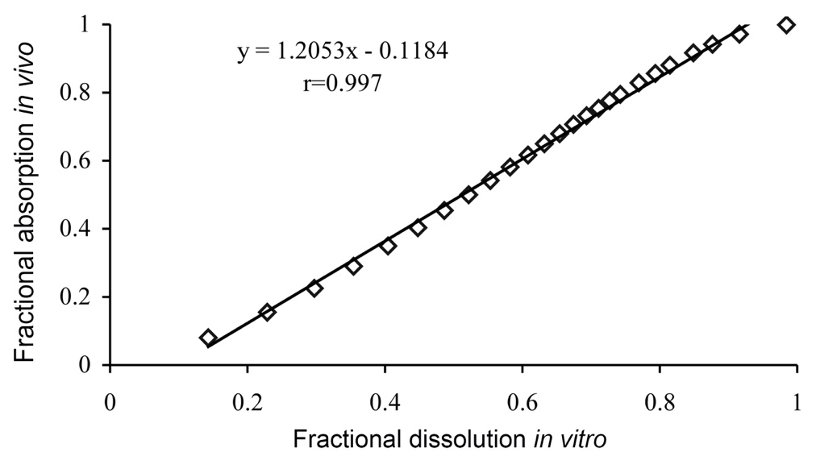

- What level of in vitro-in vivo correlation (IVIVC) do the data in the figure represent? Give a reason for your answer.
[10%]
- Across how many timepoints were the in vivo and in vitro data collected?
[10%]
- Explain how the ‘fractional dissolution in vitro’ data (plotted on the x-axis) would have been obtained.
[15%]
- Explain how the ‘fractional absorption in vivo’ data (plotted on the y-axis) would have been obtained.
[15%]

- Describe in detail, the FIVE main strategies for microneedle-enhanced transdermal drug delivery.
[50%]

Please write your answer within the lines above and below this sentence (you may delete this text)

Please check you have entered your anonymous code at the top of the first page

For staff use only. Do not delete or alter this section in any way
Marks awarded for this question:

