Workbook: Annotating maps in PowerPoint
In this practical you will learn how to use PowerPoint to annotate maps that are not required to be drawn to scale. This is useful for summarising site analyses.
At the end of this practical you will have learnt:
- How to insert a map into PowerPoint
- How to resize slide size in PowerPoint
- How to add basic shapes to PowerPoint
- How to add text to PowerPoint
- How to save your annotated map to use in your assignment
Inserting maps into PowerPoint.
There are many software packages available and used by planners to create maps, diagrams, figures, and present data such as GIS, Photoshop, SketchUp, Illustrator, and the Microsoft Suite. In today’s workshop we will be introducing you to Microsoft PowerPoint and its tools for map annotation. PowerPoint is a programme historically used to create presentations; however it can also be very useful to create basic diagrams, flow charts, and annotated maps.
Open PowerPoint and create a new Blank Presentation by clicking on ‘Blank Presentation’ followed by ‘Create’.
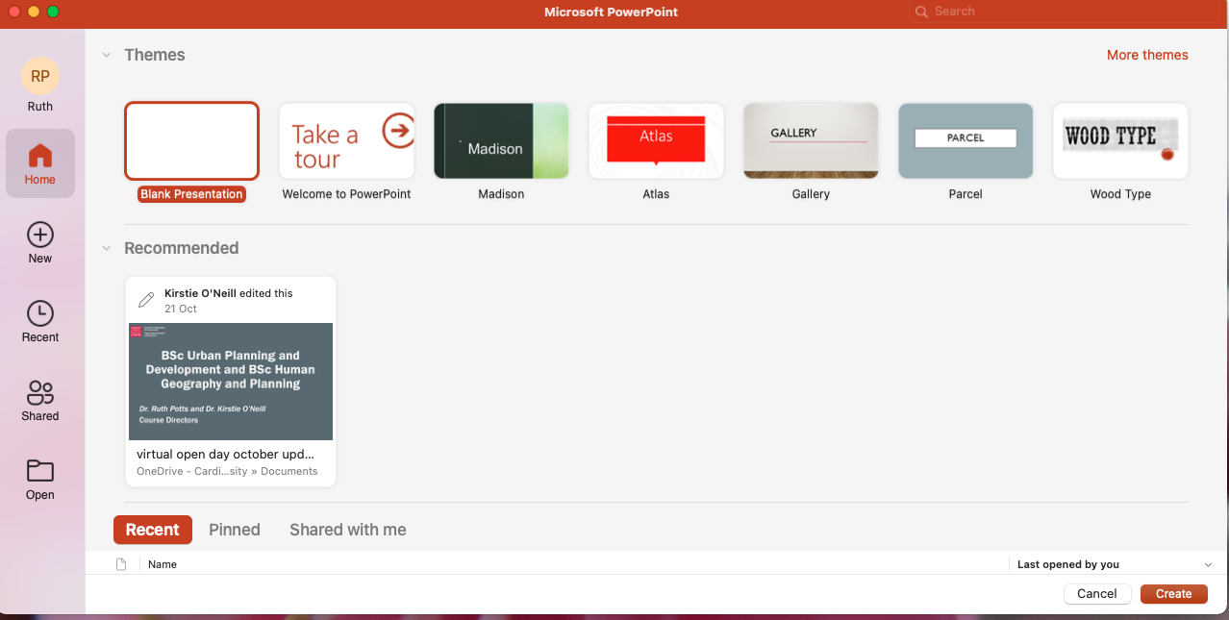

Once the Blank Presentation loads, we will need to adjust the layout of the page so that it doesn’t not have any pre-set formatting present. Select ‘Layout’ and then change the slide to ‘Blank’.
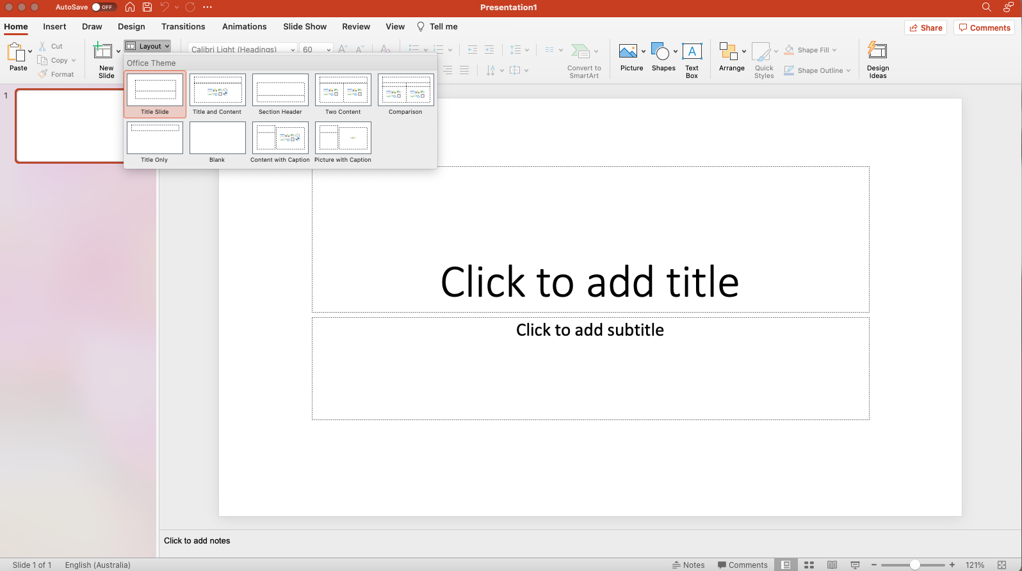
We can now insert a map into the slide. On the menu bar at the top, select ‘insert’ and then ‘pictures’, and then select ‘picture from file’. You can now find insert one of the base maps provided on Learning Central or from Digimaps that you have downloaded onto your computer.
The map will appear on the slide after you have completed the above steps.
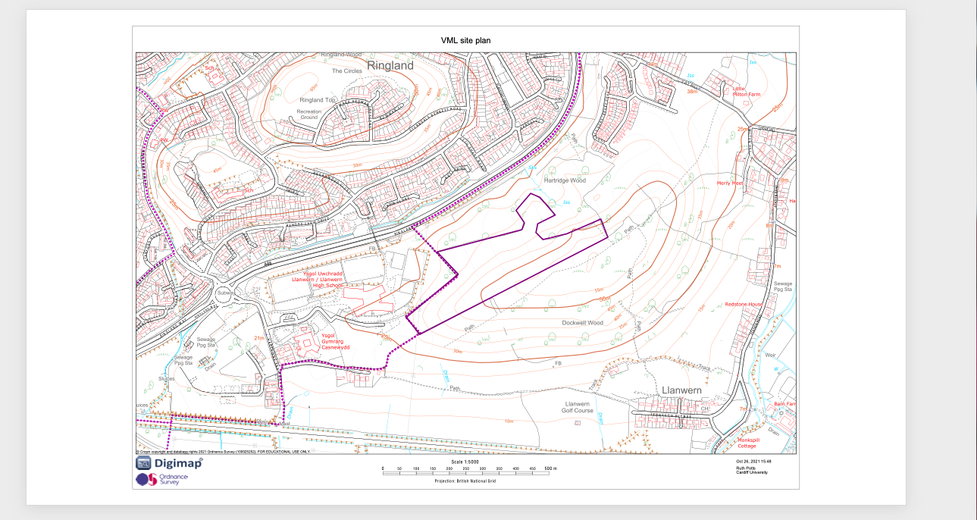

Resizing the size of slides in PowerPoint
Once you have inserted a map into the slide you will then need to consider how to ensure it is legible, and useful for your assignment. To do that, we will adjust the size of the slide and the size of the map. PowerPoints slides are formatted automatically to be optimised for computer screens and presentations on projectors, however we need to optimise this for maps to be inserted into your assignments.
Click on ‘File’ and then select ‘Page setup’. Once the Page Setup box pops up you will be able to select which size you want your slide to be. For your assignment I recommend using A3 paper as your slide size. Once you have selected A3, press OK at the bottom of the box.
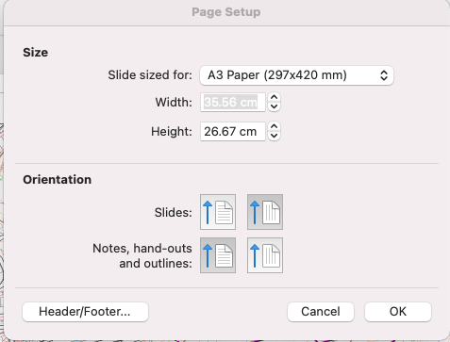
A box will pop up asking if you want to scale your content up, select Scale.
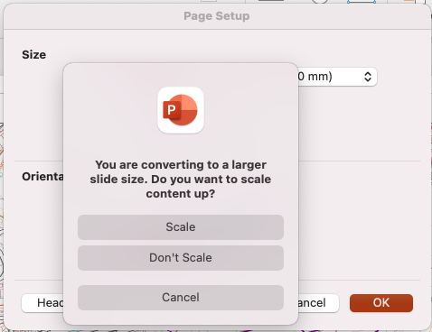

Now that the slide is A3 sized, click on your map so that the map has a black line around the outside of the image and drag it to the top left of the slide so that the image is flush with the left and top edge of the slide. You can now click on the small box at the bottom right corner of the map image and expand your map to the full extent of the slide.
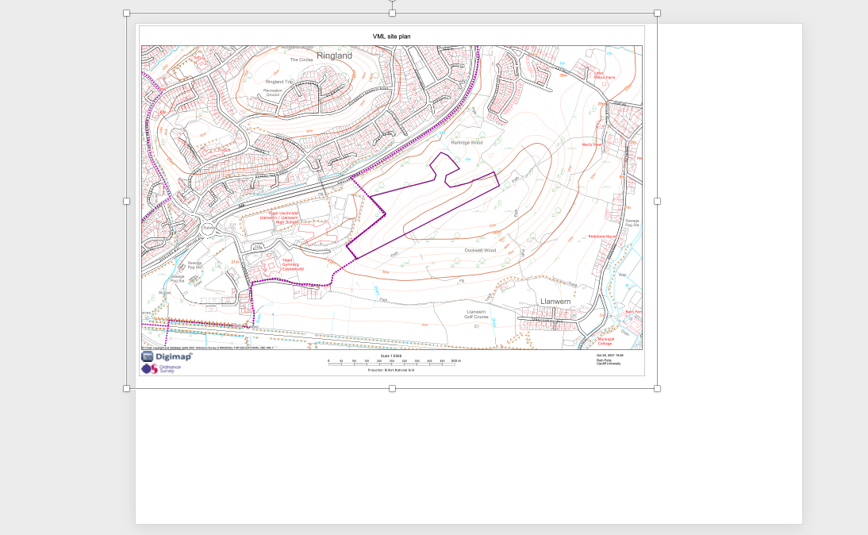
Your map is ready to be annotated.
Adding basic shapes to PowerPoint
Αφτερ α σιτε ϖισιτ ψου μαψ ωαντ το διγιτισε ψουρ μαπ το σηοω ψουρ φινδινγσ ανδ συμμαρισε ψουρ σιτε αναλψσισ ϖισυαλλψ. Το δο τηισ, ψου χαν αννοτατε ψουρ μαπ ιν ΠοωερΠοιντ υσινγ α μιξτυρε οφ ‘Σηαπεσ’ δραωινγ τοολσ. Χλιχκ ον τηε Σηαπεσ βυττον ον τηε μενυ βαρ το σεε αλλ τηε σηαπεσ αϖαιλαβλε.
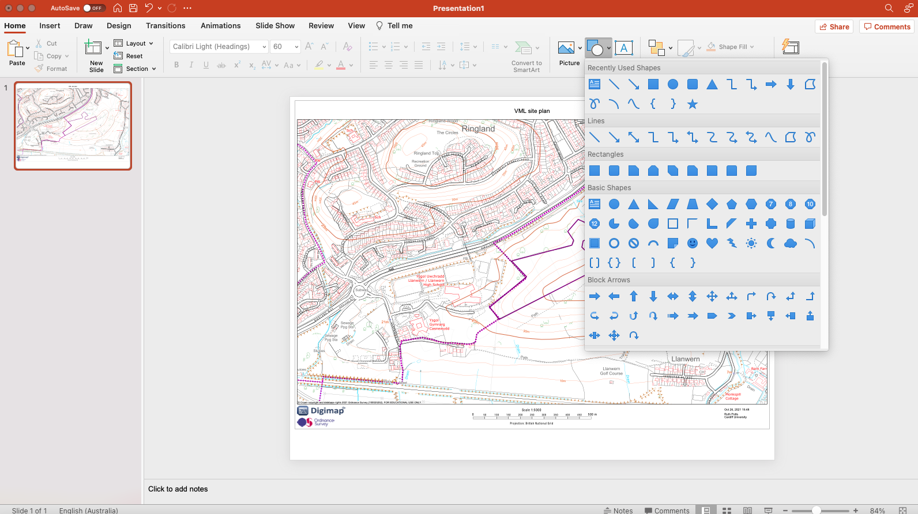
Practice drawing some of these shapes, starting with basic squares, circles, and triangles. I’ve drawn an ellipse using the circle tool, and you can see that PowerPoint automatically makes the shape blue. This isn’t very helpful because it is obscuring the map below it. In order to make the shape transparent, we need to right click on the shape and select ‘Format Shape’.
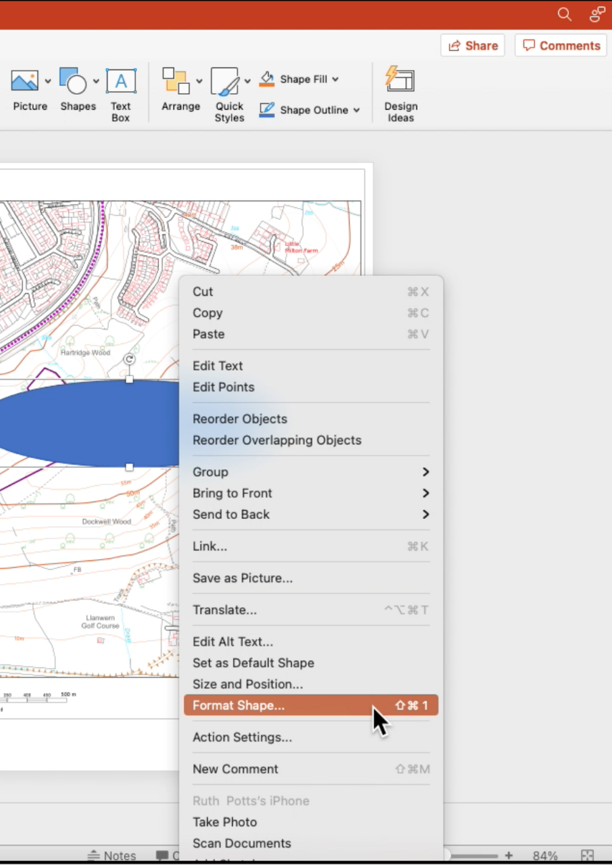
The format shape menu will then appear on your screen. Select the bucket icon, and ‘solid fill’. You can then adjust the colour to your preferred colour and transparency to 20%. 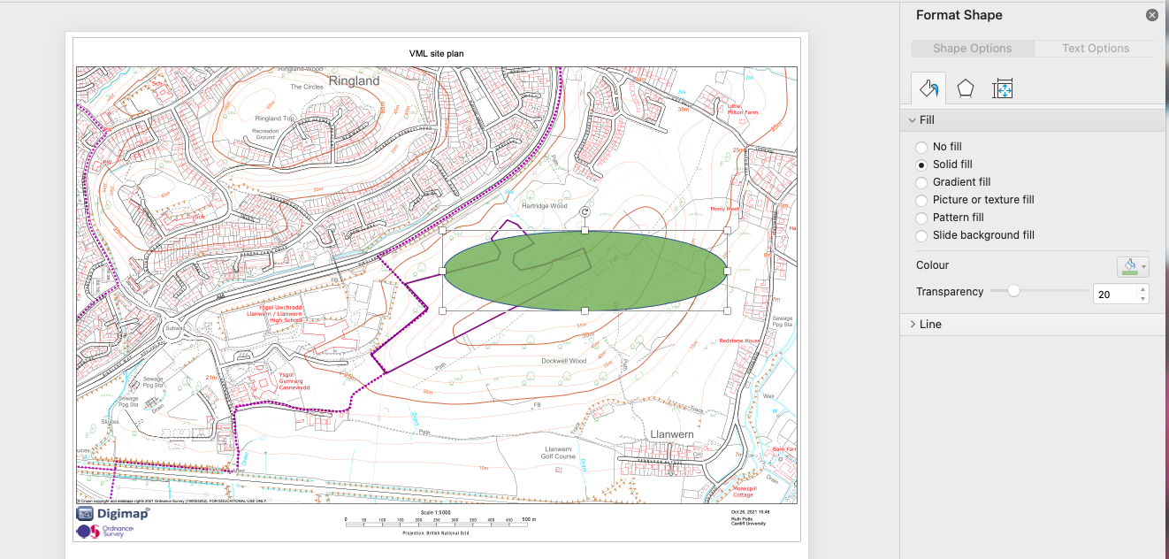

The shape is now transparent, however it is still not quite right. You can also adjust the angle of any shape you draw by clicking on the circular arrow icon above the image and then moving the mouse until you are happy with the new location of your shape.
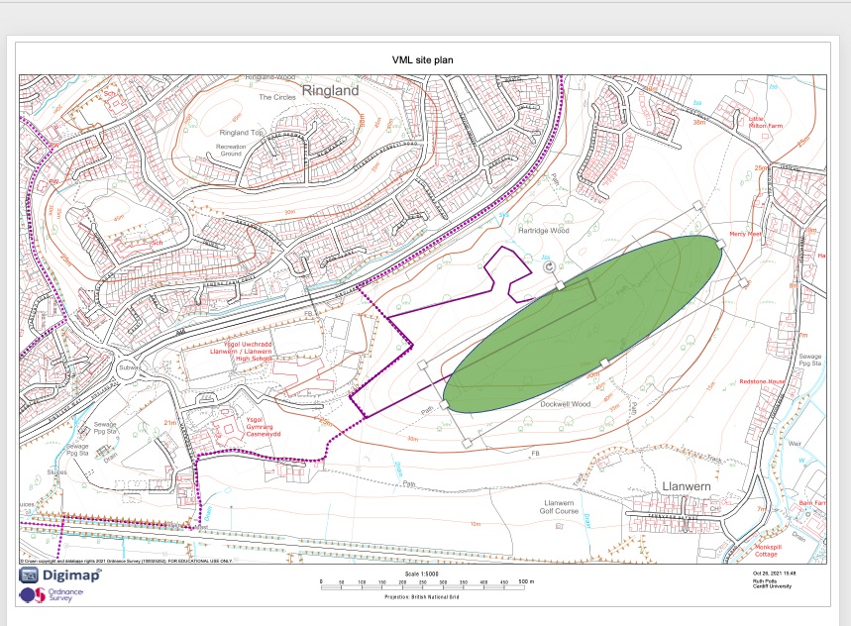
You can see how simple it is to use shapes to highlight key features of the site. I have used the circular shape to highlight the area of highest topography on the site, however you can use other shapes and lines in the shape area to identify any of the site’s or its surrounds characteristics (e.g. bus stops, residential areas, community facilities, flood risk, etc). Try experimenting with different styles of lines, colour and transparency.
You can also create custom shapes as follows. Click on the Shapes button, and select the freeform drawing tool. You can use this to draw around any area and make your own unique shapes, for example I have drawn around the Llanwern School in the image below.
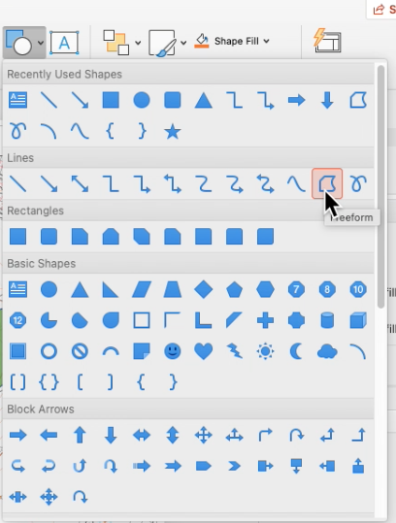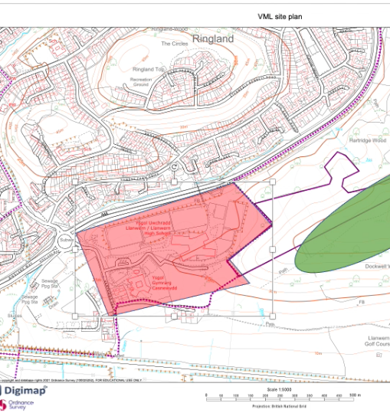
You can experiment with the thickness of lines, outline colour, arrows and other tools in PowerPoint – spend some time experimenting before moving ahead in the lab worksheet.

Adding text to PowerPoint
Once you have added all the shapes and lines you are happy with, you will need to annotate your map. Your map should use a mixture of annotation (text on the map) as well as a legend to clearly articulate what each colour, line or shape indicates. Text boxes should be used to add some of the TOSSLAD elements to your map, including a Title, Source, Scale (in this case a piece of text stating ‘Not to Scale’), Author (your student number), and the date this map was created. In this section we will work through the steps to add text to your map. There are two key ways you can add text to your map – a text box or directly into the shapes you have drawn.
To add a text box to your map, you should click on the text box button on the menu bar, and then click approximately on your map where you would like to place the text box. You can now write directly into the text box, and then click and drag the text box to relocate it in the location you want it to be on your map.
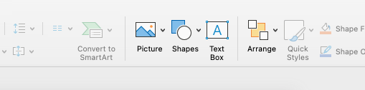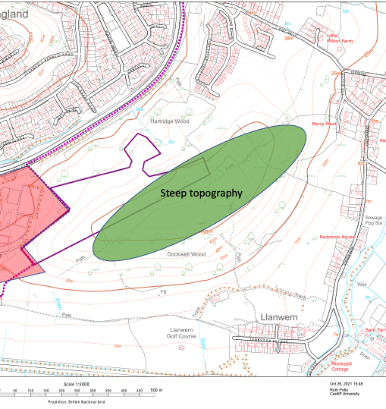
You can also add text to your map by clicking directly onto the shape you have drawn and typing into that shape. Simply click once on the shape before typing.
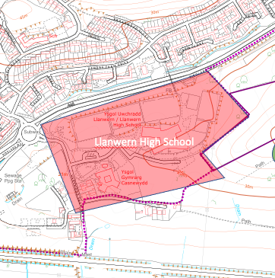

Adding a legend to your PowerPoint map
Generally we wouldn’t annotate the same things we include in our legend. The legend is used to summarise the symbols and colours, whereas we use text annotations to provide small amounts of explanation or analysis on our maps. For this exercise however, I will be using the same items to annotate with text and the legend (DO NOT DO THIS IN YOUR ASSIGNMENT).In order to add a legend to your map in PowerPoint you should click on ‘Insert’ in the menu bar and select ‘Table’. Add two columns, and as many rows as you have symbols or colours you need to include, plus ONE extra row. When you are happy click once. I have added 3 rows because I have two elements I want to include in my Legend.
After inserting the table, you will need to select ‘shading’ from the menu bar and ensure all rows have a white background.
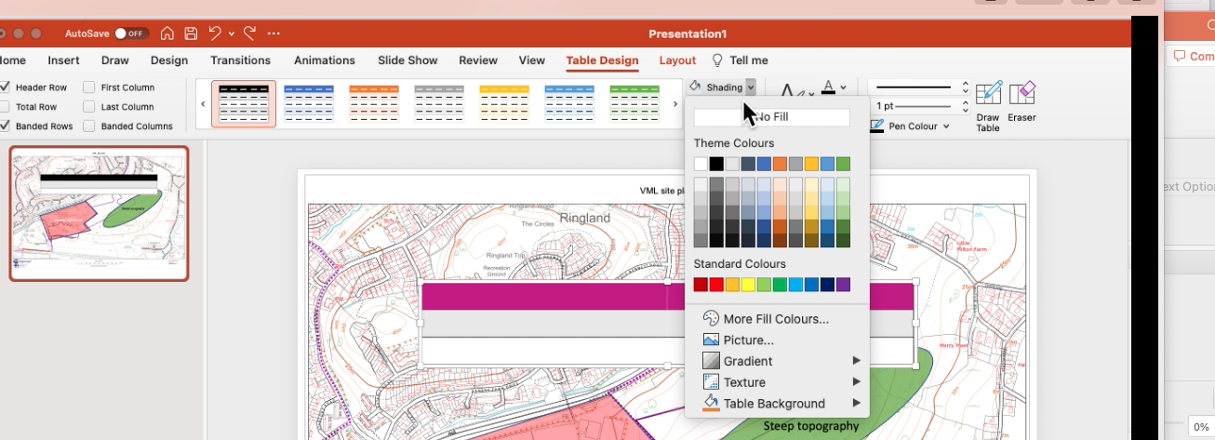

Now type in the name of the elements for inclusion into the rows of your table, starting from the second row.
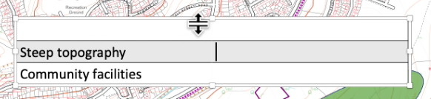
Using the shading button from the menu bar again, you can change the colour of each cell next to the text to the corresponding colour on the map, and adjust the transparency to 20% just like you did on the shapes on the map.

Now highlight the top two cells, and right click. Select ‘Merge Cells’ from the list. Finally you will need to add a title to the legend table, type ‘Legend’ into the top left row. You can now adjust the text size using the font size button, and size of the cells to make the coloured squares smaller by clicking on the line between the two halves of the table and dragging it to the desired location. You can also relocate the legend to your preferred location on the map now.
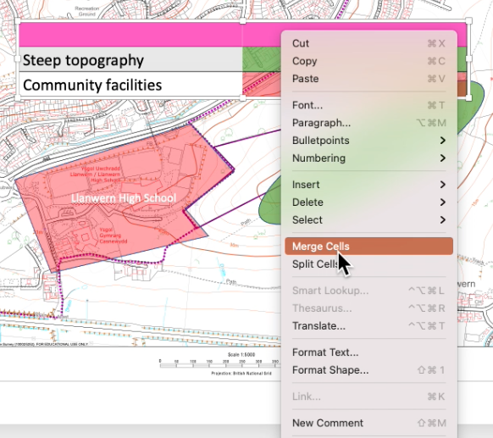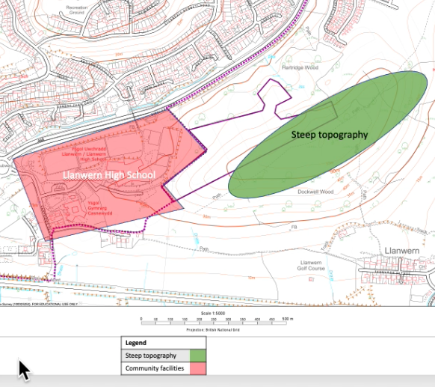

Saving your map as a JPEG
Once you have completed your map and you are happy it has no spelling errors, and all the annotations are correct, you will want to save it in a format that is easy to insert into a Word Document for assignment 1.

Click on ‘File’ and then ‘Export’.

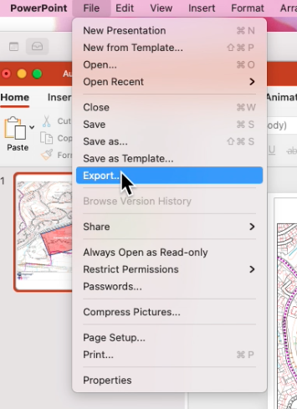

A box will pop up. Change the file format to ‘JPEG’ and insert a title that describes the map you have created. You can now click Export. Your map has been saved as a JPEG file that can be inserted into a word document.
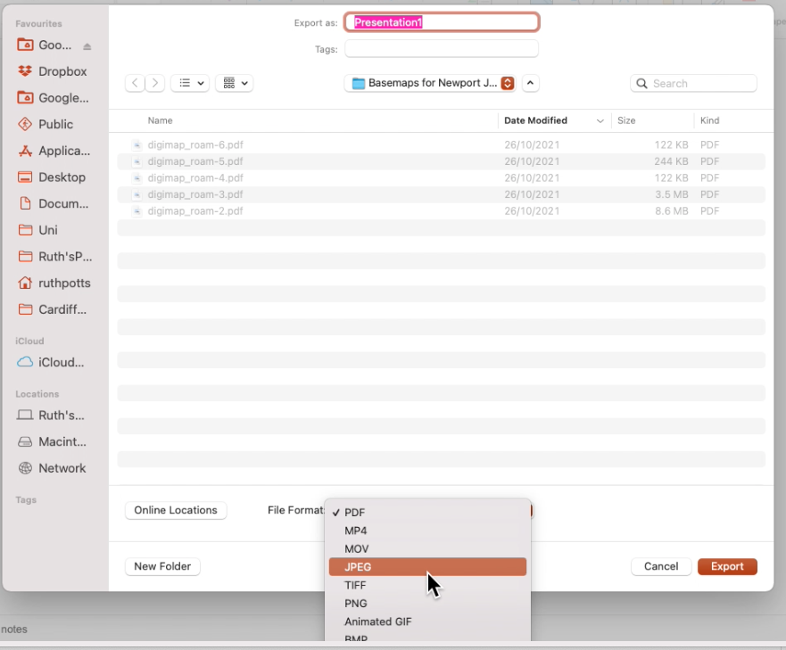

Practice doing these steps with your practice versions of your maps, before refining your ideas for the map outputs for assignment 1.

