Workbook 4: SketchUp basics
In this practical you will start to practice using SketchUp to annotate the base map created in Digimaps. In this practical you will learn the basics of drawing 2D and 3D shapes, including roads, buildings, and landscaping features.
At the end of this practical you will have learnt:
- How to use SketchUp to draw 2D shapes such as building outlines, roads, paths, and trees
- How to insert colour and texture into your SketchUp plans
Accessing SketchUp
SketchUp is a 3D modelling and design software available by licence from Trimble (provided for you by the School of Geography and Planning). It includes ‘pro’ desktop and free web-based versions of the software. SketchUp is used by practitioners across a wide variety of disciplines including urban planning, architecture, engineering, interior design, video game design and others. SketchUp is currently used by Cardiff Council as a means of visualising the city as a whole and considering proposed development applications in context. The software can be used to create models at different scales.
You can access this software on campus in the Glamorgan building computer lab or on your personal laptop using the licence that was emailed to you. Please follow the instructions that were emailed to you ahead of this module commencing to download and sign in to SketchUp Pro on your laptop OR open the software on a university computer
Once you have opened SketchUp, open your base map file that you created in Computer Lab 3 in SketchUp. Please ensure it is scaled properly as per the instructions in workbook 3.
Viewing your map in SketchUp
Before we draw anything, it’s important to know how to adjust your view of your map. There are two tools in the tool bar that help you adjust the angle and part of your map that you are looking, these are the ‘orbit’ and ‘drag’ tools.

The orbit tool looks like a stick with a red and green arrow rotating around it. This button will help you adjust the angle that you are viewing your map with. Simply click on the orbit tool button and then click and drag your view on your map, using your mouse to rotate your view.

The drag tool looks like an open palmed hand and enables you to drag the map on the screen, adjusting which part of the map you are looking at. You should click on the drag tool, then click and drag your view using the mouse on the map.

Practice using both of these tools to view your base map from different angles.

Another way to adjust your view, which is helpful for the type of drawing exercises you will be doing, is to adjust the camera angle. You can do this by clicking on the Camera menu on the menu bar, selecting ‘Standard views’, and then selecting ‘top’. This will give you a view from directly above your map, and help you to see your plan drawings in full at the same angle you will publish your maps at for the module’s assignments.

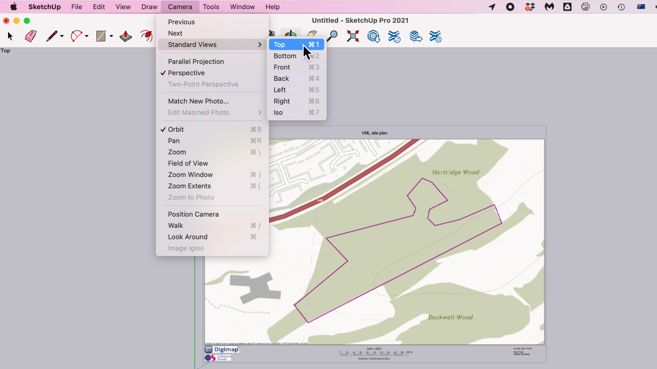

Drawing tools in SketchUp
In this module we will be using SketchUp to create a master plan and a site plan. To create each of these outputs, we need to develop some basic skills to draw individual elements in SketchUp that you may want to include in your plans. Let’s start with 2D shapes.
You can use a number of tools to draw 2D shapes in SketchUp, and these can be found in the tool bar.

The first drawing tool is the ‘line’ tool which looks like a pencil. There are two types of line drawing possible in SketchUp – line and freehand – which you can see when you click on the small black triangle next to the pencil tool icon. We will be using the line version in this module. This tool can be used by clicking on the pencil icon once in the tool bar, and then clicking once on your map to start drawing the line, and clicking once to finish drawing the line at the desired length. Let’s practice drawing a basic line.

Your line will change colour depending on the axis the line is aligned with on SketchUp. In the picture below, we are drawing on the horizontal plane which means our line is green while we draw it. You can see how long the line you are drawing is by keeping an eye on the box in the bottom right hand corner of the screen.

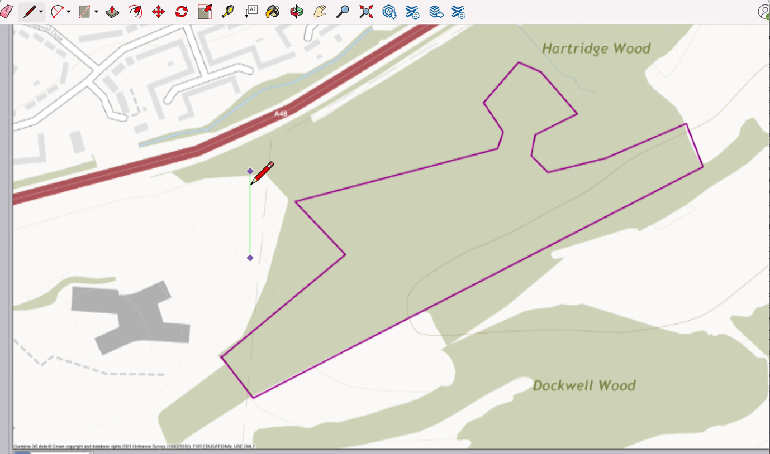

Now that we can draw a line, we can start thinking about drawing 2D shapes, such as rectangles, squares, pentagons, and triangles.

Drawing simple 2D shapes
All 2D shapes are drawn using lines. Simple right? If we use the skill we learned above to draw a single line, we can now use the line tool to draw a rectangle, which on a plan may represent a building. Let’s try to draw a building that measures 5 metres wide and 10 metres deep anywhere on our site. Let’s start by zooming in a little.

Now select the line tool again by clicking on the pencil in your menu bar. Click where you would like to start drawing on your map and draw the first side of your rectangle. Once the measurement in the bottom right hand corner box indicates your line is 5m wide (you can also simply type in 5 and press enter to ensure the line is 5m long), click on the map. You should now be able to draw a second (10m) side to your rectangle by moving your cursor in the appropriate direction on the screen.

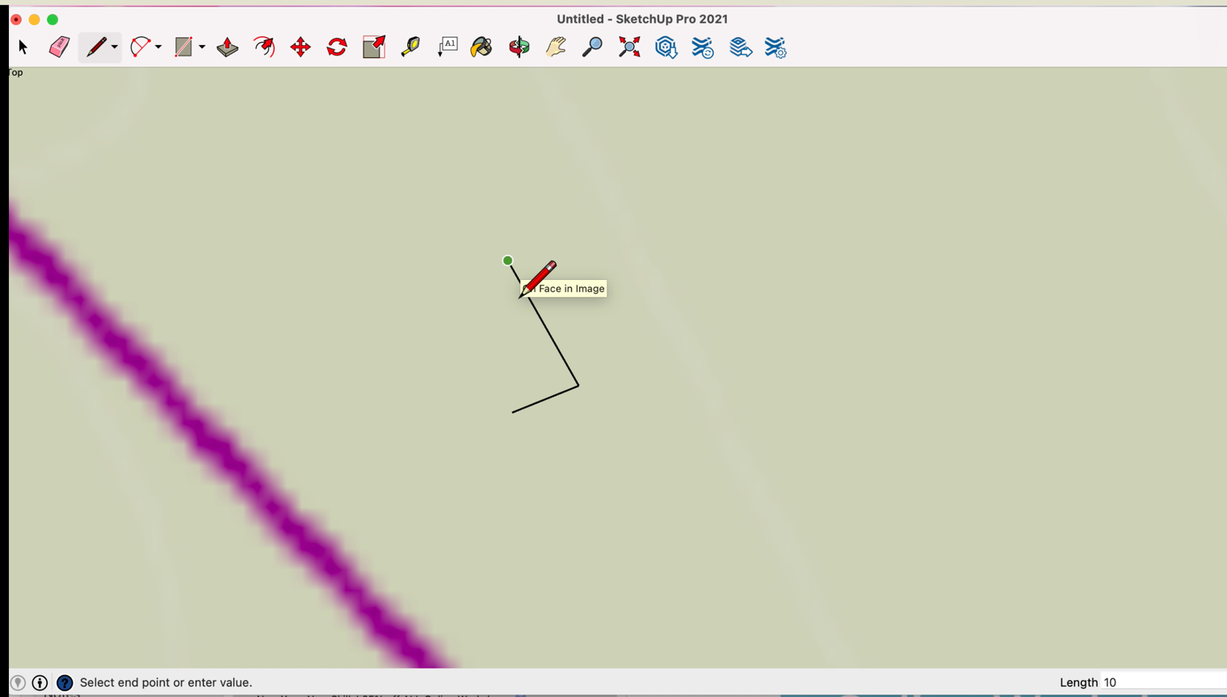

Continue with all four sides of your rectangle. Watch the colour of the line – when the line turns pink it is indicating the lines are perpendicular to each other, and when it turns green or red it is aligned with one of your horizontal axis. Once you have connected all of your lines the rectangle will turn blue, indicating you have finished drawing that 2D shape.

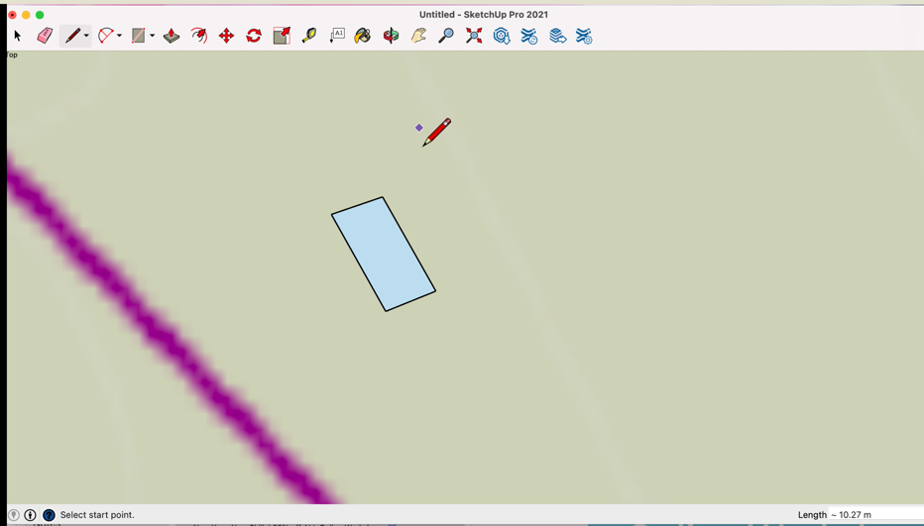

There is a second way to draw 2D shapes. You can use the object drawing tool which looks like a square with a red line diagonally though it in the tool menu bar. This button has a little black triangle next to it, which when clicked on once reveals a number of different shapes that you can draw (rectangle, square, polygon, circle). To draw any of the shapes available through this pattern, click once on the object draw tool and then click on the location on your map you would like to draw that shape. You can then adjust the size of the shape by moving your cursor further or closer to the centre point of the shape (where you clicked first on the map), once you are happy with the size, click again once on the plan.

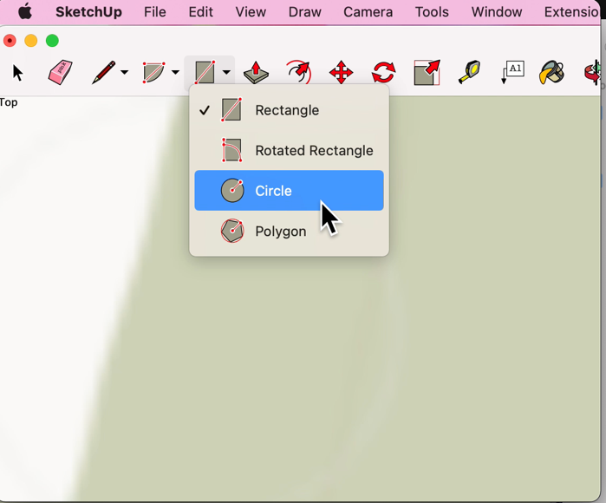

You may want to draw other 2D shapes such as triangles or squares, and these can be drawn in the same way, using the line tool to draw the desired shape. Practice drawing the following shapes:
- A square that is 20m x 20m
- A triangle with at least one side measuring 30m
- A rectangle measuring 8m x 12m

Drawing complex 2D shapes – roads and footpaths
Once you have become confident drawing basic shapes you will realise that to draw a plan for a site likely involves drawing more than straight or perpendicular lines. You will likely need to draw roads, footpaths, and irregular shaped buildings. To do this, we will need to use some of the additional drawing tools available in SketchUp.

Lines continue to form the foundation for any shape, but what if we wanted to draw a road or footpath that curved? We first need to draw a set of lines in the approximate location we want our road or footpath to be located using the line tool. Let’s assume I want to draw a road across the site where I have drawn the black line below. Note that the line is not completely straight.
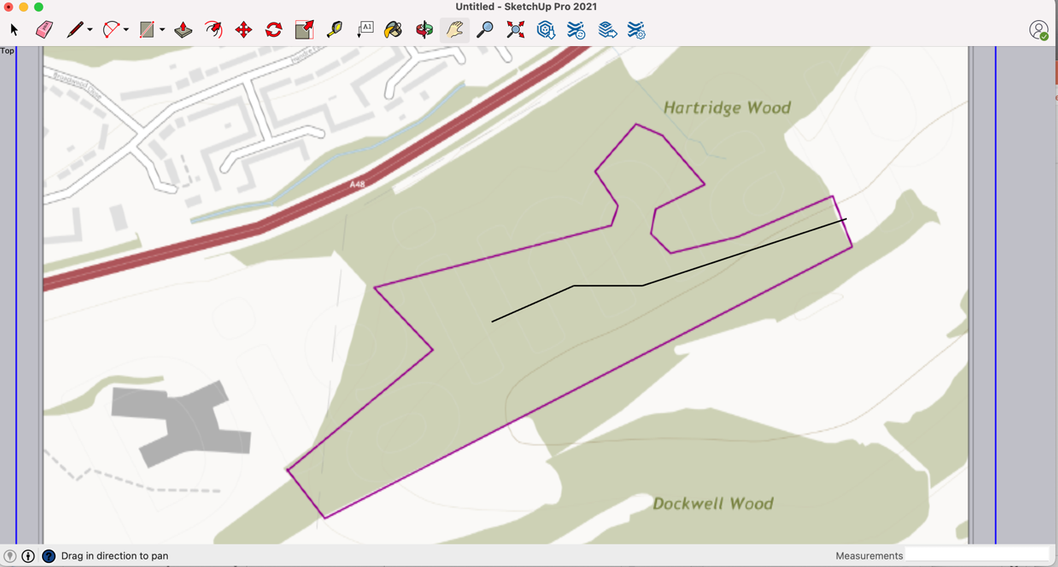
Let’s zoom in on the road where it ‘zig zags’. You can see that the road looks quite sharp in its shape, in reality roads tended to be more gently curved than ‘zig zag-y’. In order to soften the shape of our road we need to use the ‘Arc’ tool. The Arc tool looks like a semi circle with red lines running across and into it. There are several types of arc you can draw in SketchUp, but today we will use the 2 point Arc tool.
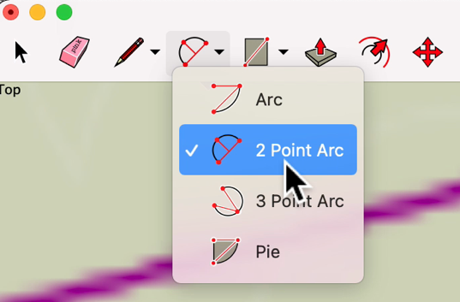

Once you have selected 2 Point Arc, you should click on your ‘zig zag’ line roughly 1cm (as seen on your screen, not to scale) from the ‘pointy’ part of your line. The arc tool will now be visible and you should select a similar point on the other side of your ‘zig zag’ to place your cursor. You can adjust the angle and curvature of the line at this stage by moving your cursor across the line. You will notice that the line is either a light blue colour, or pink. If the line is blue, you can click once to complete the step of creating a curve, which will be indicated by the triangular space between your drawn lines also turning pale blue.

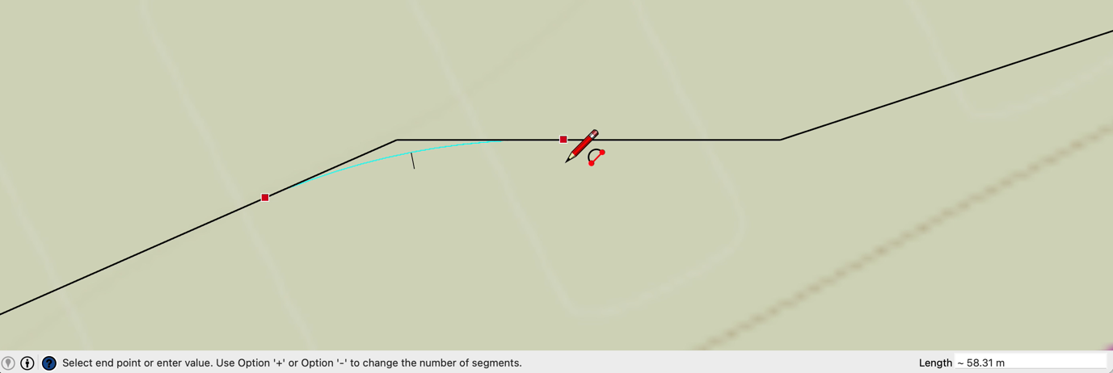

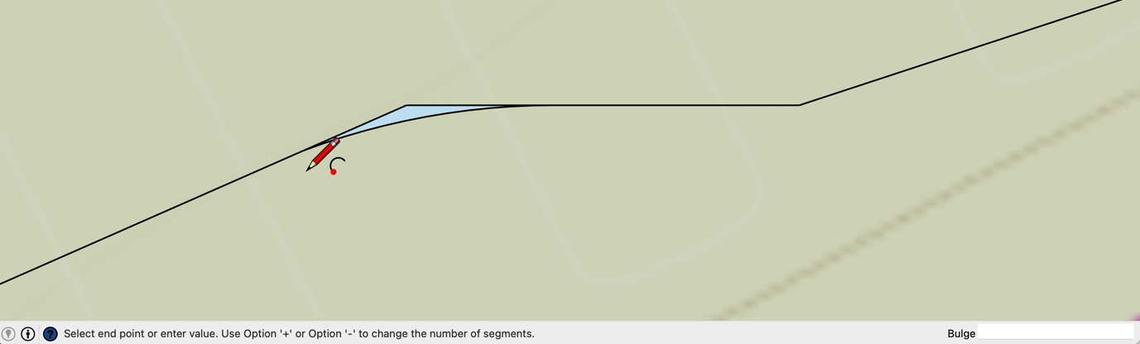

The ‘pointy’ part of the road however is still there above the curve. To remove these unwanted lines, select the cursor icon from the menu bar, and then click on each straight line once and press the delete button on your keyboard. Be careful here – if you double click on the line and press the delete button and it will delete your entire road line, rather than just the small pointy part (if this happens press control and the Z key on your keyboard to undo the previous action).

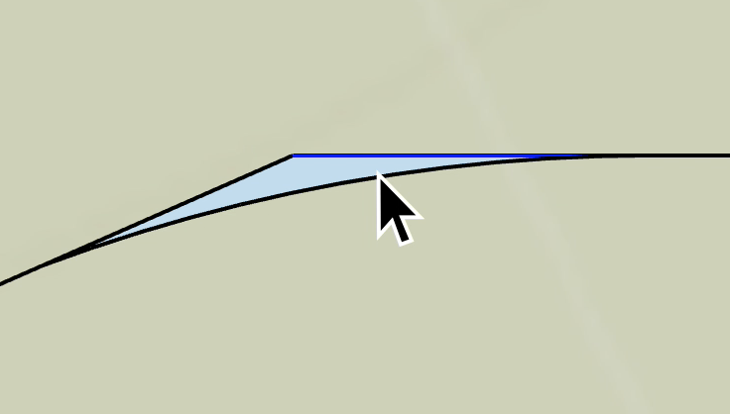

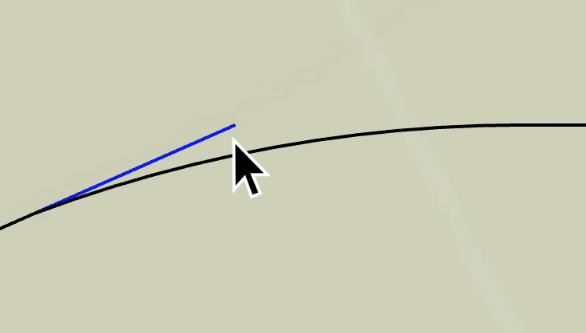

As you are using the Arc tool you will note that the line may also turn pink. This will enable you to do a ‘quick’ version of the above steps. You similarly start your arc on one side of the line by clicking once (I recommend approximately 1-1.5cm on your screen/not to scale from your ‘point’) and then move your cursor to the other side of the obtuse angle until it turns pink before clicking once again on the screen. This approach is quick because the software will automatically remove the ‘pointy’ lines for you and curve the line based on the line indicated in pink on your map.

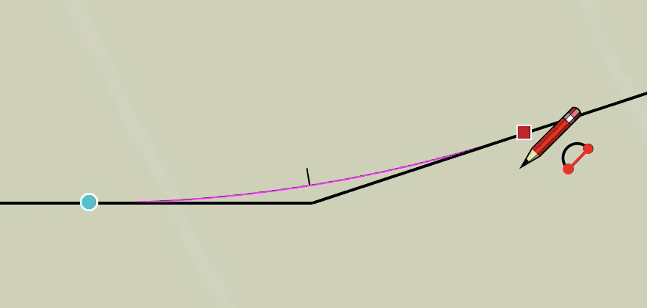

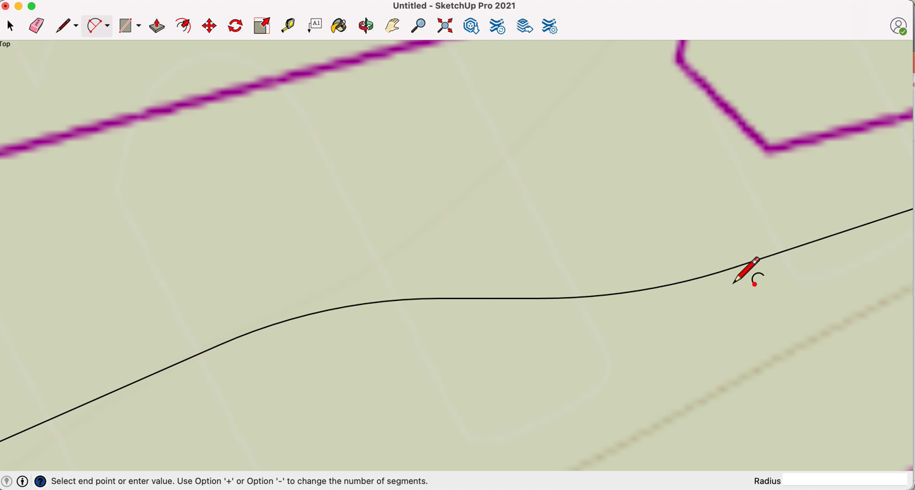

Practice doing this a few times until you feel comfortable drawing curves.

Hopefully by now you’re feeling confident and have mastered drawing curves along straight lines. When you draw a plan with a large number of roads I would recommend you draft the road layout as a series of individual connected lines on your base map first before moving onto the steps below. This will help you see your development’s proposed road network as a whole and make adjustments before you add width or colour.

Let’s turn the line you have just drawn into something that resembles a road. We are going to do this using the ‘Offset’ tool, which looks like a finger with an arrow coming out of the finger nail, and a second red line.

Click on the offset tool in your tool menu bar and then click anywhere along the line we have just finished drawing. You will now see a second line appear that mirrors the shape of your first line. You can use your cursor to move the new second line as far away from your original line as you like, and once you are happy click once again on your map. Your lines should look like the drawing below.

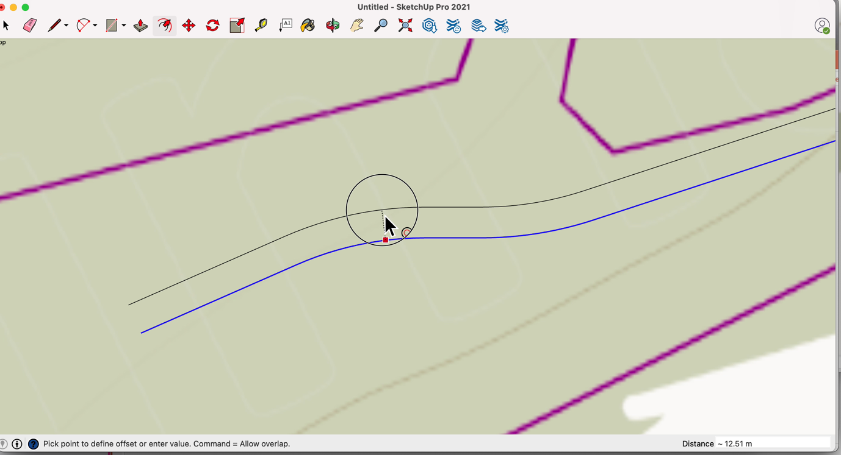

You can watch the box in the bottom right-hand corner of the screen to see how far apart your lines are in metres, which will be important when it comes to drawing roads later on (you’ll need to do some research on how wide different types of road are to decide the types of road you will use and thus how wide your roads should be in your plans). For now I have selected 12.5 metres as my width.

After you have finished using the offset tool and you are happy with how your road looks, you should use the line tool in the menu bar to close the road shape at both ends. Once both ends are ‘closed’ the road will become a pale blue colour.
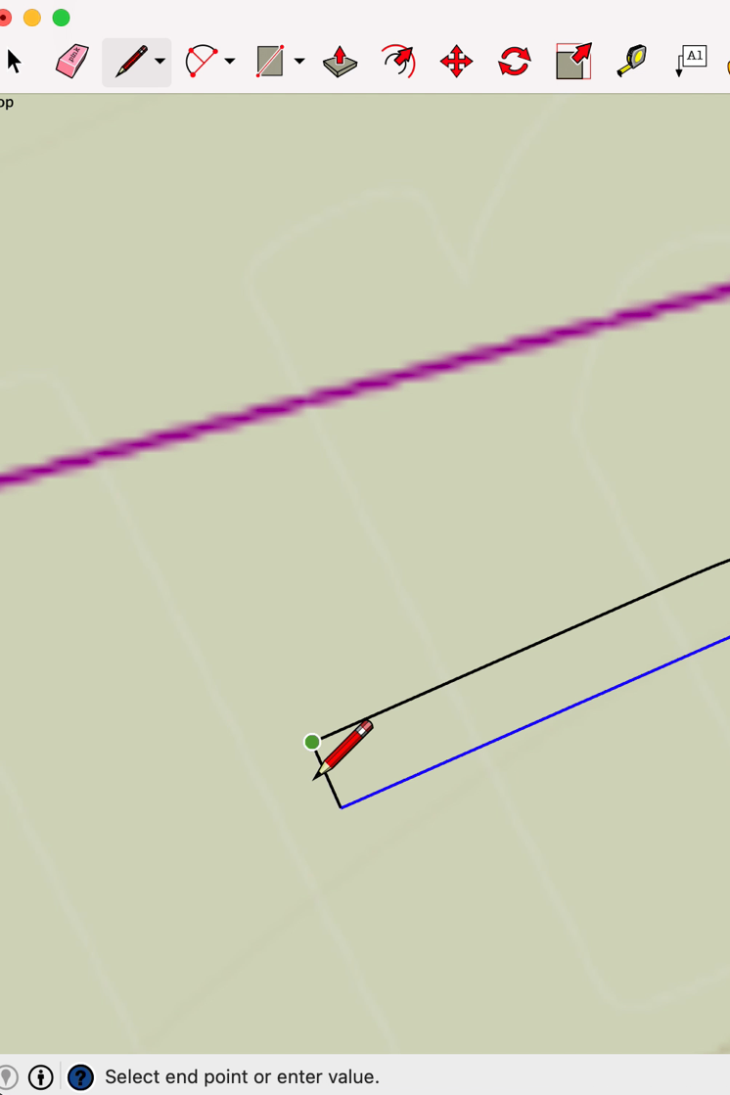

Adding colour and texture to your plans

When drawing your plans colouring in the shapes should always be completed last in your drawing process as the lines you have drawn will be less visible and difficult to edit after this. After you are completely happy with your road network on the map (and our example here is likely much more simple than your plans will include), you will need to use the paint bucket tool to insert colour into the shape. SketchUp will not allow us to colour the drawing lines, but will allow us to colour in the space between the lines.

Selecting the paint bucket tool will open the paint bucket menu box which enables you to select basic colours as well as more complex textures to colour in the different aspects of your plan. Today I have selected the dark black texture/colour from the Asphalt and Concrete options to colour my road. You will click once on your preferred texture/colour and then click once inside the pale blue shape you would like to colour.
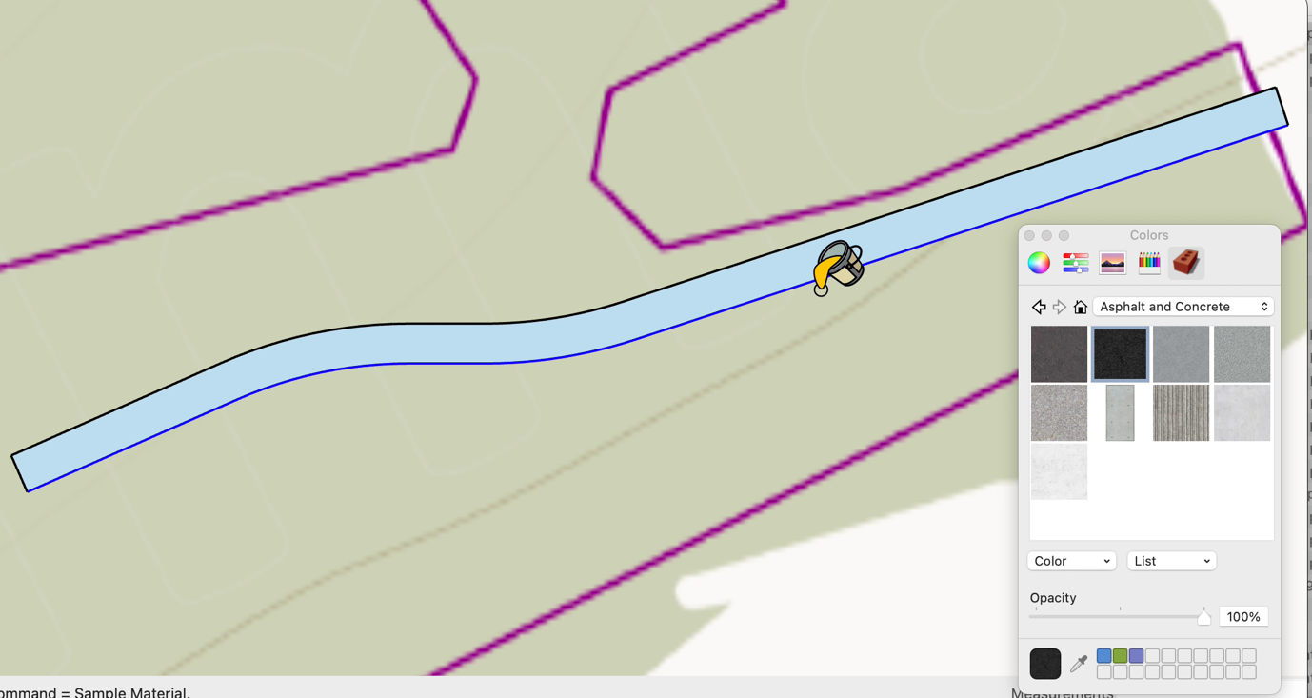

Click once to colour in your shape. Explore the different colours and texture options available to you and consider where you might be able to use them in your plans.

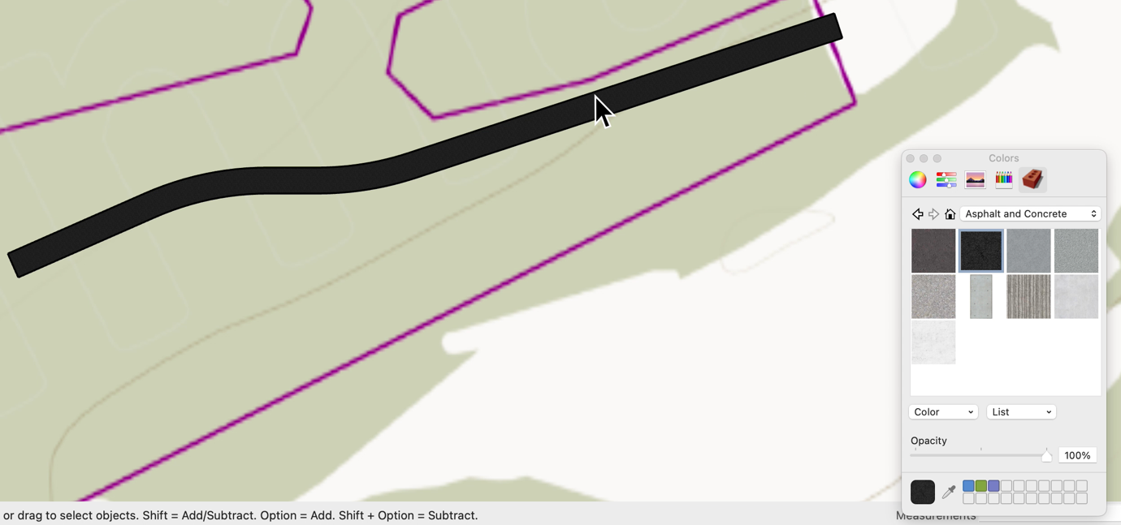

You have now completed the SketchUp basics workbook. Continue to practice these skills and use them to draw your Master and Site Plans.

