Reading into Writing Feedback
Generally, the reading to writing question was answered well in terms of organisation and language. Just make sure that you include a conclusion.
The area where everyone did less well was in task response.
- The main ideas were summarised quite clearly but sometimes there was no development of ideas and no personal evaluation and there was little reference to the actual artworks to explain how the artists achieved their aims.
- There were some attempts at citation, but this was not always done accurately or appropriately.
These are the criteria for task response for bands 5-7
BAND 5:
- Addresses the task only partially.
- Word count may fall outside +/- 10%
- Expresses a position but the development is not always clear and there may be no conclusions drawn.
- Little use of texts provided and possibly inaccurate in-text citation.
- Presents some main ideas but these are limited and not sufficiently developed; there is irrelevant detail.
BAND 6:
- Addresses all parts of the task although some parts may be more fully covered than others.
- Word count falls within +/- 10%
- Presents a relevant position although the conclusions may become unclear or repetitive.
- Some evidence of ability to summarise and/or refer to texts provided. Uses largely correct in-text citation.
- Presents relevant main ideas but these are not always sufficiently developed and there may be irrelevant detail.
BAND 7:
- Addresses all parts of the task
- Word count falls within +/- 10%
- Presents a clear position throughout the response.
- Clear evidence of ability to summarise and refer to texts provided and uses correct in-text citation.
- Extends and supports main ideas, but there may be a tendency to over-generalise. Supporting ideas may lack focus.
What are the main differences between a band 5 and a band 7?
Let’s look at some examples from your essays.
Compare the techniques used by Kahlo and Dixon to explore their personal and cultural identity in their artwork.
How well would they do in terms of task response?
- Is the response well developed with many relevant, extended and supported ideas?

- About Frida Kahlo and Michel Dixon, what they have in common is the search for their own concepts of identity and where they belong … They both struggle with two different cultural identities. They combine two elements that represent different identities to depict their inner struggles to understand their own identities

- From my position, she’s definitely a very successful artist … and she is also very successful in expressing her own sense of identity.

- About Frida Kahlo and Michel Dixon, what they have in common is the search for their own concepts of identity and where they belong. They both struggle with two different cultural identities. They combine two elements that represent different identities to depict their inner struggles to understand their own identities. Kahlo and Dixon combine two elements that represent different identities to depict their inner struggles to understand their own identities.

- Is there reference to the texts provided and correct in-text citation.

- For example, as he said, I struggled with fitting into an ethnic group category.
This is from the original text: My struggles to fit into a racial group category and how I fashion an authentic self, while constantly feeling like an outsider, is the foundational and emotional content of my work.

- As Art Perspectives (2020) maintains “the exaggerated features of this work suggest that instead of celebrating European art traditions, Kahlo is rejecting this culture and identity.”
This is from the original text: However, the exaggerated features of this work - the neck is too stretched, and the dress is too red - suggest that instead of celebrating European art traditions, Kahlo is rejecting this culture and is therefore further embracing her Mexican culture and identity.

- According to Art Perspectives (2020), Kahlos’ physical and cultural identity as central to understanding her artwork.
This is from the original text: Kahlo's body and her cultural identities are central to an understanding of her work.

- “I aim to locate myself in this discussion as a biracial Black man who has been both the victim of racism, but also as a man who, because of my light skin, is sometimes seen as white” (Dixon 2010).
This is from the original text: I aim to locate myself in this discussion as a biracial Black man who has been both the victim of racism, but also as a man who, because of my light skin, is sometimes seen as white.

- In White, Black and Confused, “My goal was to identify myself as a biracial black man who was both a victim of racism and someone who was sometimes seen as white because of my light skin,” Dixon (2019).
This is from the original text: I aim to locate myself in this discussion as a biracial Black man who has been both the victim of racism, but also as a man who, because of my light skin, is sometimes seen as white.

Now look at this sample answer below with a partner and decide to what extent it satisfies the criteria for task response.

Artists often use their work to explore issues relating to their identity. In this essay, I am going to explore the work “The Two Fridas” “Self Portrait in a Velvet Dress” by Frida Kahlo and “White, Black and Confused” by Dixon and show to what extent they have been successful in using their art as a reflection of how they identify themselves.
About Frida Kahlo and Michel Dixon, what they have in common is the search for their own concepts of identity and where they belong. They both struggle with two different cultural identities. They combine two elements that represent different identities to depict their inner struggles to understand their own identities. Kahlo and Dixon combine two elements that represent different identities to depict their inner struggles to understand their own identities.
Dixon differs from Kahlo in his attempt to break down the black and white stereotypes, and the basic and emotional content of his work is the desire to try to fit into the category of an ethnic group and how to portray a true self, but also to express the feelings of always being an outsider. While Kahlo hopes to choose a culture identity between two different cultures. She finally embraces her Mexican cultural identity.
Both artists seek their own cultural identities in their work, but the difference lies in some core differences. Dixon hopes to find a balance between his own identity while Kahlo hopes to choose one of the two identities. Comparing the two artists and their works of art not only helps us understand the artists but it also helps us understand ourselves.

THE ORIGINAL TEXTS
Text 1: Frida Kahlo
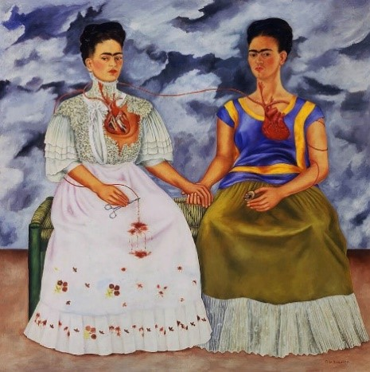
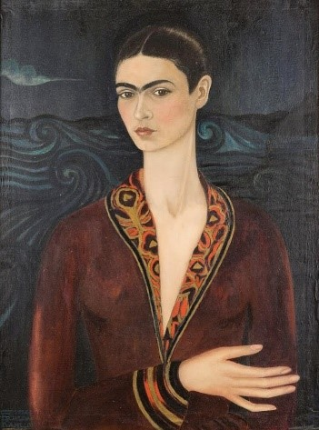
Kahlo's body and her cultural identities are central to an understanding of her work. She frequently used the imagery and symbols of her Mexican and European heritage in her self-portraits. This is illustrated by her 1939 painting The Two Fridas. In this portrait, one version of Frida is wearing a white lace dress of the European tradition, while the other wears the traditional local dress of Tehuana. Kahlo combines these two elements to portray her inner struggle to understand her identity.
The Two Fridas, 1939 by Frida Kahlo Self Portrait in a Velvet Dress, 1926 by Frida Kahlo
The painting ‘Self Portrait in a Velvet Dress’ brings both Da Vinci’s ‘Mona Lisa’ and Van Gogh’s ‘Starry Night to mind. However, the exaggerated features of this work - the neck is too stretched, and the dress is too red - suggest that instead of celebrating European art traditions, Kahlo is rejecting this culture and is therefore further embracing her Mexican culture and identity.
Lastly, Kahlo’s exploration of her identity is also shaped by a personal life event. A tragic bus accident in 1925 when she was 18 left her partially disabled and in pain for the rest of her life. Over the next three decades, she would produce a relatively small yet consistent and arresting body of work. In carefully executed paintings, Kahlo portrayed herself again and again, simultaneously exploring and questioning herself and her identity.

Text 2: Michael Dixon
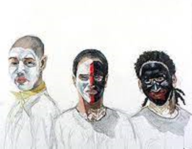
White, Black, and Confused, michaeldixonart.com

“Racial identity is complicated. We have our perceived identity (how others view us), and our self-identity (how we see ourselves). For many people, these two identities line up, and they fit nicely into the racial categories of American society. However, for others they do not. As someone who is in the middle of racial categories, my two identities are at odds with one another.
As a bi-racial American, I have often felt that I do not neatly fit into White culture or Black culture; I’m somewhere in the middle. Exploring this ‘in-between’ space has been the main focus of my creative work. I am interested in the value of Black bodies in contemporary America and want to start discussion to break down stereotypes. I aim to locate myself in this discussion as a biracial Black man who has been both the victim of racism, but also as a man who, because of my light skin, is sometimes seen as white.
My struggles to fit into a racial group category and how I fashion an authentic self, while constantly feeling like an outsider, is the foundational and emotional content of my work.

Text 1 – abridged from: Art Perspectives. 2020. Kahlo. Available at: Identity – Controversy – Justice » Kahlo Essay (unc.edu) (Accessed 27/04/2021)
Text 2 – abridged from: Dixon, M. 2019. Michael Dixon. Available at: Michael Dixon (michaeldixonart.com) (Accessed 27/04/2021)

