Reading into Writing: An Introduction to the Assessment

Look at the following statement and decide whether you agree or disagree and why.

Anyone can be an artist. Do you agree or disagree with this claim?

In the Reading to Writing Exam you have to read two different texts related to the topic in the question.
- You need to summarise and compare the views of the two writers.
- You also need to give your own views.

Look at the sample question below

Identity Project - Art & Design Pathway
Reading into Writing Assessment
For this assessment you will read two short texts about the ability to become an artist.
Using the two texts below, write a response to the following:
Anyone can become an artist
Give your response to this question in no more than 400 words
You will be marked on the following:
- Your ability to structure your essay clearly into paragraphs with an introduction and a conclusion.
- Use of linking words
- Use of language to express your opinion
- Ability to paraphrase
- Ability to use in-text citation

TEXT 1: Robert Cook, 2018, Artist & illustrator, History of Art Lecturer, Art Director (adapted)
No, just as not everyone can be a doctor, architect or millionaire. Three essential things make up an artist; skill, natural talent, and creativity. Skills can be taught; you are either born with talent or not; but to be a great artist takes great creativity. That means introducing something into art to help move it forward.
It is easier to explain by using an example. A chemist can teach some skills to an assistant, skills the chemist learned as a student. The assistant may acquire great knowledge of the drugs available on the market, their limitations, possible side effects etc. But it is the chemist who is the one who through research finds new drugs to combat illness. The chemist may work eight hours a day for years and not find the answer, but later their research, together with new findings, may result in a cure.
It is the same with an artist. Creativity is like research ability. We are all trying to find perfection and although we may never find it, if we do, we will certainly need skill, talent and creativity. And not everyone has the necessary creativity.

TEXT 2: Ray Alez, 2014, Startup Founder, Web Developer, Writer (adapted)
Yes, absolutely. You can learn art just like any other skill. The belief in being gifted or talented has absolutely no rational reason behind it. There is no special DNA for being a great painter just as there is no DNA for being a great pilot or a great doctor.
Nobody was ever born with the ability to paint well. Every artist failed at first and then got better with practice. Every famous artist had to learn at some point. People who do not understand how art works surround it with an air of mystery and perpetuate unreasonable beliefs.
If you want to become an artist, take some courses, read books, watch YouTube videos, and practice. You will be bad at first, then you will get better, then you will become excellent. Even if you did not feel talented at the beginning, people will think that you have talent after you become good. In fact, it will have nothing to do with talent - just focus, practice, experience, and thought.

Steps to follow:

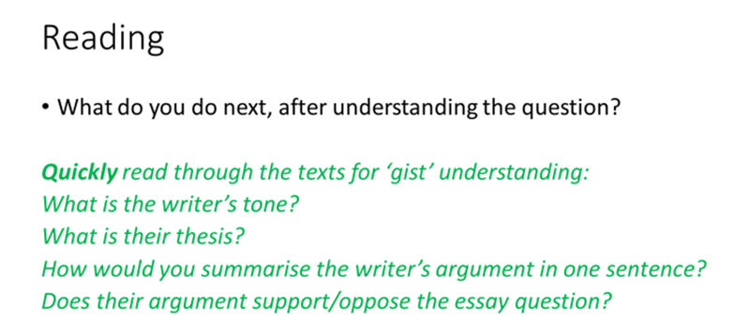
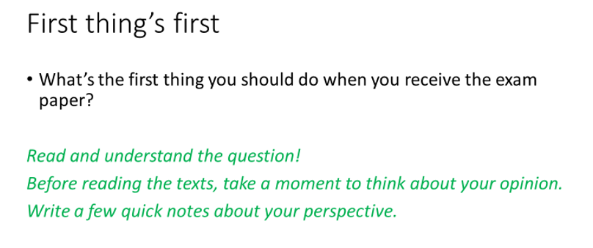
Read text 1 and complete the table below with your ideas

Writer’s tone
Thesis
One sentence summary
Position

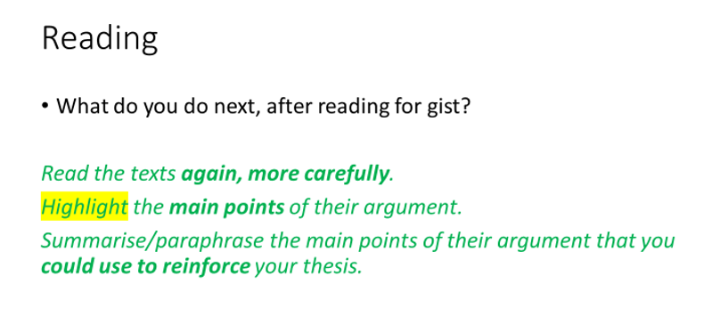

Copy and paste the main points from text 1 below and then try to paraphrase the ideas.

Now repeat the same steps for text 2

Complete the table below with your ideas

Writer’s tone

Thesis

One sentence summary

Position

Copy and paste the main points from text 2 below and then try to paraphrase the ideas.

How to structure your essay
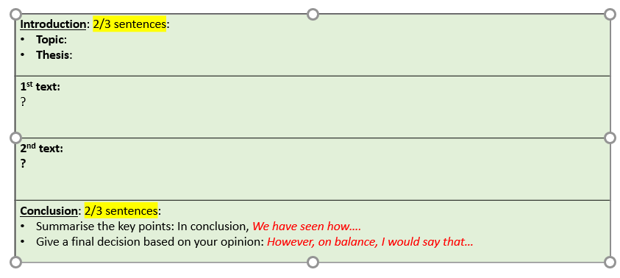

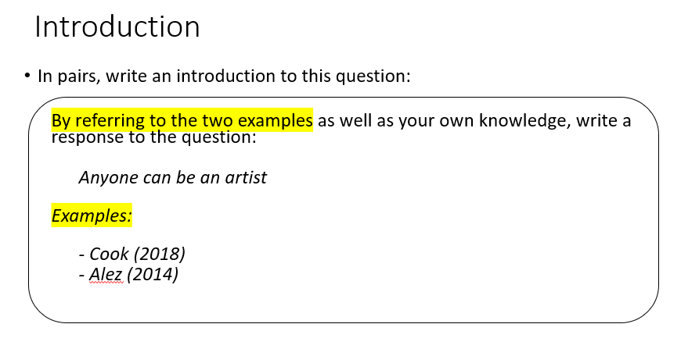
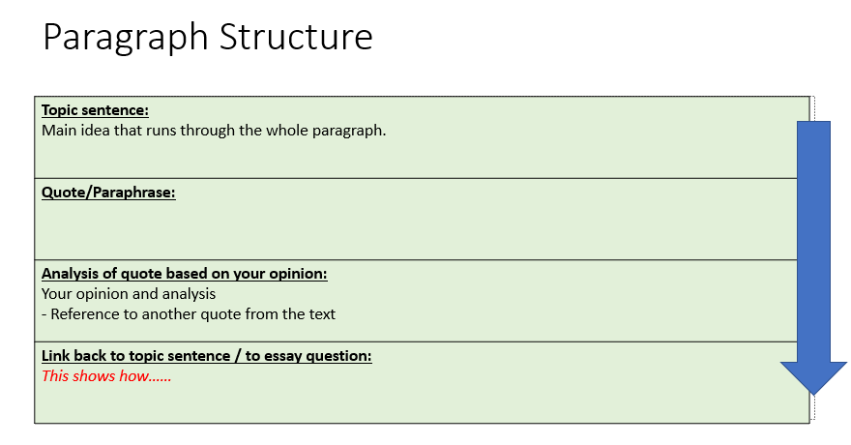

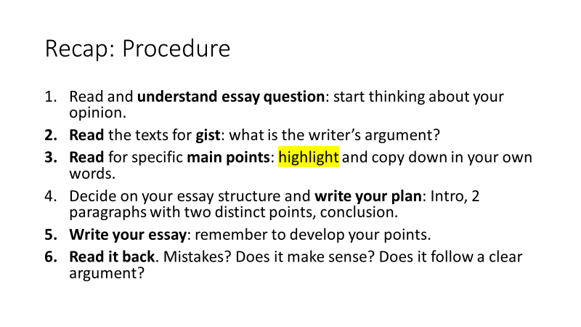
Time to practice:

You are now ready to write your answer to the question.
I will send you a link to the document.

