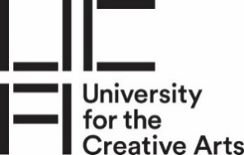
Pre-sessional English for Art and Design

15-Week Course – Project 3
10-Week Course – Project 2
6 -Week Course - Project 1
Summer 2022

ACTIVISM

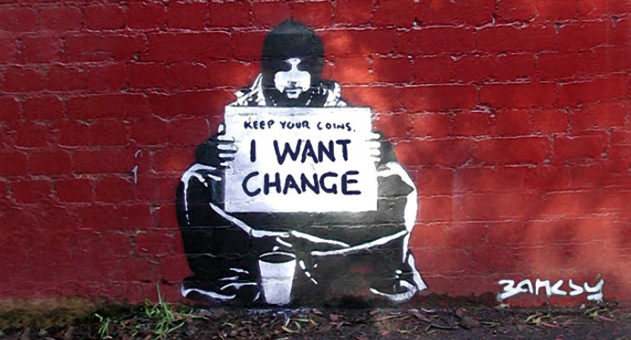

Aims and Learning Objectives | A1, A2, A3, A4  LO1, LO2, LO3, LO4, LO5
Project Start | Friday 15th July
Assessments | 11th August – 16th August

Aims and Learning Outcomes
A1 | Advance Academic English in preparation for studying on main course: help enhance academic study skills by improving reading, writing, listening and speaking skills in English and improve the overall IELTS score or equivalent by 1.5/1.0/0.5 (depending on length of course)
A2 | Develop study and research skills as well as enhance critical thinking
A3 | Increase confidence as a UCA foundation/undergraduate/postgraduate student
A4 | Develop intercultural competencies in relation to knowledge, skills and attitudes, such as: cultural self-awareness, respect, openness, empathy, curiosity and discovery

LO1 | Advanced Academic English in productive skills: writing and speaking
LO2 | Advanced Academic English in receptive skills: reading and listening
LO3 | Developed academic reflective and analytical skills
LO4 | Developed research skills: Harvard referencing and increased knowledge and ability in using academic vocabulary and grammar
LO5 | Developed ability to work independently and in groups

Project Brief

What is Activism?
Activism is when people take action to bring about social or political change.
Activist art is a term used to describe art that addresses political or social issues. It is about empowering individuals and communities, and is generally situated in the public arena with artists working closely with a community to generate the art.
Many artists use their art to comment on social and political issues. Banksy’s work, for example, makes subversive comments on social issues in the UK. Artists such as El Seed have created installations promoting peace on the DMZ between North and South Korea, while JR and Marco have used photography to challenge national stereotypes of Palestinians and Israelis. Meanwhile, activist groups such as Hate is a Virus highlight the hate crimes happening as a result of the Covid-19 virus.
At various times in history and in many different countries, students in particular have been involved in changing society and challenging the status quo. Student activism, or campus activism, is action by students to cause political, environmental, economic, or social change.
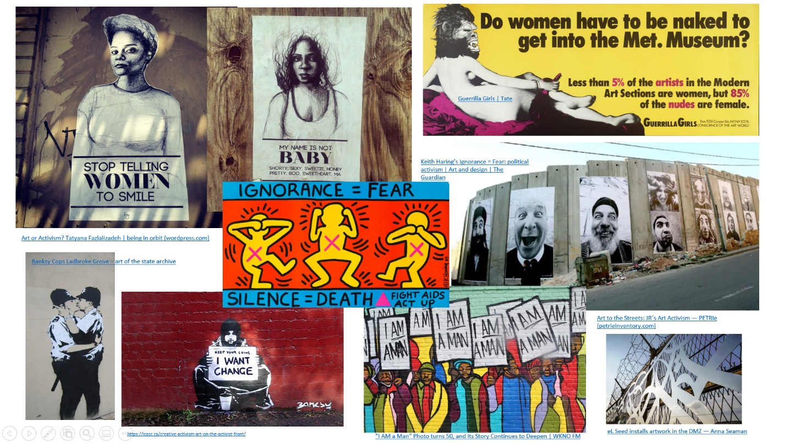

For this project, you are being asked to create an activist artwork for display on the UCA campus as part of the Student’s Union’s campaigns Campaigns (ucasu.com).
Your work can incorporate your chosen discipline if you wish. You will need to conduct research into issues that concern university students – this could be international students, LGBT students, or university students in general. Your piece of art activism will be designed to raise awareness of this issue, and should be interactive, performative, installation or/and immersive.
You will also need to conduct research into other art activist projects in order to seek inspiration for your own design – you will analyse these case studies in detail for your essay. You must explain in your interview and in your presentation why and how you were influenced by these case studies.
The following tasks are summative. The results will be recorded on your end-of-course certificate.
Task 1 – Research Essay 900 words UG / 1000 words PG
For this essay you are going to research and analyse two art activist projects which both respond to a similar social or political issue. Your decision for choosing these two projects must be based on those you consider to have been successful and that will most inspire your own art activist project idea.
You will refer to how these projects inspire you in your presentation and in your speaking assessment. The aim of this essay is to analyse the social, historical and/or political contexts of these projects, the processes and designs used, and the way in which they have empowered communities.
You need to adapt and respond to the following title:

Research and compare how [art activist projects 1 and 2] have successfully used art to respond to [political or social issue] and empower communities.

You can structure your essay in the following way:
Introduction -- Briefly introduce the two projects and the social/political issue they focus on.
Paragraph 1 – Context: What is the social or political issue that these two projects respond to? Why did these two artists decide to focus on this issue? What social or political events prompted these artists to respond to this issue?
Paragraph 2 – Creative Process: What was the process in creating these two projects? What research did the artists need to do? How did they decide upon their designs? How did they find inspiration?
Paragraph 3 – Analysis of final design: Describe the final design of both projects. Analyse how the social or political issue was expressed through the design.
Paragraph 4 – Audience Impact: Why were these two projects a success? How did they impact their audiences and empower communities?
Conclusion – Summarise your findings into these two projects and why they were successful.

You will need at least five references, and these should be listed in your bibliography. You may use visuals in your essay and these must also be correctly referenced.

Task 2 - Presentation (5 mins) - Individual Task
For your presentation you are going to present your own idea for an art activist project as part of the student campaigns for UCA’s Student’s Union: Campaigns (ucasu.com) . This project will be held at one of the university campuses and must respond to an issue that students at UK universities – or students at UCA in particular – care about. Your artwork should be interactive, performative, installation or/and immersive.
You can structure your presentation in the following way (6 slides):

Introduction: Briefly introduce your art activism idea and the issue it responds to.
Issue and research: Explain the issue you are focusing on. Why did you decide upon this issue? What research did you undertake which prompted you to focus on this issue?
Creative Process: How did you decide upon the design / style of your idea? What research did you undertake which inspired your design ideas? How did the projects you researched for your essay inspire your idea?
Design: Show a sketch of your final design. Explain the different features of your design. Where will the artwork be placed on campus and why have you chosen this location?
Audience Impact: How do you expect your audience to interact with your artwork? Why? How do you think your audience will be impacted even after they have interacted with your artwork?
Conclusion: Why do you think your artwork will be successful? Which community at the university do you expect to be empowered by this artwork and why?

Task 3: Speaking Assessment – Reflective Practice 10 mins
For your speaking assessment, you will participate in an interview where you will be asked questions relating to your research for this project. Throughout the project your tutor will set specific tasks to guide your reflection and your research. You will record these on a Padlet and the Padlet will form part of your weekly tutorial. For this assessment you should present your final Padlet to your tutor and answer questions on the work you have carried out.

Task 4: Listening Assessment
You will complete a listening assessment comprising of a variety of tasks based on authentic materials.

Task 5: Reading into writing – 400 words
You will be given some short texts relating to activism and will write an essay in response to these texts. You must make detailed reference to the texts provided and include references to the texts in your essay. You will have 90 minutes to complete this task.

Useful Secondary Sources
General Art and Design websites and databases:
- The Art Story: Guide to Visual Art: The Art Story: Visual Art Movements, Artists, Ideas and Topics
- October Gallery, London: OCTOBER GALLERY ARTISTS
- Tate Modern, London: Art and Artists | Tate
- Saatchi Gallery, London: About 35 years of art - Saatchi Gallery
- New York Museum of Modern Art: MoMA
- The Artist’s Information Company: Home - a-n The Artists Information Company (oclc.org)
- Visual Arts Data Service: Home - VADS - online resource for visual arts
- National Museum of Modern and Contemporary Art: National Museum of Modern and Contemporary Art, Korea, Seoul, South Korea — Google Arts & Culture
- Rijk Studio: Rijksstudio - Rijksmuseum
- My Modern Met: My Modern Met – The Big City That Celebrates Creative Ideas

Specific Articles and Videos
- The Art of Social Change: Tania Bruguera The art of social change – Talking Point | Tate
- Artists as Activists: Pursuing Social Justice: Artists as Activists: Pursuing Social Justice | HuffPost
- The Art of Change: Women on Waves Activist Art Org: The Art of Change: Women on Waves Activist Art Org - The Art Story Blog
- JR: My Wish: Use art to turn the world inside out: JR: My wish: Use art to turn the world inside out | TED Talk
- eL Seed: Street art with a message of hope and peace eL Seed: Street art with a message of hope and peace | TED Talk
- Rebel Women the Great Art Fight Back (video documentary): https://learningonscreen.ac.uk/ondemand/index.php/prog/1172DA83?bcast=132320368
- Art and Activism: Five Contemporary Examples: Art and Activism: Five Contemporary Examples - ArtConnect Magazine
- UCA Student’s Union Campaign: Culture Matters: Culture Matters (ucasu.com)
- A Short History of Activism: https://www.womenshistory.org/resources/general/short-history-activism
- Guerrilla Girls: https://www.guerrillagirls.com/
- Influential American protest art since WWII (NYT): https://www.nytimes.com/2020/10/15/t-magazine/most-influential-protest-art.html
- A history of protest art from Ai Weiwei to Banksy (Widewalls): https://www.widewalls.ch/magazine/protest-art
- Emma Krenzer ‘Touches’ project (sexual assault/consent): https://www.huffingtonpost.ca/2017/01/26/impact-of-sexual-assault_n_14416532.html
- The rise of student activism (Guardian): https://www.theguardian.com/education/2020/sep/15/people-thought-i-was-too-young-to-protest-the-rise-of-student-activism
- A Street-Art project addressing gender-based street harassment: Stop Telling Women to Smile - Tatyana Fazlalizadeh (tlynnfaz.com)

Glossary
To challenge the status quo – To behave or do something in a way which is contrary to what is generally accepted
To empower – To give someone power or the freedom to do something
To raise awareness – To spread knowledge of a particular problem or cause

Audience Impact – The effect that someone or something has on its viewer or participant
Immersive Art – Art which allows viewers to become part of the artwork
Installation Art – 3-dimensional art that is often ‘site specific’ and designed to transform the perception of the space
Interactive Art – A genre of art in which audiences can participate in some way, which often enhances the meaning of the artwork
Performance Art – An art form which combines visual art with dramatic art
Public Arena – All the activities and people connected with public life
Public space - places that are open and accessible to everybody, regardless of gender, race, ethnicity, age or socio-economic level, such as plazas, squares and parks.
Site-Specific Art – An art form designed to exist in a particular location

